[Skip to content](https://www.safaribooksonline.com/library/view/hands-on-machine-learning/9781491962282/ch02.html#container)

* [Safari Home](https://www.safaribooksonline.com/home/)
* [Recommended](https://www.safaribooksonline.com/r/)
* [Playlists](https://www.safaribooksonline.com/playlists/)
  + [History](https://www.safaribooksonline.com/history/)
  + [Topics](https://www.safaribooksonline.com/topics)
  + [Tutorials](https://www.safaribooksonline.com/tutorials/)
  + [Offers & Deals](https://www.safaribooksonline.com/library/view/hands-on-machine-learning/9781491962282/ch02.html)
    - [Conferences](https://www.safaribooksonline.com/oreilly-conferences/)
    - [Newsletters](https://get.oreilly.com/email-signup.html)
  + [Highlights](https://www.safaribooksonline.com/u/a70de58f-070b-479c-a5b6-e2a9675d8345/)
  + [Settings](https://www.safaribooksonline.com/u/)
  + [Support](https://www.safaribooksonline.com/public/support)
  + [Sign Out](https://www.safaribooksonline.com/accounts/logout/)

[Table of Contents for](https://www.safaribooksonline.com/library/view/hands-on-machine-learning/9781491962282/ch02.html)

[Hands-On Machine Learning with Scikit-Learn and TensorFlow](https://www.safaribooksonline.com/library/view/hands-on-machine-learning/9781491962282/ch02.html)

* [Search in book...](https://www.safaribooksonline.com/library/view/hands-on-machine-learning/9781491962282/ch02.html)

Top of Form

Bottom of Form

* [Toggle Font Controls](https://www.safaribooksonline.com/library/view/hands-on-machine-learning/9781491962282/ch02.html)

[PREVPrevious Chapter](https://www.safaribooksonline.com/library/view/hands-on-machine-learning/9781491962282/ch01.html)

[1. The Machine Learning Landscape](https://www.safaribooksonline.com/library/view/hands-on-machine-learning/9781491962282/ch01.html)

[NEXTNext Chapter](https://www.safaribooksonline.com/library/view/hands-on-machine-learning/9781491962282/ch03.html)

[3. Classification](https://www.safaribooksonline.com/library/view/hands-on-machine-learning/9781491962282/ch03.html)

**Chapter 2. End-to-End Machine Learning Project**

In this chapter, you will go through an example project end to end, pretending to be a recently hired data scientist in a real estate company.[1](https://www.safaribooksonline.com/library/view/hands-on-machine-learning/9781491962282/ch02.html#idm140583023307680) Here are the main steps you will go through:

1. Look at the big picture.
2. Get the data.
3. Discover and visualize the data to gain insights.
4. Prepare the data for Machine Learning algorithms.
5. Select a model and train it.
6. Fine-tune your model.
7. Present your solution.
8. Launch, monitor, and maintain your system.

**Working with Real Data**

When you are learning about Machine Learning it is best to actually experiment with real-world data, not just artificial datasets. Fortunately, there are thousands of open datasets to choose from, ranging across all sorts of domains. Here are a few places you can look to get data:

* Popular open data repositories:
  + [UC Irvine Machine Learning Repository](http://archive.ics.uci.edu/ml/)
  + [Kaggle datasets](https://www.kaggle.com/datasets)
  + [Amazon’s AWS datasets](http://aws.amazon.com/fr/datasets/)
* Meta portals (they list open data repositories):
  + [*http://dataportals.org/*](http://dataportals.org/)
  + [*http://opendatamonitor.eu/*](http://opendatamonitor.eu/)
  + [*http://quandl.com/*](http://quandl.com/)
* Other pages listing many popular open data repositories:
  + [Wikipedia’s list of Machine Learning datasets](https://goo.gl/SJHN2k)
  + [Quora.com question](http://goo.gl/zDR78y)
  + [Datasets subreddit](https://www.reddit.com/r/datasets)

In this chapter we chose the California Housing Prices dataset from the StatLib repository[2](https://www.safaribooksonline.com/library/view/hands-on-machine-learning/9781491962282/ch02.html#idm140583023277984) (see [Figure 2-1](https://www.safaribooksonline.com/library/view/hands-on-machine-learning/9781491962282/ch02.html#california_housing_prices_plot)). This dataset was based on data from the 1990 California census. It is not exactly recent (you could still afford a nice house in the Bay Area at the time), but it has many qualities for learning, so we will pretend it is recent data. We also added a categorical attribute and removed a few features for teaching purposes.

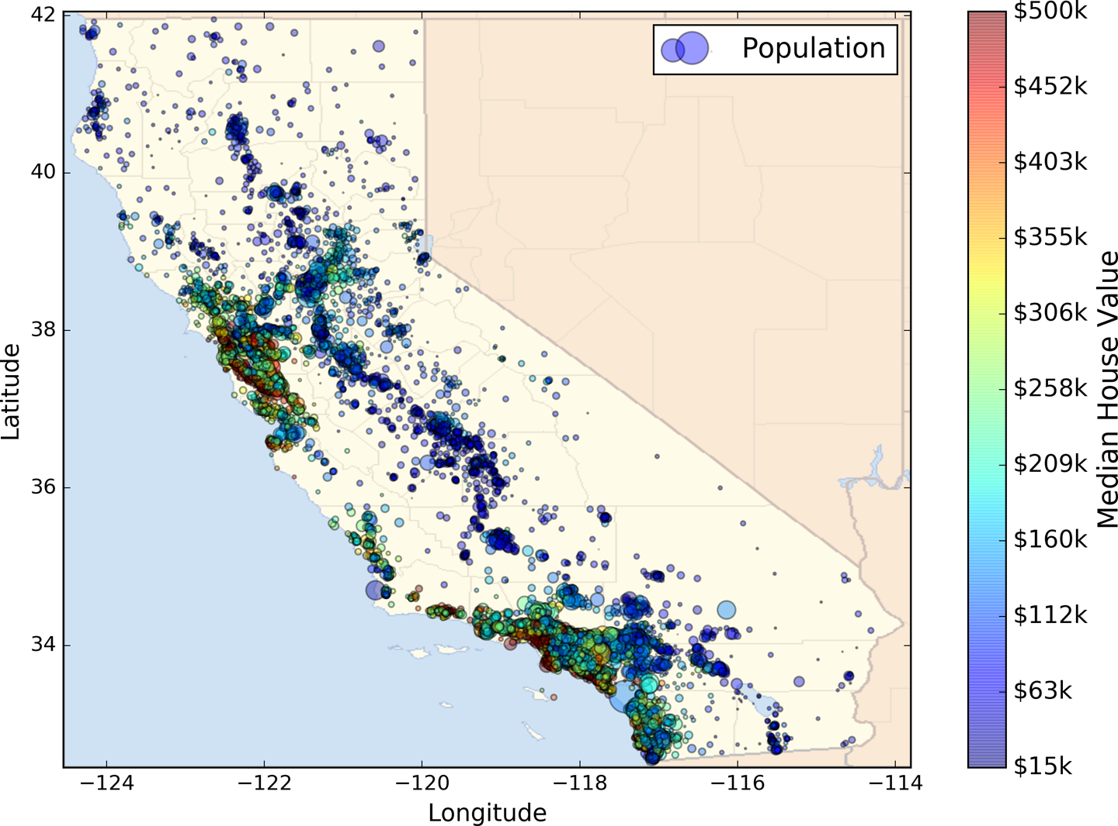

*Figure 2-1. California housing prices*

**Look at the Big Picture**

Welcome to Machine Learning Housing Corporation! The first task you are asked to perform is to build a model of housing prices in California using the California census data. This data has metrics such as the population, median income, median housing price, and so on for each block group in California. Block groups are the smallest geographical unit for which the US Census Bureau publishes sample data (a block group typically has a population of 600 to 3,000 people). We will just call them “districts” for short.

Your model should learn from this data and be able to predict the median housing price in any district, given all the other metrics.

**TIP**

Since you are a well-organized data scientist, the first thing you do is to pull out your Machine Learning project checklist. You can start with the one in [Appendix B](https://www.safaribooksonline.com/library/view/hands-on-machine-learning/9781491962282/app02.html#project_checklist_appendix); it should work reasonably well for most Machine Learning projects but make sure to adapt it to your needs. In this chapter we will go through many checklist items, but we will also skip a few, either because they are self-explanatory or because they will be discussed in later chapters.

**Frame the Problem**

The first question to ask your boss is what exactly is the business objective; building a model is probably not the end goal. How does the company expect to use and benefit from this model? This is important because it will determine how you frame the problem, what algorithms you will select, what performance measure you will use to evaluate your model, and how much effort you should spend tweaking it.

Your boss answers that your model’s output (a prediction of a district’s median housing price) will be fed to another Machine Learning system (see [Figure 2-2](https://www.safaribooksonline.com/library/view/hands-on-machine-learning/9781491962282/ch02.html#house_pricing_pipeline_diagram)), along with many other *signals*.[3](https://www.safaribooksonline.com/library/view/hands-on-machine-learning/9781491962282/ch02.html#idm140583023261776) This downstream system will determine whether it is worth investing in a given area or not. Getting this right is critical, as it directly affects revenue.

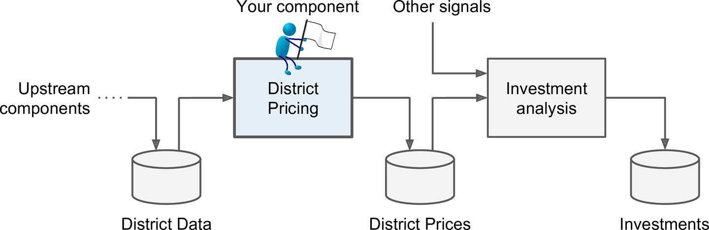

*Figure 2-2. A Machine Learning pipeline for real estate investments*

**PIPELINES**

A sequence of data processing *components* is called a data *pipeline*. Pipelines are very common in Machine Learning systems, since there is a lot of data to manipulate and many data transformations to apply.

Components typically run asynchronously. Each component pulls in a large amount of data, processes it, and spits out the result in another data store, and then some time later the next component in the pipeline pulls this data and spits out its own output, and so on. Each component is fairly self-contained: the interface between components is simply the data store. This makes the system quite simple to grasp (with the help of a data flow graph), and different teams can focus on different components. Moreover, if a component breaks down, the downstream components can often continue to run normally (at least for a while) by just using the last output from the broken component. This makes the architecture quite robust.

On the other hand, a broken component can go unnoticed for some time if proper monitoring is not implemented. The data gets stale and the overall system’s performance drops.

The next question to ask is what the current solution looks like (if any). It will often give you a reference performance, as well as insights on how to solve the problem. Your boss answers that the district housing prices are currently estimated manually by experts: a team gathers up-to-date information about a district, and when they cannot get the median housing price, they estimate it using complex rules.

This is costly and time-consuming, and their estimates are not great; in cases where they manage to find out the actual median housing price, they often realize that their estimates were off by more than 10%. This is why the company thinks that it would be useful to train a model to predict a district’s median housing price given other data about that district. The census data looks like a great dataset to exploit for this purpose, since it includes the median housing prices of thousands of districts, as well as other data.

Okay, with all this information you are now ready to start designing your system. First, you need to frame the problem: is it supervised, unsupervised, or Reinforcement Learning? Is it a classification task, a regression task, or something else? Should you use batch learning or online learning techniques? Before you read on, pause and try to answer these questions for yourself.

Have you found the answers? Let’s see: it is clearly a typical supervised learning task since you are given *labeled*training examples (each instance comes with the expected output, i.e., the district’s median housing price). Moreover, it is also a typical regression task, since you are asked to predict a value. More specifically, this is a *multivariate regression* problem since the system will use multiple features to make a prediction (it will use the district’s population, the median income, etc.). In the first chapter, you predicted life satisfaction based on just one feature, the GDP per capita, so it was a *univariate regression* problem. Finally, there is no continuous flow of data coming in the system, there is no particular need to adjust to changing data rapidly, and the data is small enough to fit in memory, so plain batch learning should do just fine.

**TIP**

If the data was huge, you could either split your batch learning work across multiple servers (using the *MapReduce* technique, as we will see later), or you could use an online learning technique instead.

**Select a Performance Measure**

Your next step is to select a performance measure. A typical performance measure for regression problems is the Root Mean Square Error (RMSE). It gives an idea of how much error the system typically makes in its predictions, with a higher weight for large errors. [Equation 2-1](https://www.safaribooksonline.com/library/view/hands-on-machine-learning/9781491962282/ch02.html#rmse_equation) shows the mathematical formula to compute the RMSE.

*Equation 2-1. Root Mean Square Error (RMSE)*

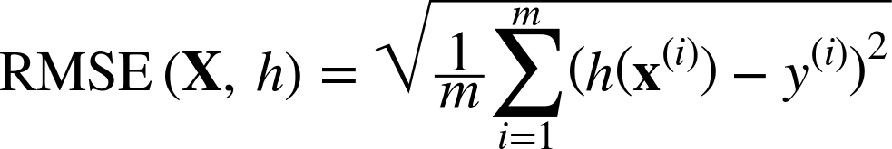

**NOTATIONS**

This equation introduces several very common Machine Learning notations that we will use throughout this book:

* *m* is the number of instances in the dataset you are measuring the RMSE on.
  + For example, if you are evaluating the RMSE on a validation set of 2,000 districts, then *m* = 2,000.
* x*(i)* is a vector of all the feature values (excluding the label) of the *ith* instance in the dataset, and *y(i)* is its label (the desired output value for that instance).
  + For example, if the first district in the dataset is located at longitude –118.29°, latitude 33.91°, and it has 1,416 inhabitants with a median income of $38,372, and the median house value is $156,400 (ignoring the other features for now), then:

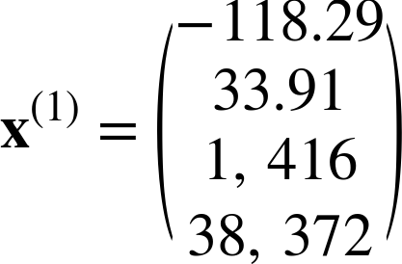

and:

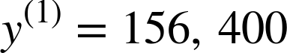

* **X** is a matrix containing all the feature values (excluding labels) of all instances in the dataset. There is one row per instance and the *ith* row is equal to the transpose of **x***(i)*, noted (**x***(i)*)*T*.[4](https://www.safaribooksonline.com/library/view/hands-on-machine-learning/9781491962282/ch02.html#idm140583023213216)
  + For example, if the first district is as just described, then the matrix **X** looks like this:

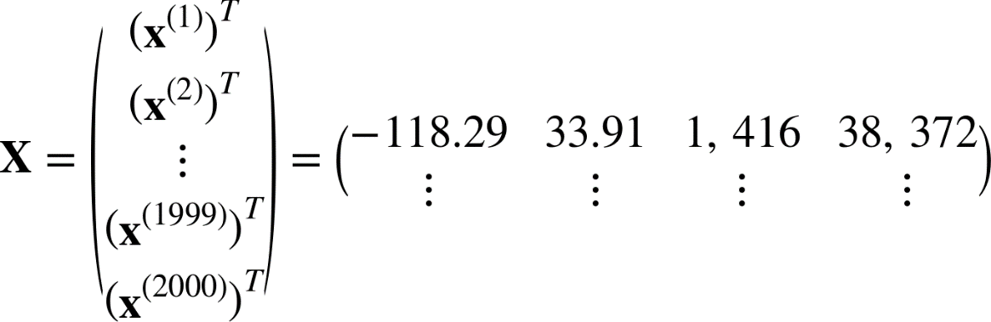

* *h* is your system’s prediction function, also called a *hypothesis*. When your system is given an instance’s feature vector **x***(i)*, it outputs a predicted value *ŷ(i)* = *h*(**x***(i)*) for that instance (*ŷ* is pronounced “y-hat”).
  + For example, if your system predicts that the median housing price in the first district is $158,400, then *ŷ*(1) = *h*(**x**(1)) = 158,400. The prediction error for this district is *ŷ*(1) – *y*(1) = 2,000.
* RMSE(**X**,*h*) is the cost function measured on the set of examples using your hypothesis *h*.

We use lowercase italic font for scalar values (such as *m* or *y(i)*) and function names (such as *h*), lowercase bold font for vectors (such as **x***(i)*), and uppercase bold font for matrices (such as **X**).

Even though the RMSE is generally the preferred performance measure for regression tasks, in some contexts you may prefer to use another function. For example, suppose that there are many outlier districts. In that case, you may consider using the *Mean Absolute Error* (also called the Average Absolute Deviation; see [Equation 2-2](https://www.safaribooksonline.com/library/view/hands-on-machine-learning/9781491962282/ch02.html#mae_equation)):

*Equation 2-2. Mean Absolute Error*

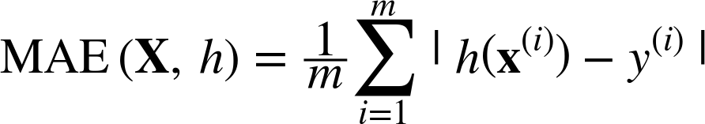

Both the RMSE and the MAE are ways to measure the distance between two vectors: the vector of predictions and the vector of target values. Various distance measures, or *norms*, are possible:

* Computing the root of a sum of squares (RMSE) corresponds to the *Euclidian norm*: it is the notion of distance you are familiar with. It is also called the ℓ2 *norm*, noted ∥ · ∥2 (or just ∥ · ∥).
* Computing the sum of absolutes (MAE) corresponds to the ℓ1 *norm*, noted ∥ · ∥1. It is sometimes called the *Manhattan norm* because it measures the distance between two points in a city if you can only travel along orthogonal city blocks.
* More generally, the ℓ*k* *norm* of a vector **v** containing *n* elements is defined as . ℓ0 just gives the number of non-zero elements in the vector, and ℓ∞gives the maximum absolute value in the vector.
* The higher the norm index, the more it focuses on large values and neglects small ones. This is why the RMSE is more sensitive to outliers than the MAE. But when outliers are exponentially rare (like in a bell-shaped curve), the RMSE performs very well and is generally preferred.

**Check the Assumptions**

Lastly, it is good practice to list and verify the assumptions that were made so far (by you or others); this can catch serious issues early on. For example, the district prices that your system outputs are going to be fed into a downstream Machine Learning system, and we assume that these prices are going to be used as such. But what if the downstream system actually converts the prices into categories (e.g., “cheap,” “medium,” or “expensive”) and then uses those categories instead of the prices themselves? In this case, getting the price perfectly right is not important at all; your system just needs to get the category right. If that’s so, then the problem should have been framed as a classification task, not a regression task. You don’t want to find this out after working on a regression system for months.

Fortunately, after talking with the team in charge of the downstream system, you are confident that they do indeed need the actual prices, not just categories. Great! You’re all set, the lights are green, and you can start coding now!

**Get the Data**

It’s time to get your hands dirty. Don’t hesitate to pick up your laptop and walk through the following code examples in a Jupyter notebook. The full Jupyter notebook is available at [*https://github.com/ageron/handson-ml*](https://github.com/ageron/handson-ml).

**Create the Workspace**

First you will need to have Python installed. It is probably already installed on your system. If not, you can get it at [*https://www.python.org/*](https://www.python.org/).[5](https://www.safaribooksonline.com/library/view/hands-on-machine-learning/9781491962282/ch02.html#idm140583023147824)

Next you need to create a workspace directory for your Machine Learning code and datasets. Open a terminal and type the following commands (after the $ prompts):

$ export ML_PATH="$HOME/ml" # You can change the path if you prefer

$ mkdir -p $ML_PATH

You will need a number of Python modules: Jupyter, NumPy, Pandas, Matplotlib, and Scikit-Learn. If you already have Jupyter running with all these modules installed, you can safely skip to [“Download the Data”](https://www.safaribooksonline.com/library/view/hands-on-machine-learning/9781491962282/ch02.html#download_the_data). If you don’t have them yet, there are many ways to install them (and their dependencies). You can use your system’s packaging system (e.g., apt-get on Ubuntu, or MacPorts or HomeBrew on macOS), install a Scientific Python distribution such as Anaconda and use its packaging system, or just use Python’s own packaging system, pip, which is included by default with the Python binary installers (since Python 2.7.9).[6](https://www.safaribooksonline.com/library/view/hands-on-machine-learning/9781491962282/ch02.html#idm140583023137216) You can check to see if pip is installed by typing the following command:

$ pip3 --version

pip 9.0.1 from [...]/lib/python3.5/site-packages (python 3.5)

You should make sure you have a recent version of pip installed, at the very least >1.4 to support binary module installation (a.k.a. wheels). To upgrade the pip module, type:[7](https://www.safaribooksonline.com/library/view/hands-on-machine-learning/9781491962282/ch02.html#idm140583022966608)

$ pip3 install --upgrade pip

Collecting pip

[...]

Successfully installed pip-9.0.1

**CREATING AN ISOLATED ENVIRONMENT**

If you would like to work in an isolated environment (which is strongly recommended so you can work on different projects without having conflicting library versions), install virtualenv by running the following pip command:

$ pip3 install --user --upgrade virtualenv

Collecting virtualenv

[...]

Successfully installed virtualenv

Now you can create an isolated Python environment by typing:

$ cd $ML_PATH

$ virtualenv env

Using base prefix '[...]'

New python executable in [...]/ml/env/bin/python3.5

Also creating executable in [...]/ml/env/bin/python

Installing setuptools, pip, wheel...done.

Now every time you want to activate this environment, just open a terminal and type:

$ cd $ML_PATH

$ source env/bin/activate

While the environment is active, any package you install using pip will be installed in this isolated environment, and Python will only have access to these packages (if you also want access to the system’s site packages, you should create the environment using virtualenv’s --system-site-packages option). Check out virtualenv’s documentation for more information.

Now you can install all the required modules and their dependencies using this simple pip command (if you are not using a virtualenv, you will need administrator rights, or to add the --user option):

$ pip3 install --upgrade jupyter matplotlib numpy pandas scipy scikit-learn

Collecting jupyter

Downloading jupyter-1.0.0-py2.py3-none-any.whl

Collecting matplotlib

[...]

To check your installation, try to import every module like this:

$ python3 -c "import jupyter, matplotlib, numpy, pandas, scipy, sklearn"

There should be no output and no error. Now you can fire up Jupyter by typing:

$ jupyter notebook

[I 15:24 NotebookApp] Serving notebooks from local directory: [...]/ml

[I 15:24 NotebookApp] 0 active kernels

[I 15:24 NotebookApp] The Jupyter Notebook is running at: http://localhost:8888/

[I 15:24 NotebookApp] Use Control-C to stop this server and shut down all

kernels (twice to skip confirmation).

A Jupyter server is now running in your terminal, listening to port 8888. You can visit this server by opening your web browser to *http://localhost:8888/* (this usually happens automatically when the server starts). You should see your empty workspace directory (containing only the *env* directory if you followed the preceding virtualenv instructions).

Now create a new Python notebook by clicking on the New button and selecting the appropriate Python version[8](https://www.safaribooksonline.com/library/view/hands-on-machine-learning/9781491962282/ch02.html#idm140583023112064) (see [Figure 2-3](https://www.safaribooksonline.com/library/view/hands-on-machine-learning/9781491962282/ch02.html#jupyter_empty_screenshot)).

This does three things: first, it creates a new notebook file called *Untitled.ipynb* in your workspace; second, it starts a Jupyter Python kernel to run this notebook; and third, it opens this notebook in a new tab. You should start by renaming this notebook to “Housing” (this will automatically rename the file to *Housing.ipynb*) by clicking Untitled and typing the new name.

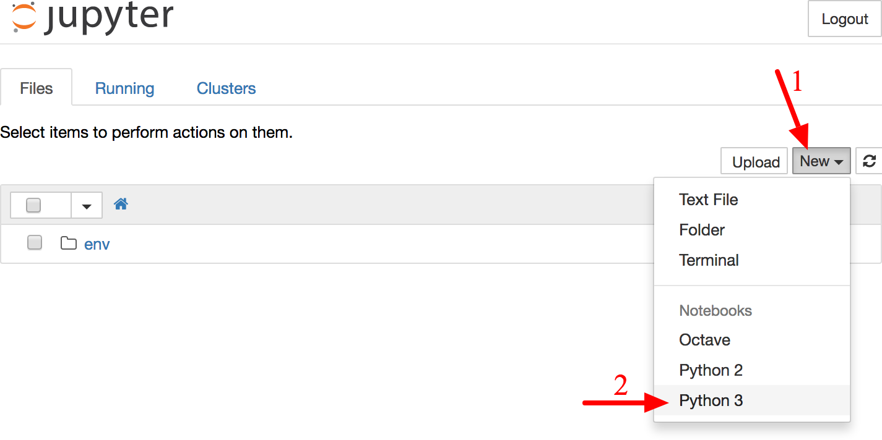

*Figure 2-3. Your workspace in Jupyter*

A notebook contains a list of cells. Each cell can contain executable code or formatted text. Right now the notebook contains only one empty code cell, labeled “In [1]:”. Try typing **print("Hello world!")** in the cell, and click on the play button (see [Figure 2-4](https://www.safaribooksonline.com/library/view/hands-on-machine-learning/9781491962282/ch02.html#jupyter_new_notebook_screenshot)) or press Shift-Enter. This sends the current cell to this notebook’s Python kernel, which runs it and returns the output. The result is displayed below the cell, and since we reached the end of the notebook, a new cell is automatically created. Go through the User Interface Tour from Jupyter’s Help menu to learn the basics.

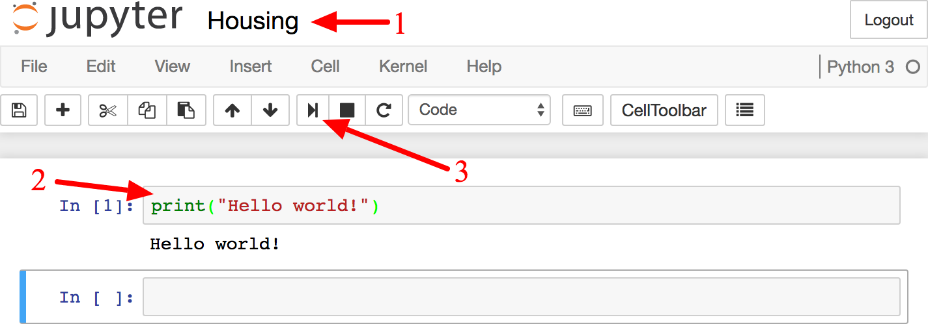

*Figure 2-4. Hello world Python notebook*

**Download the Data**

In typical environments your data would be available in a relational database (or some other common datastore) and spread across multiple tables/documents/files. To access it, you would first need to get your credentials and access authorizations,[9](https://www.safaribooksonline.com/library/view/hands-on-machine-learning/9781491962282/ch02.html#idm140583023016080) and familiarize yourself with the data schema. In this project, however, things are much simpler: you will just download a single compressed file, *housing.tgz*, which contains a comma-separated value (CSV) file called *housing.csv* with all the data.

You could use your web browser to download it, and run tar xzf housing.tgz to decompress the file and extract the CSV file, but it is preferable to create a small function to do that. It is useful in particular if data changes regularly, as it allows you to write a small script that you can run whenever you need to fetch the latest data (or you can set up a scheduled job to do that automatically at regular intervals). Automating the process of fetching the data is also useful if you need to install the dataset on multiple machines.

Here is the function to fetch the data:[10](https://www.safaribooksonline.com/library/view/hands-on-machine-learning/9781491962282/ch02.html#idm140583023012640)

**import** **os**

**import** **tarfile**

**from** **six.moves** **import** urllib

DOWNLOAD_ROOT = "https://raw.githubusercontent.com/ageron/handson-ml/master/"

HOUSING_PATH = os.path.join("datasets", "housing")

HOUSING_URL = DOWNLOAD_ROOT + "datasets/housing/housing.tgz"

**def** fetch_housing_data(housing_url=HOUSING_URL, housing_path=HOUSING_PATH):

**if** **not** os.path.isdir(housing_path):

os.makedirs(housing_path)

tgz_path = os.path.join(housing_path, "housing.tgz")

urllib.request.urlretrieve(housing_url, tgz_path)

housing_tgz = tarfile.open(tgz_path)

housing_tgz.extractall(path=housing_path)

housing_tgz.close()

Now when you call fetch_housing_data(), it creates a *datasets/housing* directory in your workspace, downloads the *housing.tgz* file, and extracts the *housing.csv* from it in this directory.

Now let’s load the data using Pandas. Once again you should write a small function to load the data:

**import** **pandas** **as** **pd**

**def** load_housing_data(housing_path=HOUSING_PATH):

csv_path = os.path.join(housing_path, "housing.csv")

**return** pd.read_csv(csv_path)

This function returns a Pandas DataFrame object containing all the data.

**Take a Quick Look at the Data Structure**

Let’s take a look at the top five rows using the DataFrame’s head() method (see [Figure 2-5](https://www.safaribooksonline.com/library/view/hands-on-machine-learning/9781491962282/ch02.html#housing_head_screenshot)).

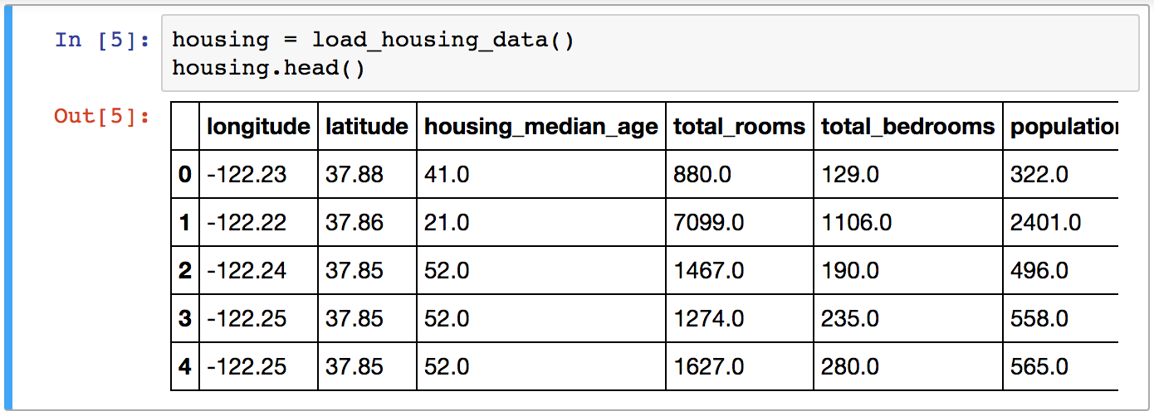

*Figure 2-5. Top five rows in the dataset*

Each row represents one district. There are 10 attributes (you can see the first 6 in the screenshot): longitude, latitude, housing_median_age, total_rooms, total_bedrooms, population, households, median_income, median_house_value, and ocean_proximity.

The info() method is useful to get a quick description of the data, in particular the total number of rows, and each attribute’s type and number of non-null values (see [Figure 2-6](https://www.safaribooksonline.com/library/view/hands-on-machine-learning/9781491962282/ch02.html#housing_info_screenshot)).

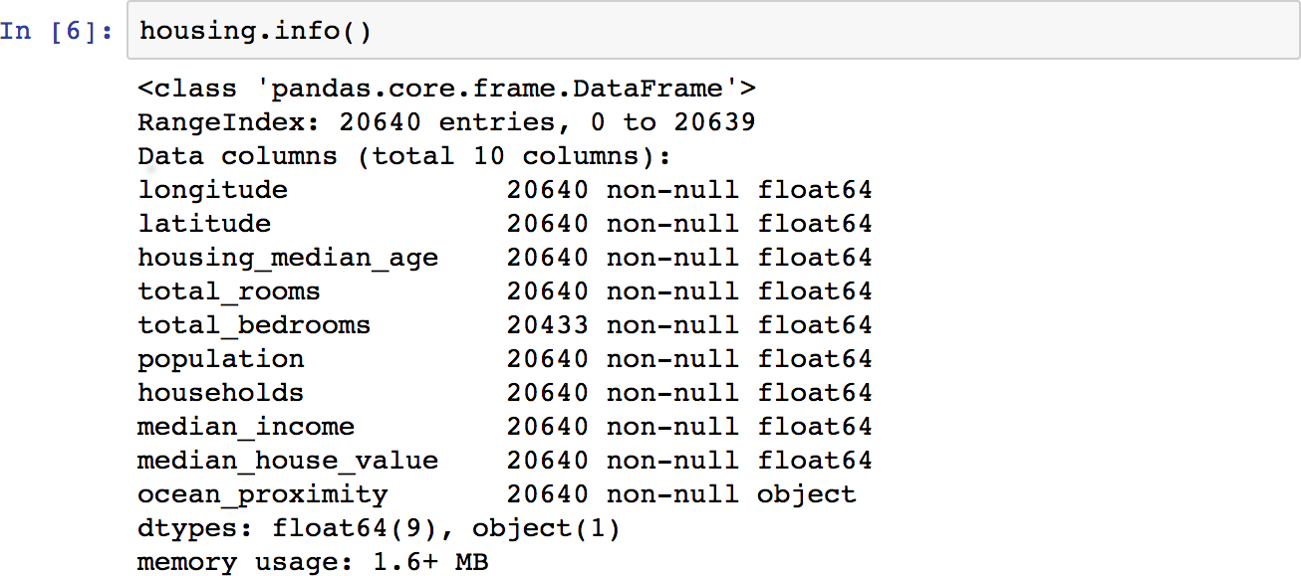

*Figure 2-6. Housing info*

There are 20,640 instances in the dataset, which means that it is fairly small by Machine Learning standards, but it’s perfect to get started. Notice that the total_bedrooms attribute has only 20,433 non-null values, meaning that 207 districts are missing this feature. We will need to take care of this later.

All attributes are numerical, except the ocean_proximity field. Its type is object, so it could hold any kind of Python object, but since you loaded this data from a CSV file you know that it must be a text attribute. When you looked at the top five rows, you probably noticed that the values in the ocean_proximity column were repetitive, which means that it is probably a categorical attribute. You can find out what categories exist and how many districts belong to each category by using the value_counts() method:

**>>>** housing["ocean_proximity"].value_counts()

<1H OCEAN 9136

INLAND 6551

NEAR OCEAN 2658

NEAR BAY 2290

ISLAND 5

Name: ocean_proximity, dtype: int64

Let’s look at the other fields. The describe() method shows a summary of the numerical attributes ([Figure 2-7](https://www.safaribooksonline.com/library/view/hands-on-machine-learning/9781491962282/ch02.html#housing_describe_screenshot)).

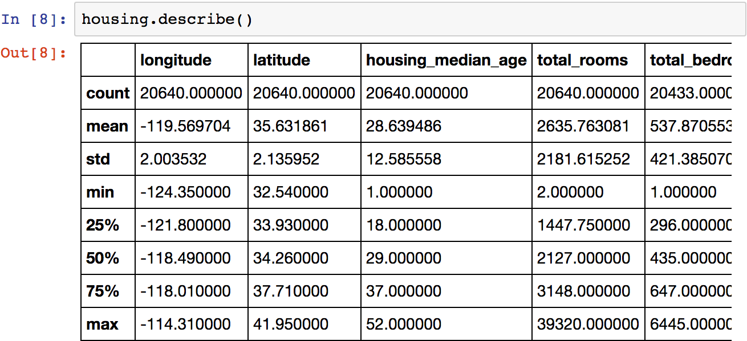

*Figure 2-7. Summary of each numerical attribute*

The count, mean, min, and max rows are self-explanatory. Note that the null values are ignored (so, for example, count of total_bedrooms is 20,433, not 20,640). The std row shows the *standard deviation*, which measures how dispersed the values are.[11](https://www.safaribooksonline.com/library/view/hands-on-machine-learning/9781491962282/ch02.html#idm140583022699840) The 25%, 50%, and 75% rows show the corresponding *percentiles*: a percentile indicates the value below which a given percentage of observations in a group of observations falls. For example, 25% of the districts have a housing_median_age lower than 18, while 50% are lower than 29 and 75% are lower than 37. These are often called the 25th percentile (or 1st *quartile*), the median, and the 75thpercentile (or 3rd quartile).

Another quick way to get a feel of the type of data you are dealing with is to plot a histogram for each numerical attribute. A histogram shows the number of instances (on the vertical axis) that have a given value range (on the horizontal axis). You can either plot this one attribute at a time, or you can call the hist() method on the whole dataset, and it will plot a histogram for each numerical attribute (see [Figure 2-8](https://www.safaribooksonline.com/library/view/hands-on-machine-learning/9781491962282/ch02.html#attribute_histogram_plots)). For example, you can see that slightly over 800 districts have a median_house_value equal to about $100,000.

%matplotlib inline *# only in a Jupyter notebook*

**import** **matplotlib.pyplot** **as** **plt**

housing.hist(bins=50, figsize=(20,15))

plt.show()

**NOTE**

The hist() method relies on Matplotlib, which in turn relies on a user-specified graphical backend to draw on your screen. So before you can plot anything, you need to specify which backend Matplotlib should use. The simplest option is to use Jupyter’s magic command %matplotlib inline. This tells Jupyter to set up Matplotlib so it uses Jupyter’s own backend. Plots are then rendered within the notebook itself. Note that calling show() is optional in a Jupyter notebook, as Jupyter will automatically display plots when a cell is executed.

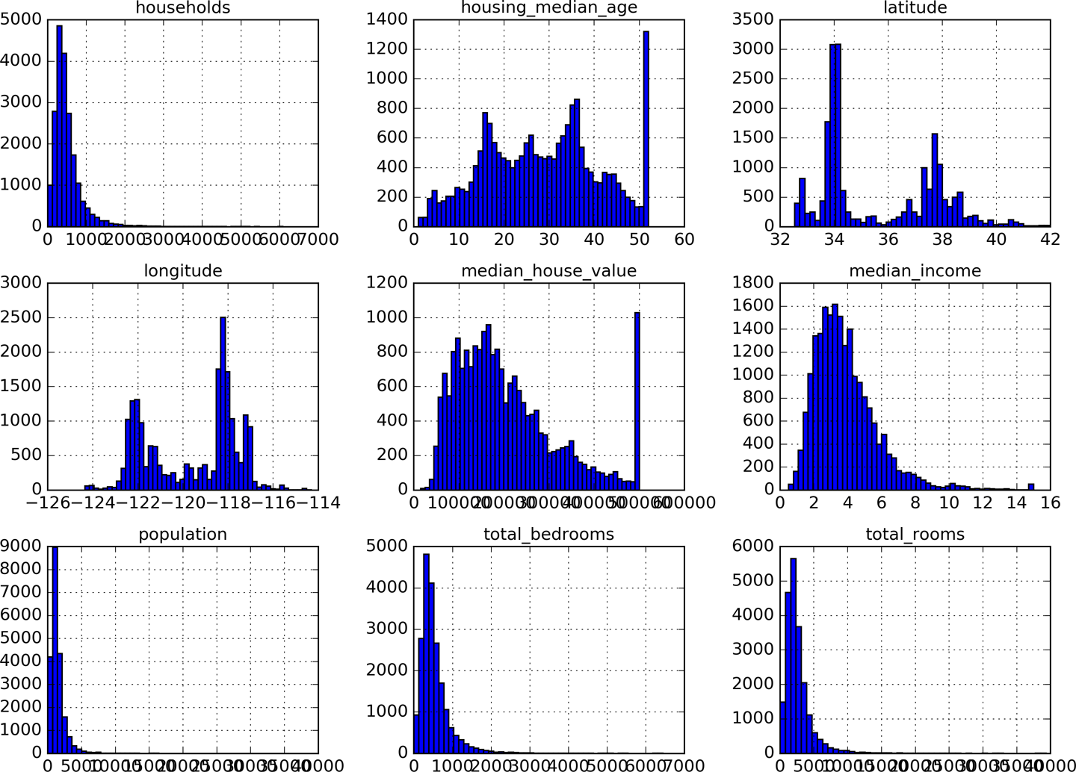

*Figure 2-8. A histogram for each numerical attribute*

Notice a few things in these histograms:

1. First, the median income attribute does not look like it is expressed in US dollars (USD). After checking with the team that collected the data, you are told that the data has been scaled and capped at 15 (actually 15.0001) for higher median incomes, and at 0.5 (actually 0.4999) for lower median incomes. Working with preprocessed attributes is common in Machine Learning, and it is not necessarily a problem, but you should try to understand how the data was computed.
2. The housing median age and the median house value were also capped. The latter may be a serious problem since it is your target attribute (your labels). Your Machine Learning algorithms may learn that prices never go beyond that limit. You need to check with your client team (the team that will use your system’s output) to see if this is a problem or not. If they tell you that they need precise predictions even beyond $500,000, then you have mainly two options:
   1. Collect proper labels for the districts whose labels were capped.
   2. Remove those districts from the training set (and also from the test set, since your system should not be evaluated poorly if it predicts values beyond $500,000).
3. These attributes have very different scales. We will discuss this later in this chapter when we explore feature scaling.
4. Finally, many histograms are *tail heavy*: they extend much farther to the right of the median than to the left. This may make it a bit harder for some Machine Learning algorithms to detect patterns. We will try transforming these attributes later on to have more bell-shaped distributions.

Hopefully you now have a better understanding of the kind of data you are dealing with.

**WARNING**

Wait! Before you look at the data any further, you need to create a test set, put it aside, and never look at it.

**Create a Test Set**

It may sound strange to voluntarily set aside part of the data at this stage. After all, you have only taken a quick glance at the data, and surely you should learn a whole lot more about it before you decide what algorithms to use, right? This is true, but your brain is an amazing pattern detection system, which means that it is highly prone to overfitting: if you look at the test set, you may stumble upon some seemingly interesting pattern in the test data that leads you to select a particular kind of Machine Learning model. When you estimate the generalization error using the test set, your estimate will be too optimistic and you will launch a system that will not perform as well as expected. This is called *data snooping* bias.

Creating a test set is theoretically quite simple: just pick some instances randomly, typically 20% of the dataset, and set them aside:

**import** **numpy** **as** **np**

**def** split_train_test(data, test_ratio):

shuffled_indices = np.random.permutation(len(data))

test_set_size = int(len(data) * test_ratio)

test_indices = shuffled_indices[:test_set_size]

train_indices = shuffled_indices[test_set_size:]

**return** data.iloc[train_indices], data.iloc[test_indices]

You can then use this function like this:

**>>>** train_set, test_set = split_train_test(housing, 0.2)

**>>> print**(len(train_set), "train +", len(test_set), "test")

16512 train + 4128 test

Well, this works, but it is not perfect: if you run the program again, it will generate a different test set! Over time, you (or your Machine Learning algorithms) will get to see the whole dataset, which is what you want to avoid.

One solution is to save the test set on the first run and then load it in subsequent runs. Another option is to set the random number generator’s seed (e.g., np.random.seed(42))[12](https://www.safaribooksonline.com/library/view/hands-on-machine-learning/9781491962282/ch02.html#idm140583022268752) before calling np.random.permutation(), so that it always generates the same shuffled indices.

But both these solutions will break next time you fetch an updated dataset. A common solution is to use each instance’s identifier to decide whether or not it should go in the test set (assuming instances have a unique and immutable identifier). For example, you could compute a hash of each instance’s identifier, keep only the last byte of the hash, and put the instance in the test set if this value is lower or equal to 51 (~20% of 256). This ensures that the test set will remain consistent across multiple runs, even if you refresh the dataset. The new test set will contain 20% of the new instances, but it will not contain any instance that was previously in the training set. Here is a possible implementation:

**import** **hashlib**

**def** test_set_check(identifier, test_ratio, hash):

**return** hash(np.int64(identifier)).digest()[-1] < 256 * test_ratio

**def** split_train_test_by_id(data, test_ratio, id_column, hash=hashlib.md5):

ids = data[id_column]

in_test_set = ids.apply(**lambda** id_: test_set_check(id_, test_ratio, hash))

**return** data.loc[~in_test_set], data.loc[in_test_set]

Unfortunately, the housing dataset does not have an identifier column. The simplest solution is to use the row index as the ID:

housing_with_id = housing.reset_index() *# adds an `index` column*

train_set, test_set = split_train_test_by_id(housing_with_id, 0.2, "index")

If you use the row index as a unique identifier, you need to make sure that new data gets appended to the end of the dataset, and no row ever gets deleted. If this is not possible, then you can try to use the most stable features to build a unique identifier. For example, a district’s latitude and longitude are guaranteed to be stable for a few million years, so you could combine them into an ID like so:[13](https://www.safaribooksonline.com/library/view/hands-on-machine-learning/9781491962282/ch02.html#idm140583022231136)

housing_with_id["id"] = housing["longitude"] * 1000 + housing["latitude"]

train_set, test_set = split_train_test_by_id(housing_with_id, 0.2, "id")

Scikit-Learn provides a few functions to split datasets into multiple subsets in various ways. The simplest function is train_test_split, which does pretty much the same thing as the function split_train_testdefined earlier, with a couple of additional features. First there is a random_state parameter that allows you to set the random generator seed as explained previously, and second you can pass it multiple datasets with an identical number of rows, and it will split them on the same indices (this is very useful, for example, if you have a separate DataFrame for labels):

**from** **sklearn.model_selection** **import** train_test_split

train_set, test_set = train_test_split(housing, test_size=0.2, random_state=42)

So far we have considered purely random sampling methods. This is generally fine if your dataset is large enough (especially relative to the number of attributes), but if it is not, you run the risk of introducing a significant sampling bias. When a survey company decides to call 1,000 people to ask them a few questions, they don’t just pick 1,000 people randomly in a phone booth. They try to ensure that these 1,000 people are representative of the whole population. For example, the US population is composed of 51.3% female and 48.7% male, so a well-conducted survey in the US would try to maintain this ratio in the sample: 513 female and 487 male. This is called *stratified sampling*: the population is divided into homogeneous subgroups called *strata*, and the right number of instances is sampled from each stratum to guarantee that the test set is representative of the overall population. If they used purely random sampling, there would be about 12% chance of sampling a skewed test set with either less than 49% female or more than 54% female. Either way, the survey results would be significantly biased.

Suppose you chatted with experts who told you that the median income is a very important attribute to predict median housing prices. You may want to ensure that the test set is representative of the various categories of incomes in the whole dataset. Since the median income is a continuous numerical attribute, you first need to create an income category attribute. Let’s look at the median income histogram more closely (back in [Figure 2-8](https://www.safaribooksonline.com/library/view/hands-on-machine-learning/9781491962282/ch02.html#attribute_histogram_plots)): most median income values are clustered around $20,000–$50,000, but some median incomes go far beyond $60,000. It is important to have a sufficient number of instances in your dataset for each stratum, or else the estimate of the stratum’s importance may be biased. This means that you should not have too many strata, and each stratum should be large enough. The following code creates an income category attribute by dividing the median income by 1.5 (to limit the number of income categories), and rounding up using ceil (to have discrete categories), and then merging all the categories greater than 5 into category 5:

housing["income_cat"] = np.ceil(housing["median_income"] / 1.5)

housing["income_cat"].where(housing["income_cat"] < 5, 5.0, inplace=True)

These income categories are represented on [Figure 2-9](https://www.safaribooksonline.com/library/view/hands-on-machine-learning/9781491962282/ch02.html#housing_income_cat_hist_screenshot)):

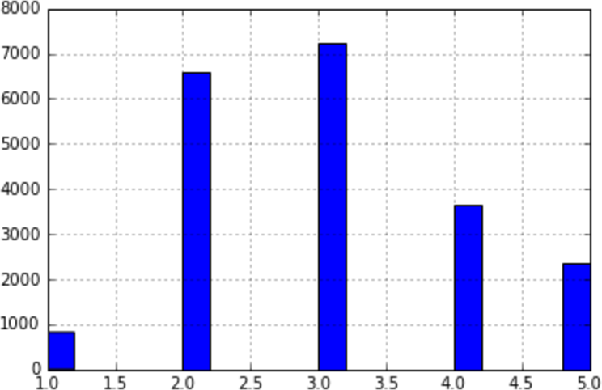

*Figure 2-9. Histogram of income categories*

Now you are ready to do stratified sampling based on the income category. For this you can use Scikit-Learn’s StratifiedShuffleSplit class:

**from** **sklearn.model_selection** **import** StratifiedShuffleSplit

split = StratifiedShuffleSplit(n_splits=1, test_size=0.2, random_state=42)

**for** train_index, test_index **in** split.split(housing, housing["income_cat"]):

strat_train_set = housing.loc[train_index]

strat_test_set = housing.loc[test_index]

Let’s see if this worked as expected. You can start by looking at the income category proportions in the test set:

**>>>** strat_test_set["income_cat"].value_counts() / len(strat_test_set)

3.0 0.350533

2.0 0.318798

4.0 0.176357

5.0 0.114583

1.0 0.039729

Name: income_cat, dtype: float64

With similar code you can measure the income category proportions in the full dataset. [Figure 2-10](https://www.safaribooksonline.com/library/view/hands-on-machine-learning/9781491962282/ch02.html#compare_sampling_errors_screenshot) compares the income category proportions in the overall dataset, in the test set generated with stratified sampling, and in a test set generated using purely random sampling. As you can see, the test set generated using stratified sampling has income category proportions almost identical to those in the full dataset, whereas the test set generated using purely random sampling is quite skewed.

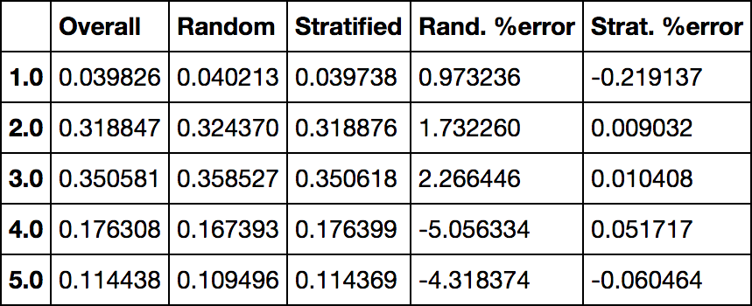

*Figure 2-10. Sampling bias comparison of stratified versus purely random sampling*

Now you should remove the income_cat attribute so the data is back to its original state:

**for** set_ **in** (strat_train_set, strat_test_set):

set_.drop("income_cat", axis=1, inplace=True)

We spent quite a bit of time on test set generation for a good reason: this is an often neglected but critical part of a Machine Learning project. Moreover, many of these ideas will be useful later when we discuss cross-validation. Now it’s time to move on to the next stage: exploring the data.

**Discover and Visualize the Data to Gain Insights**

So far you have only taken a quick glance at the data to get a general understanding of the kind of data you are manipulating. Now the goal is to go a little bit more in depth.

First, make sure you have put the test set aside and you are only exploring the training set. Also, if the training set is very large, you may want to sample an exploration set, to make manipulations easy and fast. In our case, the set is quite small so you can just work directly on the full set. Let’s create a copy so you can play with it without harming the training set:

housing = strat_train_set.copy()

**Visualizing Geographical Data**

Since there is geographical information (latitude and longitude), it is a good idea to create a scatterplot of all districts to visualize the data ([Figure 2-11](https://www.safaribooksonline.com/library/view/hands-on-machine-learning/9781491962282/ch02.html#bad_visualization_plot)):

housing.plot(kind="scatter", x="longitude", y="latitude")

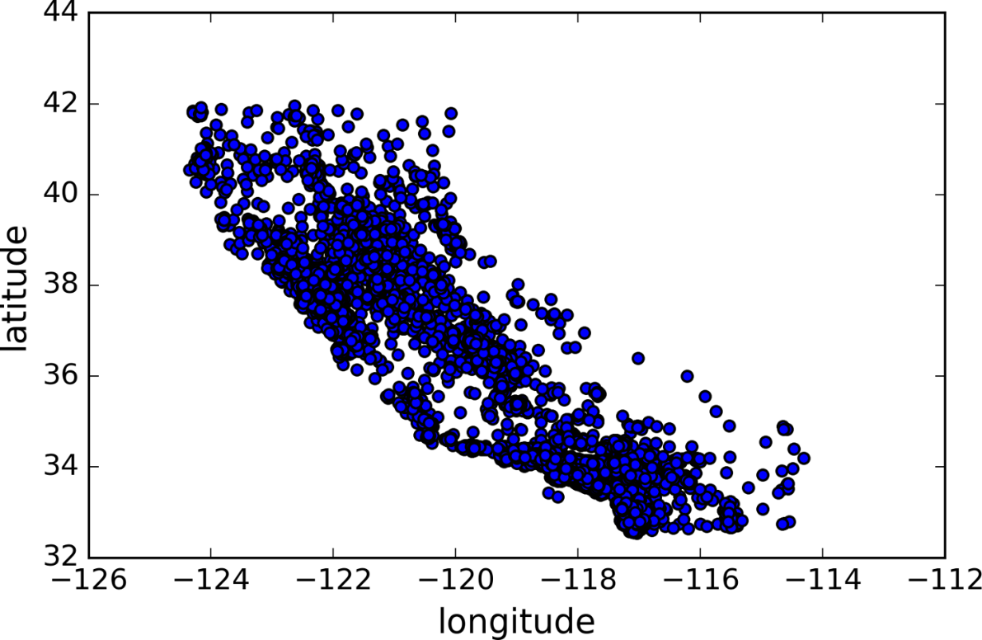

*Figure 2-11. A geographical scatterplot of the data*

This looks like California all right, but other than that it is hard to see any particular pattern. Setting the alphaoption to 0.1 makes it much easier to visualize the places where there is a high density of data points ([Figure 2-12](https://www.safaribooksonline.com/library/view/hands-on-machine-learning/9781491962282/ch02.html#better_visualization_plot)):

housing.plot(kind="scatter", x="longitude", y="latitude", alpha=0.1)

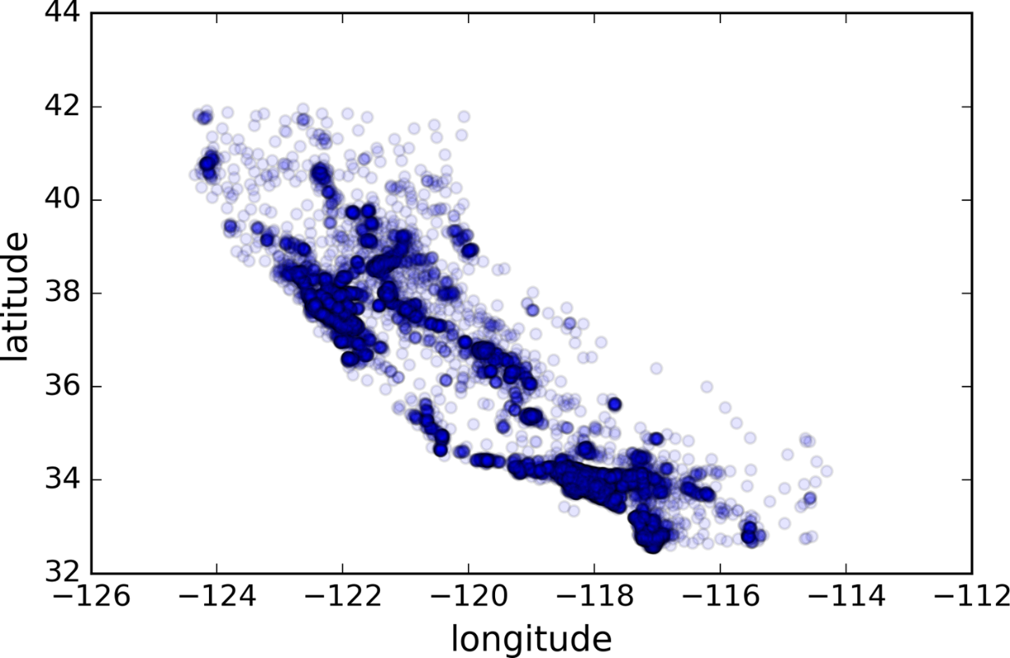

*Figure 2-12. A better visualization highlighting high-density areas*

Now that’s much better: you can clearly see the high-density areas, namely the Bay Area and around Los Angeles and San Diego, plus a long line of fairly high density in the Central Valley, in particular around Sacramento and Fresno.

More generally, our brains are very good at spotting patterns on pictures, but you may need to play around with visualization parameters to make the patterns stand out.

Now let’s look at the housing prices ([Figure 2-13](https://www.safaribooksonline.com/library/view/hands-on-machine-learning/9781491962282/ch02.html#housing_prices_scatterplot)). The radius of each circle represents the district’s population (option s), and the color represents the price (option c). We will use a predefined color map (option cmap) called jet, which ranges from blue (low values) to red (high prices):[14](https://www.safaribooksonline.com/library/view/hands-on-machine-learning/9781491962282/ch02.html#idm140583021629600)

housing.plot(kind="scatter", x="longitude", y="latitude", alpha=0.4,

s=housing["population"]/100, label="population", figsize=(10,7),

c="median_house_value", cmap=plt.get_cmap("jet"), colorbar=True,

)

plt.legend()

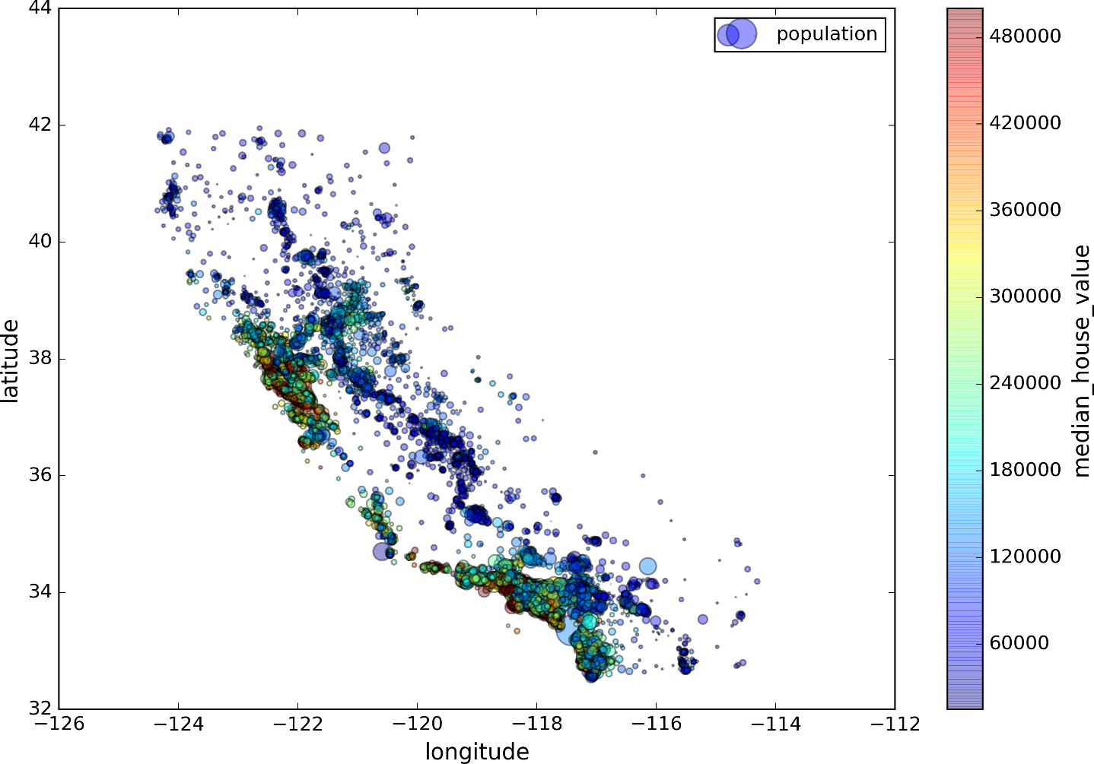

*Figure 2-13. California housing prices*

This image tells you that the housing prices are very much related to the location (e.g., close to the ocean) and to the population density, as you probably knew already. It will probably be useful to use a clustering algorithm to detect the main clusters, and add new features that measure the proximity to the cluster centers. The ocean proximity attribute may be useful as well, although in Northern California the housing prices in coastal districts are not too high, so it is not a simple rule.

**Looking for Correlations**

Since the dataset is not too large, you can easily compute the *standard correlation coefficient* (also called *Pearson’s r*) between every pair of attributes using the corr() method:

corr_matrix = housing.corr()

Now let’s look at how much each attribute correlates with the median house value:

**>>>** corr_matrix["median_house_value"].sort_values(ascending=False)

median_house_value 1.000000

median_income 0.687170

total_rooms 0.135231

housing_median_age 0.114220

households 0.064702

total_bedrooms 0.047865

population -0.026699

longitude -0.047279

latitude -0.142826

Name: median_house_value, dtype: float64

The correlation coefficient ranges from –1 to 1. When it is close to 1, it means that there is a strong positive correlation; for example, the median house value tends to go up when the median income goes up. When the coefficient is close to –1, it means that there is a strong negative correlation; you can see a small negative correlation between the latitude and the median house value (i.e., prices have a slight tendency to go down when you go north). Finally, coefficients close to zero mean that there is no linear correlation. [Figure 2-14](https://www.safaribooksonline.com/library/view/hands-on-machine-learning/9781491962282/ch02.html#correlation_coefficient_plots) shows various plots along with the correlation coefficient between their horizontal and vertical axes.

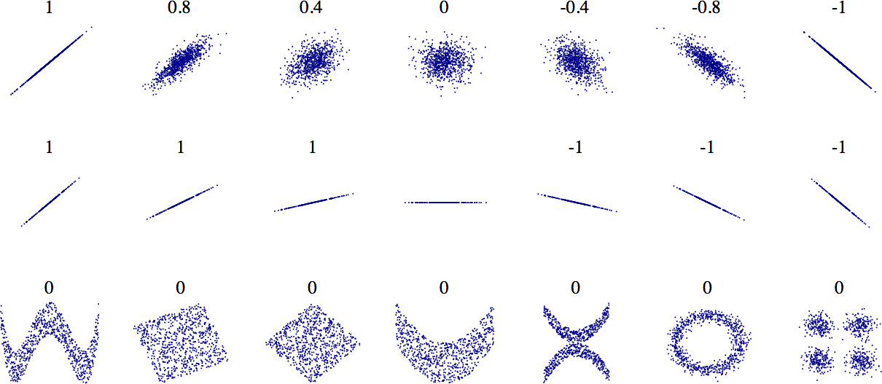

*Figure 2-14. Standard correlation coefficient of various datasets (source: Wikipedia; public domain image)*

**WARNING**

The correlation coefficient only measures linear correlations (“if *x* goes up, then *y* generally goes up/down”). It may completely miss out on nonlinear relationships (e.g., “if *x* is close to zero then *y*generally goes up”). Note how all the plots of the bottom row have a correlation coefficient equal to zero despite the fact that their axes are clearly not independent: these are examples of nonlinear relationships. Also, the second row shows examples where the correlation coefficient is equal to 1 or –1; notice that this has nothing to do with the slope. For example, your height in inches has a correlation coefficient of 1 with your height in feet or in nanometers.

Another way to check for correlation between attributes is to use Pandas’ scatter_matrix function, which plots every numerical attribute against every other numerical attribute. Since there are now 11 numerical attributes, you would get 112 = 121 plots, which would not fit on a page, so let’s just focus on a few promising attributes that seem most correlated with the median housing value ([Figure 2-15](https://www.safaribooksonline.com/library/view/hands-on-machine-learning/9781491962282/ch02.html#scatter_matrix_plot)):

**from** **pandas.tools.plotting** **import** scatter_matrix

attributes = ["median_house_value", "median_income", "total_rooms",

"housing_median_age"]

scatter_matrix(housing[attributes], figsize=(12, 8))

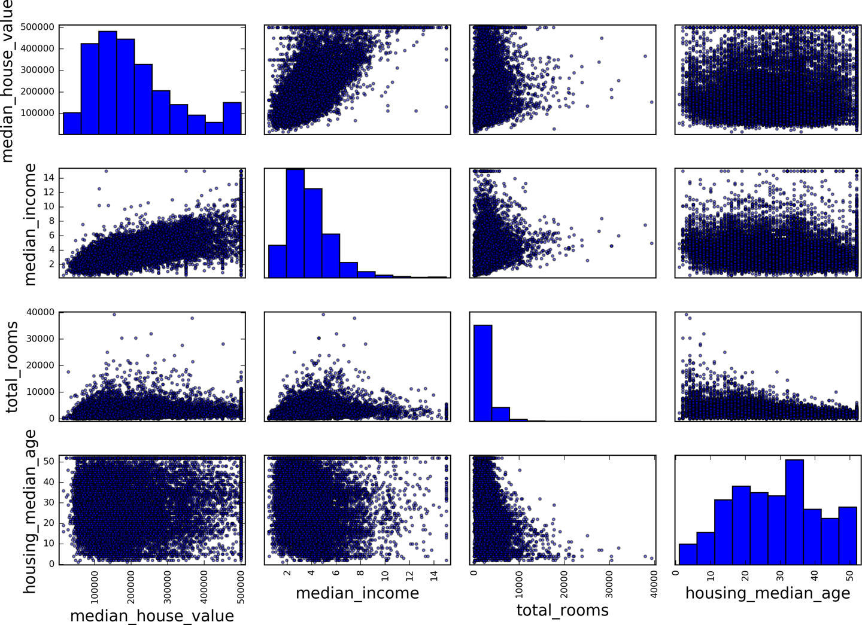

*Figure 2-15. Scatter matrix*

The main diagonal (top left to bottom right) would be full of straight lines if Pandas plotted each variable against itself, which would not be very useful. So instead Pandas displays a histogram of each attribute (other options are available; see Pandas’ documentation for more details).

The most promising attribute to predict the median house value is the median income, so let’s zoom in on their correlation scatterplot ([Figure 2-16](https://www.safaribooksonline.com/library/view/hands-on-machine-learning/9781491962282/ch02.html#income_vs_house_value_scatterplot)):

housing.plot(kind="scatter", x="median_income", y="median_house_value",

alpha=0.1)

This plot reveals a few things. First, the correlation is indeed very strong; you can clearly see the upward trend and the points are not too dispersed. Second, the price cap that we noticed earlier is clearly visible as a horizontal line at $500,000. But this plot reveals other less obvious straight lines: a horizontal line around $450,000, another around $350,000, perhaps one around $280,000, and a few more below that. You may want to try removing the corresponding districts to prevent your algorithms from learning to reproduce these data quirks.

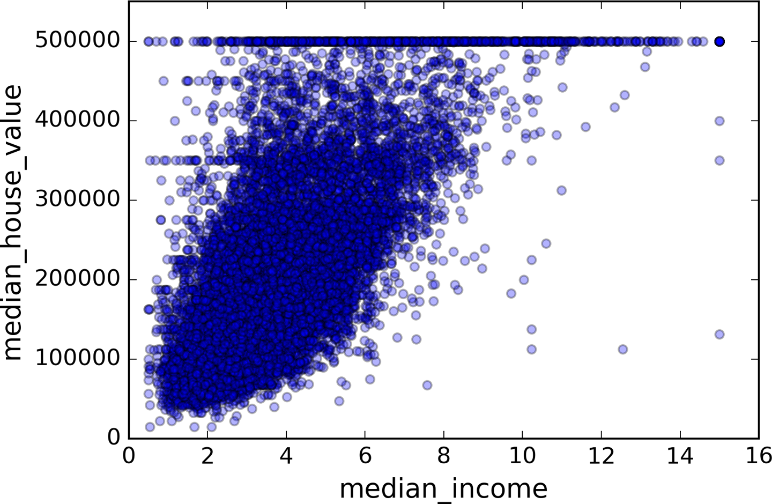

*Figure 2-16. Median income versus median house value*

**Experimenting with Attribute Combinations**

Hopefully the previous sections gave you an idea of a few ways you can explore the data and gain insights. You identified a few data quirks that you may want to clean up before feeding the data to a Machine Learning algorithm, and you found interesting correlations between attributes, in particular with the target attribute. You also noticed that some attributes have a tail-heavy distribution, so you may want to transform them (e.g., by computing their logarithm). Of course, your mileage will vary considerably with each project, but the general ideas are similar.

One last thing you may want to do before actually preparing the data for Machine Learning algorithms is to try out various attribute combinations. For example, the total number of rooms in a district is not very useful if you don’t know how many households there are. What you really want is the number of rooms per household. Similarly, the total number of bedrooms by itself is not very useful: you probably want to compare it to the number of rooms. And the population per household also seems like an interesting attribute combination to look at. Let’s create these new attributes:

housing["rooms_per_household"] = housing["total_rooms"]/housing["households"]

housing["bedrooms_per_room"] = housing["total_bedrooms"]/housing["total_rooms"]

housing["population_per_household"]=housing["population"]/housing["households"]

And now let’s look at the correlation matrix again:

**>>>** corr_matrix = housing.corr()

**>>>** corr_matrix["median_house_value"].sort_values(ascending=False)

median_house_value 1.000000

median_income 0.687160

rooms_per_household 0.146285

total_rooms 0.135097

housing_median_age 0.114110

households 0.064506

total_bedrooms 0.047689

population_per_household -0.021985

population -0.026920

longitude -0.047432

latitude -0.142724

bedrooms_per_room -0.259984

Name: median_house_value, dtype: float64

Hey, not bad! The new bedrooms_per_room attribute is much more correlated with the median house value than the total number of rooms or bedrooms. Apparently houses with a lower bedroom/room ratio tend to be more expensive. The number of rooms per household is also more informative than the total number of rooms in a district—obviously the larger the houses, the more expensive they are.

This round of exploration does not have to be absolutely thorough; the point is to start off on the right foot and quickly gain insights that will help you get a first reasonably good prototype. But this is an iterative process: once you get a prototype up and running, you can analyze its output to gain more insights and come back to this exploration step.

**Prepare the Data for Machine Learning Algorithms**

It’s time to prepare the data for your Machine Learning algorithms. Instead of just doing this manually, you should write functions to do that, for several good reasons:

* This will allow you to reproduce these transformations easily on any dataset (e.g., the next time you get a fresh dataset).
* You will gradually build a library of transformation functions that you can reuse in future projects.
* You can use these functions in your live system to transform the new data before feeding it to your algorithms.
* This will make it possible for you to easily try various transformations and see which combination of transformations works best.

But first let’s revert to a clean training set (by copying strat_train_set once again), and let’s separate the predictors and the labels since we don’t necessarily want to apply the same transformations to the predictors and the target values (note that drop() creates a copy of the data and does not affect strat_train_set):

housing = strat_train_set.drop("median_house_value", axis=1)

housing_labels = strat_train_set["median_house_value"].copy()

**Data Cleaning**

Most Machine Learning algorithms cannot work with missing features, so let’s create a few functions to take care of them. You noticed earlier that the total_bedrooms attribute has some missing values, so let’s fix this. You have three options:

* Get rid of the corresponding districts.
* Get rid of the whole attribute.
* Set the values to some value (zero, the mean, the median, etc.).

You can accomplish these easily using DataFrame’s dropna(), drop(), and fillna() methods:

housing.dropna(subset=["total_bedrooms"]) *# option 1*

housing.drop("total_bedrooms", axis=1) *# option 2*

median = housing["total_bedrooms"].median() *# option 3*

housing["total_bedrooms"].fillna(median, inplace=True)

If you choose option 3, you should compute the median value on the training set, and use it to fill the missing values in the training set, but also don’t forget to save the median value that you have computed. You will need it later to replace missing values in the test set when you want to evaluate your system, and also once the system goes live to replace missing values in new data.

Scikit-Learn provides a handy class to take care of missing values: Imputer. Here is how to use it. First, you need to create an Imputer instance, specifying that you want to replace each attribute’s missing values with the median of that attribute:

**from** **sklearn.preprocessing** **import** Imputer

imputer = Imputer(strategy="median")

Since the median can only be computed on numerical attributes, we need to create a copy of the data without the text attribute ocean_proximity:

housing_num = housing.drop("ocean_proximity", axis=1)

Now you can fit the imputer instance to the training data using the fit() method:

imputer.fit(housing_num)

The imputer has simply computed the median of each attribute and stored the result in its statistics_instance variable. Only the total_bedrooms attribute had missing values, but we cannot be sure that there won’t be any missing values in new data after the system goes live, so it is safer to apply the imputer to all the numerical attributes:

**>>>** imputer.statistics_

array([ -118.51 , 34.26 , 29. , 2119.5 , 433. , 1164. , 408. , 3.5409])

**>>>** housing_num.median().values

array([ -118.51 , 34.26 , 29. , 2119.5 , 433. , 1164. , 408. , 3.5409])

Now you can use this “trained” imputer to transform the training set by replacing missing values by the learned medians:

X = imputer.transform(housing_num)

The result is a plain Numpy array containing the transformed features. If you want to put it back into a Pandas DataFrame, it’s simple:

housing_tr = pd.DataFrame(X, columns=housing_num.columns)

**SCIKIT-LEARN DESIGN**

Scikit-Learn’s API is remarkably well designed. The [main design principles](http://goo.gl/wL10sI) are:[15](https://www.safaribooksonline.com/library/view/hands-on-machine-learning/9781491962282/ch02.html#idm140583021047856)

* **Consistency**. All objects share a consistent and simple interface:
  + *Estimators*. Any object that can estimate some parameters based on a dataset is called an *estimator* (e.g., an imputer is an estimator). The estimation itself is performed by the fit()method, and it takes only a dataset as a parameter (or two for supervised learning algorithms; the second dataset contains the labels). Any other parameter needed to guide the estimation process is considered a hyperparameter (such as an imputer’s strategy), and it must be set as an instance variable (generally via a constructor parameter).
  + *Transformers*. Some estimators (such as an imputer) can also transform a dataset; these are called *transformers*. Once again, the API is quite simple: the transformation is performed by the transform() method with the dataset to transform as a parameter. It returns the transformed dataset. This transformation generally relies on the learned parameters, as is the case for an imputer. All transformers also have a convenience method called fit_transform() that is equivalent to calling fit() and then transform() (but sometimes fit_transform() is optimized and runs much faster).
  + *Predictors*. Finally, some estimators are capable of making predictions given a dataset; they are called *predictors*. For example, the LinearRegression model in the previous chapter was a predictor: it predicted life satisfaction given a country’s GDP per capita. A predictor has a predict() method that takes a dataset of new instances and returns a dataset of corresponding predictions. It also has a score() method that measures the quality of the predictions given a test set (and the corresponding labels in the case of supervised learning algorithms).[16](https://www.safaribooksonline.com/library/view/hands-on-machine-learning/9781491962282/ch02.html#idm140583020818208)
* **Inspection**. All the estimator’s hyperparameters are accessible directly via public instance variables (e.g., imputer.strategy), and all the estimator’s learned parameters are also accessible via public instance variables with an underscore suffix (e.g., imputer.statistics_).
* **Nonproliferation of classes**. Datasets are represented as NumPy arrays or SciPy sparse matrices, instead of homemade classes. Hyperparameters are just regular Python strings or numbers.
* **Composition**. Existing building blocks are reused as much as possible. For example, it is easy to create a Pipeline estimator from an arbitrary sequence of transformers followed by a final estimator, as we will see.
* **Sensible defaults**. Scikit-Learn provides reasonable default values for most parameters, making it easy to create a baseline working system quickly.

**Handling Text and Categorical Attributes**

Earlier we left out the categorical attribute ocean_proximity because it is a text attribute so we cannot compute its median:

**>>>** housing_cat = housing["ocean_proximity"]

**>>>** housing_cat.head(10)

17606 <1H OCEAN

18632 <1H OCEAN

14650 NEAR OCEAN

3230 INLAND

3555 <1H OCEAN

19480 INLAND

8879 <1H OCEAN

13685 INLAND

4937 <1H OCEAN

4861 <1H OCEAN

Name: ocean_proximity, dtype: object

Most Machine Learning algorithms prefer to work with numbers anyway, so let’s convert these categories from text to numbers. For this, we can use Pandas’ factorize() method which maps each category to a different integer:

**>>>** housing_cat_encoded, housing_categories = housing_cat.factorize()

**>>>** housing_cat_encoded[:10]

array([0, 0, 1, 2, 0, 2, 0, 2, 0, 0])

This is better: housing_cat_encoded is now purely numerical. The factorize() method also returns the list of categories (“<1H OCEAN” was mapped to 0, “NEAR OCEAN” was mapped to 1, etc.):

**>>>** housing_categories

Index(['<1H OCEAN', 'NEAR OCEAN', 'INLAND', 'NEAR BAY', 'ISLAND'], dtype='object')

One issue with this representation is that ML algorithms will assume that two nearby values are more similar than two distant values. Obviously this is not the case (for example, categories 0 and 4 are more similar than categories 0 and 2). To fix this issue, a common solution is to create one binary attribute per category: one attribute equal to 1 when the category is “<1H OCEAN” (and 0 otherwise), another attribute equal to 1 when the category is “NEAR OCEAN” (and 0 otherwise), and so on. This is called *one-hot encoding*, because only one attribute will be equal to 1 (hot), while the others will be 0 (cold).

Scikit-Learn provides a OneHotEncoder encoder to convert integer categorical values into one-hot vectors. Let’s encode the categories as one-hot vectors:

**>>> from** **sklearn.preprocessing** **import** OneHotEncoder

**>>>** encoder = OneHotEncoder()

**>>>** housing_cat_1hot = encoder.fit_transform(housing_cat_encoded.reshape(-1,1))

**>>>** housing_cat_1hot

<16512x5 sparse matrix of type '<class 'numpy.float64'>'

with 16512 stored elements in Compressed Sparse Row format>

Note that fit_transform() expects a 2D array, but housing_cat_encoded is a 1D array, so we need to reshape it[17](https://www.safaribooksonline.com/library/view/hands-on-machine-learning/9781491962282/ch02.html#idm140583020692928). Also, notice that the output is a SciPy *sparse matrix*, instead of a NumPy array. This is very useful when you have categorical attributes with thousands of categories. After one-hot encoding we get a matrix with thousands of columns, and the matrix is full of zeros except for a single 1 per row. Using up tons of memory mostly to store zeros would be very wasteful, so instead a sparse matrix only stores the location of the nonzero elements. You can use it mostly like a normal 2D array,[18](https://www.safaribooksonline.com/library/view/hands-on-machine-learning/9781491962282/ch02.html#idm140583020689168) but if you really want to convert it to a (dense) NumPy array, just call the toarray() method:

**>>>** housing_cat_1hot.toarray()

array([[ 1., 0., 0., 0., 0.],

[ 1., 0., 0., 0., 0.],

[ 0., 1., 0., 0., 0.],

...,

[ 0., 0., 1., 0., 0.],

[ 1., 0., 0., 0., 0.],

[ 0., 0., 0., 1., 0.]])

You can apply both transformations (from text categories to integer categories, then from integer categories to one-hot vectors) in one shot using the CategoricalEncoder class. It is not part of Scikit-Learn 0.19.0 and earlier, but it will be added shortly, so it may already be available by the time you read this. If it is not, you can simply get it from the Jupyter notebook for this chapter (the code was copied from Pull Request #9151). Here is how to use it:

**>>> from** **sklearn.preprocessing** **import** CategoricalEncoder *# or get from notebook*

**>>>** cat_encoder = CategoricalEncoder()

**>>>** housing_cat_reshaped = housing_cat.values.reshape(-1, 1)

**>>>** housing_cat_1hot = cat_encoder.fit_transform(housing_cat_reshaped)

**>>>** housing_cat_1hot

<16512x5 sparse matrix of type '<class 'numpy.float64'>'

with 16512 stored elements in Compressed Sparse Row format>

By default, the CategoricalEncoder outputs a sparse matrix, but you can set the encoding to "onehot-dense" if you prefer a dense matrix:

**>>>** cat_encoder = CategoricalEncoder(encoding="onehot-dense")

**>>>** housing_cat_1hot = cat_encoder.fit_transform(housing_cat_reshaped)

**>>>** housing_cat_1hot

array([[ 1., 0., 0., 0., 0.],

[ 1., 0., 0., 0., 0.],

[ 0., 0., 0., 0., 1.],

...,

[ 0., 1., 0., 0., 0.],

[ 1., 0., 0., 0., 0.],

[ 0., 0., 0., 1., 0.]])

You can get the list of categories using the encoder’s categories_ instance variable. It is a list containing a 1D array of categories for each categorical attribute (in this case, a list containing a single array since there is a just one categorical attribute):

**>>>** cat_encoder.categories_

[array(['<1H OCEAN', 'INLAND', 'ISLAND', 'NEAR BAY', 'NEAR OCEAN'], dtype=object)]

**TIP**

If a categorical attribute has a large number of possible categories (e.g., country code, profession, species, etc.), then one-hot encoding will result in a large number of input features. This may slow down training and degrade performance. If this happens, you will want to produce denser representations called *embeddings*, but this requires a good understanding of neural networks (see [Chapter 14](https://www.safaribooksonline.com/library/view/hands-on-machine-learning/9781491962282/ch14.html#rnn_chapter) for more details).

**Custom Transformers**

Although Scikit-Learn provides many useful transformers, you will need to write your own for tasks such as custom cleanup operations or combining specific attributes. You will want your transformer to work seamlessly with Scikit-Learn functionalities (such as pipelines), and since Scikit-Learn relies on duck typing (not inheritance), all you need is to create a class and implement three methods: fit() (returning self), transform(), and fit_transform(). You can get the last one for free by simply adding TransformerMixin as a base class. Also, if you add BaseEstimator as a base class (and avoid *args and **kargs in your constructor) you will get two extra methods (get_params() and set_params()) that will be useful for automatic hyperparameter tuning. For example, here is a small transformer class that adds the combined attributes we discussed earlier:

**from** **sklearn.base** **import** BaseEstimator, TransformerMixin

rooms_ix, bedrooms_ix, population_ix, household_ix = 3, 4, 5, 6

**class** **CombinedAttributesAdder**(BaseEstimator, TransformerMixin):

**def** __init__(self, add_bedrooms_per_room = True): *# no *args or **kargs*

self.add_bedrooms_per_room = add_bedrooms_per_room

**def** fit(self, X, y=None):

**return** self *# nothing else to do*

**def** transform(self, X, y=None):

rooms_per_household = X[:, rooms_ix] / X[:, household_ix]

population_per_household = X[:, population_ix] / X[:, household_ix]

**if** self.add_bedrooms_per_room:

bedrooms_per_room = X[:, bedrooms_ix] / X[:, rooms_ix]

**return** np.c_[X, rooms_per_household, population_per_household,

bedrooms_per_room]

**else**:

**return** np.c_[X, rooms_per_household, population_per_household]

attr_adder = CombinedAttributesAdder(add_bedrooms_per_room=False)

housing_extra_attribs = attr_adder.transform(housing.values)

In this example the transformer has one hyperparameter, add_bedrooms_per_room, set to True by default (it is often helpful to provide sensible defaults). This hyperparameter will allow you to easily find out whether adding this attribute helps the Machine Learning algorithms or not. More generally, you can add a hyperparameter to gate any data preparation step that you are not 100% sure about. The more you automate these data preparation steps, the more combinations you can automatically try out, making it much more likely that you will find a great combination (and saving you a lot of time).

**Feature Scaling**

One of the most important transformations you need to apply to your data is *feature scaling*. With few exceptions, Machine Learning algorithms don’t perform well when the input numerical attributes have very different scales. This is the case for the housing data: the total number of rooms ranges from about 6 to 39,320, while the median incomes only range from 0 to 15. Note that scaling the target values is generally not required.

There are two common ways to get all attributes to have the same scale: *min-max scaling* and *standardization*.

Min-max scaling (many people call this *normalization*) is quite simple: values are shifted and rescaled so that they end up ranging from 0 to 1. We do this by subtracting the min value and dividing by the max minus the min. Scikit-Learn provides a transformer called MinMaxScaler for this. It has a feature_range hyperparameter that lets you change the range if you don’t want 0–1 for some reason.

Standardization is quite different: first it subtracts the mean value (so standardized values always have a zero mean), and then it divides by the variance so that the resulting distribution has unit variance. Unlike min-max scaling, standardization does not bound values to a specific range, which may be a problem for some algorithms (e.g., neural networks often expect an input value ranging from 0 to 1). However, standardization is much less affected by outliers. For example, suppose a district had a median income equal to 100 (by mistake). Min-max scaling would then crush all the other values from 0–15 down to 0–0.15, whereas standardization would not be much affected. Scikit-Learn provides a transformer called StandardScaler for standardization.

**WARNING**

As with all the transformations, it is important to fit the scalers to the training data only, not to the full dataset (including the test set). Only then can you use them to transform the training set and the test set (and new data).

**Transformation Pipelines**

As you can see, there are many data transformation steps that need to be executed in the right order. Fortunately, Scikit-Learn provides the Pipeline class to help with such sequences of transformations. Here is a small pipeline for the numerical attributes:

**from** **sklearn.pipeline** **import** Pipeline

**from** **sklearn.preprocessing** **import** StandardScaler

num_pipeline = Pipeline([

('imputer', Imputer(strategy="median")),

('attribs_adder', CombinedAttributesAdder()),

('std_scaler', StandardScaler()),

])

housing_num_tr = num_pipeline.fit_transform(housing_num)

The Pipeline constructor takes a list of name/estimator pairs defining a sequence of steps. All but the last estimator must be transformers (i.e., they must have a fit_transform() method). The names can be anything you like (as long as they don’t contain double underscores “__”).

When you call the pipeline’s fit() method, it calls fit_transform() sequentially on all transformers, passing the output of each call as the parameter to the next call, until it reaches the final estimator, for which it just calls the fit() method.

The pipeline exposes the same methods as the final estimator. In this example, the last estimator is a StandardScaler, which is a transformer, so the pipeline has a transform() method that applies all the transforms to the data in sequence (it also has a fit_transform method that we could have used instead of calling fit() and then transform()).

Now it would be nice if we could feed a Pandas DataFrame containing non-numerical columns directly into our pipeline, instead of having to first manually extract the numerical columns into a NumPy array. There is nothing in Scikit-Learn to handle Pandas DataFrames,[19](https://www.safaribooksonline.com/library/view/hands-on-machine-learning/9781491962282/ch02.html#idm140583020257840) but we can write a custom transformer for this task:

**from** **sklearn.base** **import** BaseEstimator, TransformerMixin

**class** **DataFrameSelector**(BaseEstimator, TransformerMixin):

**def** __init__(self, attribute_names):

self.attribute_names = attribute_names

**def** fit(self, X, y=None):

**return** self

**def** transform(self, X):

**return** X[self.attribute_names].values

Our DataFrameSelector will transform the data by selecting the desired attributes, dropping the rest, and converting the resulting DataFrame to a NumPy array. With this, you can easily write a pipeline that will take a Pandas DataFrame and handle only the numerical values: the pipeline would just start with a DataFrameSelector to pick only the numerical attributes, followed by the other preprocessing steps we discussed earlier. And you can just as easily write another pipeline for the categorical attributes as well by simply selecting the categorical attributes using a DataFrameSelector and then applying a CategoricalEncoder .

num_attribs = list(housing_num)

cat_attribs = ["ocean_proximity"]

num_pipeline = Pipeline([

('selector', DataFrameSelector(num_attribs)),

('imputer', Imputer(strategy="median")),

('attribs_adder', CombinedAttributesAdder()),

('std_scaler', StandardScaler()),

])

cat_pipeline = Pipeline([

('selector', DataFrameSelector(cat_attribs)),

('cat_encoder', CategoricalEncoder(encoding="onehot-dense")),

])

But how can you join these two pipelines into a single pipeline? The answer is to use Scikit-Learn’s FeatureUnion class. You give it a list of transformers (which can be entire transformer pipelines); when its transform() method is called, it runs each transformer’s transform() method in parallel, waits for their output, and then concatenates them and returns the result (and of course calling its fit() method calls each transformer’s fit() method). A full pipeline handling both numerical and categorical attributes may look like this:

**from** **sklearn.pipeline** **import** FeatureUnion

full_pipeline = FeatureUnion(transformer_list=[

("num_pipeline", num_pipeline),

("cat_pipeline", cat_pipeline),

])

And you can run the whole pipeline simply:

**>>>** housing_prepared = full_pipeline.fit_transform(housing)

**>>>** housing_prepared

array([[-1.15604281, 0.77194962, 0.74333089, ..., 0. ,

0. , 0. ],

[-1.17602483, 0.6596948 , -1.1653172 , ..., 0. ,

0. , 0. ],

[...]

**>>>** housing_prepared.shape

(16512, 16)

**Select and Train a Model**

At last! You framed the problem, you got the data and explored it, you sampled a training set and a test set, and you wrote transformation pipelines to clean up and prepare your data for Machine Learning algorithms automatically. You are now ready to select and train a Machine Learning model.

**Training and Evaluating on the Training Set**

The good news is that thanks to all these previous steps, things are now going to be much simpler than you might think. Let’s first train a Linear Regression model, like we did in the previous chapter:

**from** **sklearn.linear_model** **import** LinearRegression

lin_reg = LinearRegression()

lin_reg.fit(housing_prepared, housing_labels)

Done! You now have a working Linear Regression model. Let’s try it out on a few instances from the training set:

**>>>** some_data = housing.iloc[:5]

**>>>** some_labels = housing_labels.iloc[:5]

**>>>** some_data_prepared = full_pipeline.transform(some_data)

**>>> print**("Predictions:", lin_reg.predict(some_data_prepared))

Predictions: [ 210644.6045 317768.8069 210956.4333 59218.9888 189747.5584]

**>>> print**("Labels:", list(some_labels))

Labels: [286600.0, 340600.0, 196900.0, 46300.0, 254500.0]

It works, although the predictions are not exactly accurate (e.g., the first prediction is off by close to 40%!). Let’s measure this regression model’s RMSE on the whole training set using Scikit-Learn’s mean_squared_errorfunction:

**>>> from** **sklearn.metrics** **import** mean_squared_error

**>>>** housing_predictions = lin_reg.predict(housing_prepared)

**>>>** lin_mse = mean_squared_error(housing_labels, housing_predictions)

**>>>** lin_rmse = np.sqrt(lin_mse)

**>>>** lin_rmse

68628.198198489219

Okay, this is better than nothing but clearly not a great score: most districts’ median_housing_values range between $120,000 and $265,000, so a typical prediction error of $68,628 is not very satisfying. This is an example of a model underfitting the training data. When this happens it can mean that the features do not provide enough information to make good predictions, or that the model is not powerful enough. As we saw in the previous chapter, the main ways to fix underfitting are to select a more powerful model, to feed the training algorithm with better features, or to reduce the constraints on the model. This model is not regularized, so this rules out the last option. You could try to add more features (e.g., the log of the population), but first let’s try a more complex model to see how it does.

Let’s train a DecisionTreeRegressor. This is a powerful model, capable of finding complex nonlinear relationships in the data (Decision Trees are presented in more detail in [Chapter 6](https://www.safaribooksonline.com/library/view/hands-on-machine-learning/9781491962282/ch06.html#trees_chapter)). The code should look familiar by now:

**from** **sklearn.tree** **import** DecisionTreeRegressor

tree_reg = DecisionTreeRegressor()

tree_reg.fit(housing_prepared, housing_labels)

Now that the model is trained, let’s evaluate it on the training set:

**>>>** housing_predictions = tree_reg.predict(housing_prepared)

**>>>** tree_mse = mean_squared_error(housing_labels, housing_predictions)

**>>>** tree_rmse = np.sqrt(tree_mse)

**>>>** tree_rmse

0.0

Wait, what!? No error at all? Could this model really be absolutely perfect? Of course, it is much more likely that the model has badly overfit the data. How can you be sure? As we saw earlier, you don’t want to touch the test set until you are ready to launch a model you are confident about, so you need to use part of the training set for training, and part for model validation.

**Better Evaluation Using Cross-Validation**

One way to evaluate the Decision Tree model would be to use the train_test_split function to split the training set into a smaller training set and a validation set, then train your models against the smaller training set and evaluate them against the validation set. It’s a bit of work, but nothing too difficult and it would work fairly well.

A great alternative is to use Scikit-Learn’s *cross-validation* feature. The following code performs *K-fold cross-validation*: it randomly splits the training set into 10 distinct subsets called *folds*, then it trains and evaluates the Decision Tree model 10 times, picking a different fold for evaluation every time and training on the other 9 folds. The result is an array containing the 10 evaluation scores:

**from** **sklearn.model_selection** **import** cross_val_score

scores = cross_val_score(tree_reg, housing_prepared, housing_labels,

scoring="neg_mean_squared_error", cv=10)

tree_rmse_scores = np.sqrt(-scores)

**WARNING**

Scikit-Learn cross-validation features expect a utility function (greater is better) rather than a cost function (lower is better), so the scoring function is actually the opposite of the MSE (i.e., a negative value), which is why the preceding code computes -scores before calculating the square root.

Let’s look at the results:

**>>> def** display_scores(scores):

**...**  **print**("Scores:", scores)

**...**  **print**("Mean:", scores.mean())

**...**  **print**("Standard deviation:", scores.std())

**...**

**>>>** display_scores(tree_rmse_scores)

Scores: [ 70232.0136482 66828.46839892 72444.08721003 70761.50186201

71125.52697653 75581.29319857 70169.59286164 70055.37863456

75370.49116773 71222.39081244]

Mean: 71379.0744771

Standard deviation: 2458.31882043

Now the Decision Tree doesn’t look as good as it did earlier. In fact, it seems to perform worse than the Linear Regression model! Notice that cross-validation allows you to get not only an estimate of the performance of your model, but also a measure of how precise this estimate is (i.e., its standard deviation). The Decision Tree has a score of approximately 71,379, generally ±2,458. You would not have this information if you just used one validation set. But cross-validation comes at the cost of training the model several times, so it is not always possible.

Let’s compute the same scores for the Linear Regression model just to be sure:

**>>>** lin_scores = cross_val_score(lin_reg, housing_prepared, housing_labels,

**...**  scoring="neg_mean_squared_error", cv=10)

**...**

**>>>** lin_rmse_scores = np.sqrt(-lin_scores)

**>>>** display_scores(lin_rmse_scores)

Scores: [ 66782.73843989 66960.118071 70347.95244419 74739.57052552

68031.13388938 71193.84183426 64969.63056405 68281.61137997

71552.91566558 67665.10082067]

Mean: 69052.4613635

Standard deviation: 2731.6740018

That’s right: the Decision Tree model is overfitting so badly that it performs worse than the Linear Regression model.

Let’s try one last model now: the RandomForestRegressor. As we will see in [Chapter 7](https://www.safaribooksonline.com/library/view/hands-on-machine-learning/9781491962282/ch07.html#ensembles_chapter), Random Forests work by training many Decision Trees on random subsets of the features, then averaging out their predictions. Building a model on top of many other models is called *Ensemble Learning*, and it is often a great way to push ML algorithms even further. We will skip most of the code since it is essentially the same as for the other models:

**>>> from** **sklearn.ensemble** **import** RandomForestRegressor

**>>>** forest_reg = RandomForestRegressor()

**>>>** forest_reg.fit(housing_prepared, housing_labels)

**>>>** [...]

**>>>** forest_rmse

21941.911027380233

**>>>** display_scores(forest_rmse_scores)

Scores: [ 51650.94405471 48920.80645498 52979.16096752 54412.74042021

50861.29381163 56488.55699727 51866.90120786 49752.24599537

55399.50713191 53309.74548294]

Mean: 52564.1902524

Standard deviation: 2301.87380392

Wow, this is much better: Random Forests look very promising. However, note that the score on the training set is still much lower than on the validation sets, meaning that the model is still overfitting the training set. Possible solutions for overfitting are to simplify the model, constrain it (i.e., regularize it), or get a lot more training data. However, before you dive much deeper in Random Forests, you should try out many other models from various categories of Machine Learning algorithms (several Support Vector Machines with different kernels, possibly a neural network, etc.), without spending too much time tweaking the hyperparameters. The goal is to shortlist a few (two to five) promising models.

**TIP**

You should save every model you experiment with, so you can come back easily to any model you want. Make sure you save both the hyperparameters and the trained parameters, as well as the cross-validation scores and perhaps the actual predictions as well. This will allow you to easily compare scores across model types, and compare the types of errors they make. You can easily save Scikit-Learn models by using Python’s pickle module, or using sklearn.externals.joblib, which is more efficient at serializing large NumPy arrays:

**from** **sklearn.externals** **import** joblib

joblib.dump(my_model, "my_model.pkl")

*# and later...*

my_model_loaded = joblib.load("my_model.pkl")

**Fine-Tune Your Model**

Let’s assume that you now have a shortlist of promising models. You now need to fine-tune them. Let’s look at a few ways you can do that.

**Grid Search**

One way to do that would be to fiddle with the hyperparameters manually, until you find a great combination of hyperparameter values. This would be very tedious work, and you may not have time to explore many combinations.

Instead you should get Scikit-Learn’s GridSearchCV to search for you. All you need to do is tell it which hyperparameters you want it to experiment with, and what values to try out, and it will evaluate all the possible combinations of hyperparameter values, using cross-validation. For example, the following code searches for the best combination of hyperparameter values for the RandomForestRegressor:

**from** **sklearn.model_selection** **import** GridSearchCV

param_grid = [

{'n_estimators': [3, 10, 30], 'max_features': [2, 4, 6, 8]},

{'bootstrap': [False], 'n_estimators': [3, 10], 'max_features': [2, 3, 4]},

]

forest_reg = RandomForestRegressor()

grid_search = GridSearchCV(forest_reg, param_grid, cv=5,

scoring='neg_mean_squared_error')

grid_search.fit(housing_prepared, housing_labels)

**TIP**

When you have no idea what value a hyperparameter should have, a simple approach is to try out consecutive powers of 10 (or a smaller number if you want a more fine-grained search, as shown in this example with the n_estimators hyperparameter).

This param_grid tells Scikit-Learn to first evaluate all 3 × 4 = 12 combinations of n_estimators and max_features hyperparameter values specified in the first dict (don’t worry about what these hyperparameters mean for now; they will be explained in [Chapter 7](https://www.safaribooksonline.com/library/view/hands-on-machine-learning/9781491962282/ch07.html#ensembles_chapter)), then try all 2 × 3 = 6 combinations of hyperparameter values in the second dict, but this time with the bootstrap hyperparameter set to Falseinstead of True (which is the default value for this hyperparameter).

All in all, the grid search will explore 12 + 6 = 18 combinations of RandomForestRegressor hyperparameter values, and it will train each model five times (since we are using five-fold cross validation). In other words, all in all, there will be 18 × 5 = 90 rounds of training! It may take quite a long time, but when it is done you can get the best combination of parameters like this:

**>>>** grid_search.best_params_

{'max_features': 8, 'n_estimators': 30}

**TIP**

Since 8 and 30 are the maximum values that were evaluated, you should probably try searching again with higher values, since the score may continue to improve.

You can also get the best estimator directly:

**>>>** grid_search.best_estimator_

RandomForestRegressor(bootstrap=True, criterion='mse', max_depth=None,

max_features=8, max_leaf_nodes=None, min_impurity_decrease=0.0,

min_impurity_split=None, min_samples_leaf=1,

min_samples_split=2, min_weight_fraction_leaf=0.0,

n_estimators=30, n_jobs=1, oob_score=False, random_state=42,

verbose=0, warm_start=False)

**NOTE**

If GridSearchCV is initialized with refit=True (which is the default), then once it finds the best estimator using cross-validation, it retrains it on the whole training set. This is usually a good idea since feeding it more data will likely improve its performance.

And of course the evaluation scores are also available:

**>>>** cvres = grid_search.cv_results_

**>>> for** mean_score, params **in** zip(cvres["mean_test_score"], cvres["params"]):

**...**  **print**(np.sqrt(-mean_score), params)

**...**

63647.854446 {'n_estimators': 3, 'max_features': 2}

55611.5015988 {'n_estimators': 10, 'max_features': 2}

53370.0640736 {'n_estimators': 30, 'max_features': 2}

60959.1388585 {'n_estimators': 3, 'max_features': 4}

52740.5841667 {'n_estimators': 10, 'max_features': 4}

50374.1421461 {'n_estimators': 30, 'max_features': 4}

58661.2866462 {'n_estimators': 3, 'max_features': 6}

52009.9739798 {'n_estimators': 10, 'max_features': 6}

50154.1177737 {'n_estimators': 30, 'max_features': 6}

57865.3616801 {'n_estimators': 3, 'max_features': 8}

51730.0755087 {'n_estimators': 10, 'max_features': 8}

49694.8514333 {'n_estimators': 30, 'max_features': 8}

62874.4073931 {'n_estimators': 3, 'bootstrap': False, 'max_features': 2}

54643.4998083 {'n_estimators': 10, 'bootstrap': False, 'max_features': 2}

59437.8922859 {'n_estimators': 3, 'bootstrap': False, 'max_features': 3}

52735.3582936 {'n_estimators': 10, 'bootstrap': False, 'max_features': 3}

57490.0168279 {'n_estimators': 3, 'bootstrap': False, 'max_features': 4}

51008.2615672 {'n_estimators': 10, 'bootstrap': False, 'max_features': 4}

In this example, we obtain the best solution by setting the max_features hyperparameter to 8, and the n_estimators hyperparameter to 30. The RMSE score for this combination is 49,694, which is slightly better than the score you got earlier using the default hyperparameter values (which was 52,564). Congratulations, you have successfully fine-tuned your best model!

**TIP**

Don’t forget that you can treat some of the data preparation steps as hyperparameters. For example, the grid search will automatically find out whether or not to add a feature you were not sure about (e.g., using the add_bedrooms_per_room hyperparameter of your CombinedAttributesAddertransformer). It may similarly be used to automatically find the best way to handle outliers, missing features, feature selection, and more.

**Randomized Search**

The grid search approach is fine when you are exploring relatively few combinations, like in the previous example, but when the hyperparameter *search space* is large, it is often preferable to use RandomizedSearchCVinstead. This class can be used in much the same way as the GridSearchCV class, but instead of trying out all possible combinations, it evaluates a given number of random combinations by selecting a random value for each hyperparameter at every iteration. This approach has two main benefits:

* If you let the randomized search run for, say, 1,000 iterations, this approach will explore 1,000 different values for each hyperparameter (instead of just a few values per hyperparameter with the grid search approach).
* You have more control over the computing budget you want to allocate to hyperparameter search, simply by setting the number of iterations.

**Ensemble Methods**

Another way to fine-tune your system is to try to combine the models that perform best. The group (or “ensemble”) will often perform better than the best individual model (just like Random Forests perform better than the individual Decision Trees they rely on), especially if the individual models make very different types of errors. We will cover this topic in more detail in [Chapter 7](https://www.safaribooksonline.com/library/view/hands-on-machine-learning/9781491962282/ch07.html#ensembles_chapter).

**Analyze the Best Models and Their Errors**

You will often gain good insights on the problem by inspecting the best models. For example, the RandomForestRegressor can indicate the relative importance of each attribute for making accurate predictions:

**>>>** feature_importances = grid_search.best_estimator_.feature_importances_

**>>>** feature_importances

array([ 7.33442355e-02, 6.29090705e-02, 4.11437985e-02,

1.46726854e-02, 1.41064835e-02, 1.48742809e-02,

1.42575993e-02, 3.66158981e-01, 5.64191792e-02,

1.08792957e-01, 5.33510773e-02, 1.03114883e-02,

1.64780994e-01, 6.02803867e-05, 1.96041560e-03,

2.85647464e-03])

Let’s display these importance scores next to their corresponding attribute names:

**>>>** extra_attribs = ["rooms_per_hhold", "pop_per_hhold", "bedrooms_per_room"]

**>>>** cat_encoder = cat_pipeline.named_steps["cat_encoder"]

**>>>** cat_one_hot_attribs = list(cat_encoder.categories_[0])

**>>>** attributes = num_attribs + extra_attribs + cat_one_hot_attribs

**>>>** sorted(zip(feature_importances, attributes), reverse=True)

[(0.36615898061813418, 'median_income'),

(0.16478099356159051, 'INLAND'),

(0.10879295677551573, 'pop_per_hhold'),

(0.073344235516012421, 'longitude'),

(0.062909070482620302, 'latitude'),

(0.056419179181954007, 'rooms_per_hhold'),

(0.053351077347675809, 'bedrooms_per_room'),

(0.041143798478729635, 'housing_median_age'),

(0.014874280890402767, 'population'),

(0.014672685420543237, 'total_rooms'),

(0.014257599323407807, 'households'),

(0.014106483453584102, 'total_bedrooms'),

(0.010311488326303787, '<1H OCEAN'),

(0.0028564746373201579, 'NEAR OCEAN'),

(0.0019604155994780701, 'NEAR BAY'),

(6.0280386727365991e-05, 'ISLAND')]

With this information, you may want to try dropping some of the less useful features (e.g., apparently only one ocean_proximity category is really useful, so you could try dropping the others).

You should also look at the specific errors that your system makes, then try to understand why it makes them and what could fix the problem (adding extra features or, on the contrary, getting rid of uninformative ones, cleaning up outliers, etc.).

**Evaluate Your System on the Test Set**

After tweaking your models for a while, you eventually have a system that performs sufficiently well. Now is the time to evaluate the final model on the test set. There is nothing special about this process; just get the predictors and the labels from your test set, run your full_pipeline to transform the data (call transform(), *not*fit_transform()!), and evaluate the final model on the test set:

final_model = grid_search.best_estimator_

X_test = strat_test_set.drop("median_house_value", axis=1)

y_test = strat_test_set["median_house_value"].copy()

X_test_prepared = full_pipeline.transform(X_test)

final_predictions = final_model.predict(X_test_prepared)

final_mse = mean_squared_error(y_test, final_predictions)

final_rmse = np.sqrt(final_mse) *# => evaluates to 47,766.0*

The performance will usually be slightly worse than what you measured using cross-validation if you did a lot of hyperparameter tuning (because your system ends up fine-tuned to perform well on the validation data, and will likely not perform as well on unknown datasets). It is not the case in this example, but when this happens you must resist the temptation to tweak the hyperparameters to make the numbers look good on the test set; the improvements would be unlikely to generalize to new data.

Now comes the project prelaunch phase: you need to present your solution (highlighting what you have learned, what worked and what did not, what assumptions were made, and what your system’s limitations are), document everything, and create nice presentations with clear visualizations and easy-to-remember statements (e.g., “the median income is the number one predictor of housing prices”).

**Launch, Monitor, and Maintain Your System**

Perfect, you got approval to launch! You need to get your solution ready for production, in particular by plugging the production input data sources into your system and writing tests.

You also need to write monitoring code to check your system’s live performance at regular intervals and trigger alerts when it drops. This is important to catch not only sudden breakage, but also performance degradation. This is quite common because models tend to “rot” as data evolves over time, unless the models are regularly trained on fresh data.

Evaluating your system’s performance will require sampling the system’s predictions and evaluating them. This will generally require a human analysis. These analysts may be field experts, or workers on a crowdsourcing platform (such as Amazon Mechanical Turk or CrowdFlower). Either way, you need to plug the human evaluation pipeline into your system.

You should also make sure you evaluate the system’s input data quality. Sometimes performance will degrade slightly because of a poor quality signal (e.g., a malfunctioning sensor sending random values, or another team’s output becoming stale), but it may take a while before your system’s performance degrades enough to trigger an alert. If you monitor your system’s inputs, you may catch this earlier. Monitoring the inputs is particularly important for online learning systems.

Finally, you will generally want to train your models on a regular basis using fresh data. You should automate this process as much as possible. If you don’t, you are very likely to refresh your model only every six months (at best), and your system’s performance may fluctuate severely over time. If your system is an online learning system, you should make sure you save snapshots of its state at regular intervals so you can easily roll back to a previously working state.

**Try It Out!**

Hopefully this chapter gave you a good idea of what a Machine Learning project looks like, and showed you some of the tools you can use to train a great system. As you can see, much of the work is in the data preparation step, building monitoring tools, setting up human evaluation pipelines, and automating regular model training. The Machine Learning algorithms are also important, of course, but it is probably preferable to be comfortable with the overall process and know three or four algorithms well rather than to spend all your time exploring advanced algorithms and not enough time on the overall process.

So, if you have not already done so, now is a good time to pick up a laptop, select a dataset that you are interested in, and try to go through the whole process from A to Z. A good place to start is on a competition website such as [*http://kaggle.com/*](http://kaggle.com/): you will have a dataset to play with, a clear goal, and people to share the experience with.

**Exercises**

Using this chapter’s housing dataset:

1. Try a Support Vector Machine regressor (sklearn.svm.SVR), with various hyperparameters such as kernel="linear" (with various values for the C hyperparameter) or kernel="rbf" (with various values for the C and gamma hyperparameters). Don’t worry about what these hyperparameters mean for now. How does the best SVR predictor perform?
2. Try replacing GridSearchCV with RandomizedSearchCV.
3. Try adding a transformer in the preparation pipeline to select only the most important attributes.
4. Try creating a single pipeline that does the full data preparation plus the final prediction.
5. Automatically explore some preparation options using GridSearchCV.

Solutions to these exercises are available in the online Jupyter notebooks at [*https://github.com/ageron/handson-ml*](https://github.com/ageron/handson-ml).

[1](https://www.safaribooksonline.com/library/view/hands-on-machine-learning/9781491962282/ch02.html#idm140583023307680-marker) The example project is completely fictitious; the goal is just to illustrate the main steps of a Machine Learning project, not to learn anything about the real estate business.

[2](https://www.safaribooksonline.com/library/view/hands-on-machine-learning/9781491962282/ch02.html#idm140583023277984-marker) The original dataset appeared in R. Kelley Pace and Ronald Barry, “Sparse Spatial Autoregressions,” *Statistics & Probability Letters* 33, no. 3 (1997): 291–297.

[3](https://www.safaribooksonline.com/library/view/hands-on-machine-learning/9781491962282/ch02.html#idm140583023261776-marker) A piece of information fed to a Machine Learning system is often called a *signal* in reference to Shannon’s information theory: you want a high signal/noise ratio.

[4](https://www.safaribooksonline.com/library/view/hands-on-machine-learning/9781491962282/ch02.html#idm140583023213216-marker) Recall that the transpose operator flips a column vector into a row vector (and vice versa).

[5](https://www.safaribooksonline.com/library/view/hands-on-machine-learning/9781491962282/ch02.html#idm140583023147824-marker) The latest version of Python 3 is recommended. Python 2.7+ should work fine too, but it is deprecated. If you use Python 2, you must add from __future__ import division, print_function, unicode_literals at the beginning of your code.

[6](https://www.safaribooksonline.com/library/view/hands-on-machine-learning/9781491962282/ch02.html#idm140583023137216-marker) We will show the installation steps using pip in a bash shell on a Linux or macOS system. You may need to adapt these commands to your own system. On Windows, we recommend installing Anaconda instead.

[7](https://www.safaribooksonline.com/library/view/hands-on-machine-learning/9781491962282/ch02.html#idm140583022966608-marker) You may need to have administrator rights to run this command; if so, try prefixing it with sudo.

[8](https://www.safaribooksonline.com/library/view/hands-on-machine-learning/9781491962282/ch02.html#idm140583023112064-marker) Note that Jupyter can handle multiple versions of Python, and even many other languages such as R or Octave.

[9](https://www.safaribooksonline.com/library/view/hands-on-machine-learning/9781491962282/ch02.html#idm140583023016080-marker) You might also need to check legal constraints, such as private fields that should never be copied to unsafe datastores.

[10](https://www.safaribooksonline.com/library/view/hands-on-machine-learning/9781491962282/ch02.html#idm140583023012640-marker) In a real project you would save this code in a Python file, but for now you can just write it in your Jupyter notebook.

[11](https://www.safaribooksonline.com/library/view/hands-on-machine-learning/9781491962282/ch02.html#idm140583022699840-marker) The standard deviation is generally denoted σ (the Greek letter sigma), and it is the square root of the *variance*, which is the average of the squared deviation from the mean. When a feature has a bell-shaped *normal distribution* (also called a *Gaussian distribution*), which is very common, the “68-95-99.7” rule applies: about 68% of the values fall within 1σ of the mean, 95% within 2σ, and 99.7% within 3σ.

[12](https://www.safaribooksonline.com/library/view/hands-on-machine-learning/9781491962282/ch02.html#idm140583022268752-marker) You will often see people set the random seed to 42. This number has no special property, other than to be The Answer to the Ultimate Question of Life, the Universe, and Everything.

[13](https://www.safaribooksonline.com/library/view/hands-on-machine-learning/9781491962282/ch02.html#idm140583022231136-marker) The location information is actually quite coarse, and as a result many districts will have the exact same ID, so they will end up in the same set (test or train). This introduces some unfortunate sampling bias.

[14](https://www.safaribooksonline.com/library/view/hands-on-machine-learning/9781491962282/ch02.html#idm140583021629600-marker) If you are reading this in grayscale, grab a red pen and scribble over most of the coastline from the Bay Area down to San Diego (as you might expect). You can add a patch of yellow around Sacramento as well.

[15](https://www.safaribooksonline.com/library/view/hands-on-machine-learning/9781491962282/ch02.html#idm140583021047856-marker) For more details on the design principles, see “API design for machine learning software: experiences from the scikit-learn project,” L. Buitinck, G. Louppe, M. Blondel, F. Pedregosa, A. Müller, et al. (2013).

[16](https://www.safaribooksonline.com/library/view/hands-on-machine-learning/9781491962282/ch02.html#idm140583020818208-marker) Some predictors also provide methods to measure the confidence of their predictions.

[17](https://www.safaribooksonline.com/library/view/hands-on-machine-learning/9781491962282/ch02.html#idm140583020692928-marker) NumPy’s reshape() function allows one dimension to be –1, which means “unspecified”: the value is inferred from the length of the array and the remaining dimensions.

[18](https://www.safaribooksonline.com/library/view/hands-on-machine-learning/9781491962282/ch02.html#idm140583020689168-marker) See SciPy’s documentation for more details.

[19](https://www.safaribooksonline.com/library/view/hands-on-machine-learning/9781491962282/ch02.html#idm140583020257840-marker) But check out Pull Request #3886, which may introduce a ColumnTransformer class making attribute-specific transformations easy. You could also run pip3 install sklearn-pandas to get a DataFrameMapper class with a similar objective.

* [Recommended](https://www.safaribooksonline.com/r/)

* [Playlists](https://www.safaribooksonline.com/playlists/)

* [History](https://www.safaribooksonline.com/history/)

* [Topics](https://www.safaribooksonline.com/topics?q=*&limit=21)

* [Tutorials](https://www.safaribooksonline.com/tutorials/)

* [Settings](https://www.safaribooksonline.com/u/)

* [Support](https://www.safaribooksonline.com/public/support)

* [Get the App](https://www.safaribooksonline.com/apps/)

* [Sign Out](https://www.safaribooksonline.com/accounts/logout/)

© 2018 [Safari](https://www.safaribooksonline.com/). [Terms of Service](https://www.safaribooksonline.com/terms/) / [Privacy Policy](https://www.safaribooksonline.com/privacy/)

[Skip to content](https://www.safaribooksonline.com/library/view/hands-on-machine-learning/9781491962282/ch03.html#container)

* [Safari Home](https://www.safaribooksonline.com/home/)
* [Recommended](https://www.safaribooksonline.com/r/)
* [Playlists](https://www.safaribooksonline.com/playlists/)
  + [History](https://www.safaribooksonline.com/history/)
  + [Topics](https://www.safaribooksonline.com/topics)
  + [Tutorials](https://www.safaribooksonline.com/tutorials/)
  + [Offers & Deals](https://www.safaribooksonline.com/library/view/hands-on-machine-learning/9781491962282/ch03.html)
    - [Conferences](https://www.safaribooksonline.com/oreilly-conferences/)
    - [Newsletters](https://get.oreilly.com/email-signup.html)
  + [Highlights](https://www.safaribooksonline.com/u/a70de58f-070b-479c-a5b6-e2a9675d8345/)
  + [Settings](https://www.safaribooksonline.com/u/)
  + [Support](https://www.safaribooksonline.com/public/support)
  + [Sign Out](https://www.safaribooksonline.com/accounts/logout/)

[Table of Contents for](https://www.safaribooksonline.com/library/view/hands-on-machine-learning/9781491962282/ch03.html)

[Hands-On Machine Learning with Scikit-Learn and TensorFlow](https://www.safaribooksonline.com/library/view/hands-on-machine-learning/9781491962282/ch03.html)

* [Search in book...](https://www.safaribooksonline.com/library/view/hands-on-machine-learning/9781491962282/ch03.html)

Top of Form

Bottom of Form

* [Toggle Font Controls](https://www.safaribooksonline.com/library/view/hands-on-machine-learning/9781491962282/ch03.html)

[PREVPrevious Chapter](https://www.safaribooksonline.com/library/view/hands-on-machine-learning/9781491962282/ch02.html)

[2. End-to-End Machine Learning Project](https://www.safaribooksonline.com/library/view/hands-on-machine-learning/9781491962282/ch02.html)

[NEXTNext Chapter](https://www.safaribooksonline.com/library/view/hands-on-machine-learning/9781491962282/ch04.html)

[4. Training Models](https://www.safaribooksonline.com/library/view/hands-on-machine-learning/9781491962282/ch04.html)

**Chapter 3. Classification**

In [Chapter 1](https://www.safaribooksonline.com/library/view/hands-on-machine-learning/9781491962282/ch01.html#landscape_chapter) we mentioned that the most common supervised learning tasks are regression (predicting values) and classification (predicting classes). In [Chapter 2](https://www.safaribooksonline.com/library/view/hands-on-machine-learning/9781491962282/ch02.html#project_chapter) we explored a regression task, predicting housing values, using various algorithms such as Linear Regression, Decision Trees, and Random Forests (which will be explained in further detail in later chapters). Now we will turn our attention to classification systems.

**MNIST**

In this chapter, we will be using the MNIST dataset, which is a set of 70,000 small images of digits handwritten by high school students and employees of the US Census Bureau. Each image is labeled with the digit it represents. This set has been studied so much that it is often called the “Hello World” of Machine Learning: whenever people come up with a new classification algorithm, they are curious to see how it will perform on MNIST. Whenever someone learns Machine Learning, sooner or later they tackle MNIST.

Scikit-Learn provides many helper functions to download popular datasets. MNIST is one of them. The following code fetches the MNIST dataset:[1](https://www.safaribooksonline.com/library/view/hands-on-machine-learning/9781491962282/ch03.html#idm140583018681024)

**>>> from** **sklearn.datasets** **import** fetch_mldata

**>>>** mnist = fetch_mldata('MNIST original')

**>>>** mnist

{'COL_NAMES': ['label', 'data'],

'DESCR': 'mldata.org dataset: mnist-original',

'data': array([[0, 0, 0, ..., 0, 0, 0],

[0, 0, 0, ..., 0, 0, 0],

[0, 0, 0, ..., 0, 0, 0],

...,

[0, 0, 0, ..., 0, 0, 0],

[0, 0, 0, ..., 0, 0, 0],

[0, 0, 0, ..., 0, 0, 0]], dtype=uint8),

'target': array([ 0., 0., 0., ..., 9., 9., 9.])}

Datasets loaded by Scikit-Learn generally have a similar dictionary structure including:

* A DESCR key describing the dataset
* A data key containing an array with one row per instance and one column per feature
* A target key containing an array with the labels

Let’s look at these arrays:

**>>>** X, y = mnist["data"], mnist["target"]

**>>>** X.shape

(70000, 784)

**>>>** y.shape

(70000,)

There are 70,000 images, and each image has 784 features. This is because each image is 28×28 pixels, and each feature simply represents one pixel’s intensity, from 0 (white) to 255 (black). Let’s take a peek at one digit from the dataset. All you need to do is grab an instance’s feature vector, reshape it to a 28×28 array, and display it using Matplotlib’s imshow() function:

%matplotlib inline

**import** **matplotlib**

**import** **matplotlib.pyplot** **as** **plt**

some_digit = X[36000]

some_digit_image = some_digit.reshape(28, 28)

plt.imshow(some_digit_image, cmap = matplotlib.cm.binary,

interpolation="nearest")

plt.axis("off")

plt.show()



This looks like a 5, and indeed that’s what the label tells us:

**>>>** y[36000]

5.0

[Figure 3-1](https://www.safaribooksonline.com/library/view/hands-on-machine-learning/9781491962282/ch03.html#more_digits_plot) shows a few more images from the MNIST dataset to give you a feel for the complexity of the classification task.

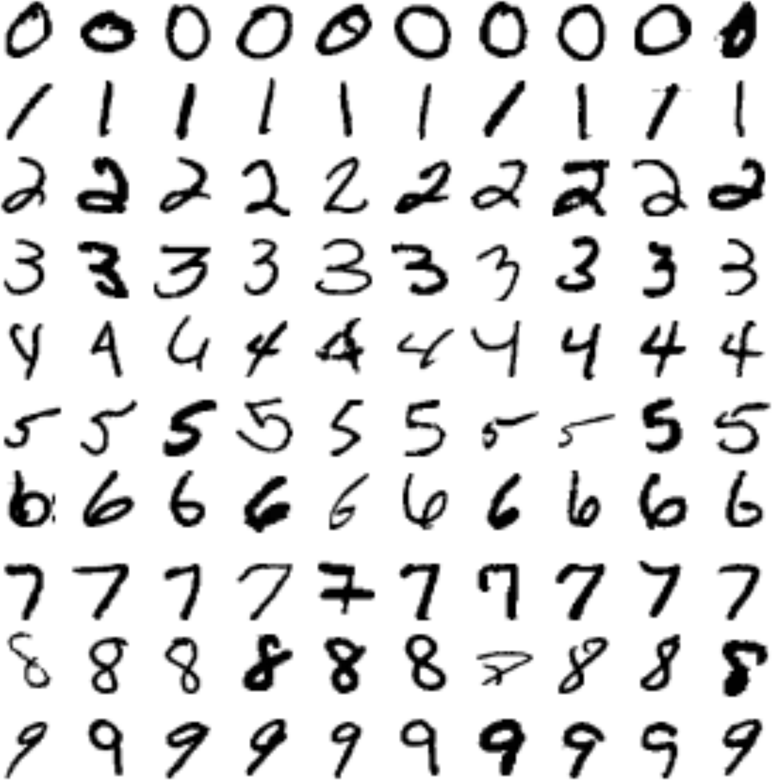

*Figure 3-1. A few digits from the MNIST dataset*

But wait! You should always create a test set and set it aside before inspecting the data closely. The MNIST dataset is actually already split into a training set (the first 60,000 images) and a test set (the last 10,000 images):

X_train, X_test, y_train, y_test = X[:60000], X[60000:], y[:60000], y[60000:]

Let’s also shuffle the training set; this will guarantee that all cross-validation folds will be similar (you don’t want one fold to be missing some digits). Moreover, some learning algorithms are sensitive to the order of the training instances, and they perform poorly if they get many similar instances in a row. Shuffling the dataset ensures that this won’t happen:[2](https://www.safaribooksonline.com/library/view/hands-on-machine-learning/9781491962282/ch03.html#idm140583018272848)

**import** **numpy** **as** **np**

shuffle_index = np.random.permutation(60000)

X_train, y_train = X_train[shuffle_index], y_train[shuffle_index]

**Training a Binary Classifier**

Let’s simplify the problem for now and only try to identify one digit—for example, the number 5. This “5-detector” will be an example of a *binary classifier*, capable of distinguishing between just two classes, 5 and not-5. Let’s create the target vectors for this classification task:

y_train_5 = (y_train == 5) *# True for all 5s, False for all other digits.*

y_test_5 = (y_test == 5)

Okay, now let’s pick a classifier and train it. A good place to start is with a *Stochastic Gradient Descent* (SGD) classifier, using Scikit-Learn’s SGDClassifier class. This classifier has the advantage of being capable of handling very large datasets efficiently. This is in part because SGD deals with training instances independently, one at a time (which also makes SGD well suited for *online learning*), as we will see later. Let’s create an SGDClassifier and train it on the whole training set:

**from** **sklearn.linear_model** **import** SGDClassifier

sgd_clf = SGDClassifier(random_state=42)

sgd_clf.fit(X_train, y_train_5)

**TIP**

The SGDClassifier relies on randomness during training (hence the name “stochastic”). If you want reproducible results, you should set the random_state parameter.

Now you can use it to detect images of the number 5:

**>>>** sgd_clf.predict([some_digit])

array([ True], dtype=bool)

The classifier guesses that this image represents a 5 (True). Looks like it guessed right in this particular case! Now, let’s evaluate this model’s performance.

**Performance Measures**

Evaluating a classifier is often significantly trickier than evaluating a regressor, so we will spend a large part of this chapter on this topic. There are many performance measures available, so grab another coffee and get ready to learn many new concepts and acronyms!

**Measuring Accuracy Using Cross-Validation**

A good way to evaluate a model is to use cross-validation, just as you did in [Chapter 2](https://www.safaribooksonline.com/library/view/hands-on-machine-learning/9781491962282/ch02.html#project_chapter).

**IMPLEMENTING CROSS-VALIDATION**

Occasionally you will need more control over the cross-validation process than what Scikit-Learn provides off-the-shelf. In these cases, you can implement cross-validation yourself; it is actually fairly straightforward. The following code does roughly the same thing as Scikit-Learn’s cross_val_score() function, and prints the same result:

**from** **sklearn.model_selection** **import** StratifiedKFold

**from** **sklearn.base** **import** clone

skfolds = StratifiedKFold(n_splits=3, random_state=42)

**for** train_index, test_index **in** skfolds.split(X_train, y_train_5):

clone_clf = clone(sgd_clf)

X_train_folds = X_train[train_index]

y_train_folds = y_train_5[train_index]

X_test_fold = X_train[test_index]

y_test_fold = y_train_5[test_index]

clone_clf.fit(X_train_folds, y_train_folds)

y_pred = clone_clf.predict(X_test_fold)

n_correct = sum(y_pred == y_test_fold)

**print**(n_correct / len(y_pred)) *# prints 0.9502, 0.96565 and 0.96495*

The StratifiedKFold class performs stratified sampling (as explained in [Chapter 2](https://www.safaribooksonline.com/library/view/hands-on-machine-learning/9781491962282/ch02.html#project_chapter)) to produce folds that contain a representative ratio of each class. At each iteration the code creates a clone of the classifier, trains that clone on the training folds, and makes predictions on the test fold. Then it counts the number of correct predictions and outputs the ratio of correct predictions.

Let’s use the cross_val_score() function to evaluate your SGDClassifier model using K-fold cross-validation, with three folds. Remember that K-fold cross-validation means splitting the training set into K-folds (in this case, three), then making predictions and evaluating them on each fold using a model trained on the remaining folds (see [Chapter 2](https://www.safaribooksonline.com/library/view/hands-on-machine-learning/9781491962282/ch02.html#project_chapter)):

**>>> from** **sklearn.model_selection** **import** cross_val_score

**>>>** cross_val_score(sgd_clf, X_train, y_train_5, cv=3, scoring="accuracy")

array([ 0.9502 , 0.96565, 0.96495])

Wow! Above 95% *accuracy* (ratio of correct predictions) on all cross-validation folds? This looks amazing, doesn’t it? Well, before you get too excited, let’s look at a very dumb classifier that just classifies every single image in the “not-5” class:

**from** **sklearn.base** **import** BaseEstimator

**class** **Never5Classifier**(BaseEstimator):

**def** fit(self, X, y=None):

**pass**

**def** predict(self, X):

**return** np.zeros((len(X), 1), dtype=bool)

Can you guess this model’s accuracy? Let’s find out:

**>>>** never_5_clf = Never5Classifier()

**>>>** cross_val_score(never_5_clf, X_train, y_train_5, cv=3, scoring="accuracy")

array([ 0.909 , 0.90715, 0.9128 ])

That’s right, it has over 90% accuracy! This is simply because only about 10% of the images are 5s, so if you always guess that an image is *not* a 5, you will be right about 90% of the time. Beats Nostradamus.

This demonstrates why accuracy is generally not the preferred performance measure for classifiers, especially when you are dealing with *skewed datasets* (i.e., when some classes are much more frequent than others).

**Confusion Matrix**

A much better way to evaluate the performance of a classifier is to look at the *confusion matrix*. The general idea is to count the number of times instances of class A are classified as class B. For example, to know the number of times the classifier confused images of 5s with 3s, you would look in the 5th row and 3rd column of the confusion matrix.

To compute the confusion matrix, you first need to have a set of predictions, so they can be compared to the actual targets. You could make predictions on the test set, but let’s keep it untouched for now (remember that you want to use the test set only at the very end of your project, once you have a classifier that you are ready to launch). Instead, you can use the cross_val_predict() function:

from sklearn.model_selection import cross_val_predict

y_train_pred = cross_val_predict(sgd_clf, X_train, y_train_5, cv=3)

Just like the cross_val_score() function, cross_val_predict() performs K-fold cross-validation, but instead of returning the evaluation scores, it returns the predictions made on each test fold. This means that you get a clean prediction for each instance in the training set (“clean” meaning that the prediction is made by a model that never saw the data during training).

Now you are ready to get the confusion matrix using the confusion_matrix() function. Just pass it the target classes (y_train_5) and the predicted classes (y_train_pred):

**>>> from** **sklearn.metrics** **import** confusion_matrix

**>>>** confusion_matrix(y_train_5, y_train_pred)

array([[53272, 1307],

[ 1077, 4344]])

Each row in a confusion matrix represents an *actual class*, while each column represents a *predicted class*. The first row of this matrix considers non-5 images (the *negative class*): 53,272 of them were correctly classified as non-5s (they are called *true negatives*), while the remaining 1,307 were wrongly classified as 5s (*false positives*). The second row considers the images of 5s (the *positive class*): 1,077 were wrongly classified as non-5s (*false negatives*), while the remaining 4,344 were correctly classified as 5s (*true positives*). A perfect classifier would have only true positives and true negatives, so its confusion matrix would have nonzero values only on its main diagonal (top left to bottom right):

**>>>** confusion_matrix(y_train_5, y_train_perfect_predictions)

array([[54579, 0],

[ 0, 5421]])

The confusion matrix gives you a lot of information, but sometimes you may prefer a more concise metric. An interesting one to look at is the accuracy of the positive predictions; this is called the *precision* of the classifier ([Equation 3-1](https://www.safaribooksonline.com/library/view/hands-on-machine-learning/9781491962282/ch03.html#equation_three_one)).

*Equation 3-1. Precision*

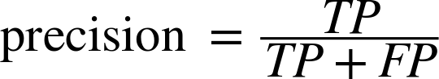

TP is the number of true positives, and FP is the number of false positives.

A trivial way to have perfect precision is to make one single positive prediction and ensure it is correct (precision = 1/1 = 100%). This would not be very useful since the classifier would ignore all but one positive instance. So precision is typically used along with another metric named *recall*, also called *sensitivity* or *true positive rate*(*TPR*): this is the ratio of positive instances that are correctly detected by the classifier ([Equation 3-2](https://www.safaribooksonline.com/library/view/hands-on-machine-learning/9781491962282/ch03.html#equation_three_two)).

*Equation 3-2. Recall*

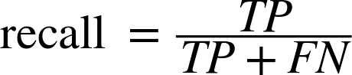

FN is of course the number of false negatives.

If you are confused about the confusion matrix, [Figure 3-2](https://www.safaribooksonline.com/library/view/hands-on-machine-learning/9781491962282/ch03.html#confusion_matrix_diagram) may help.

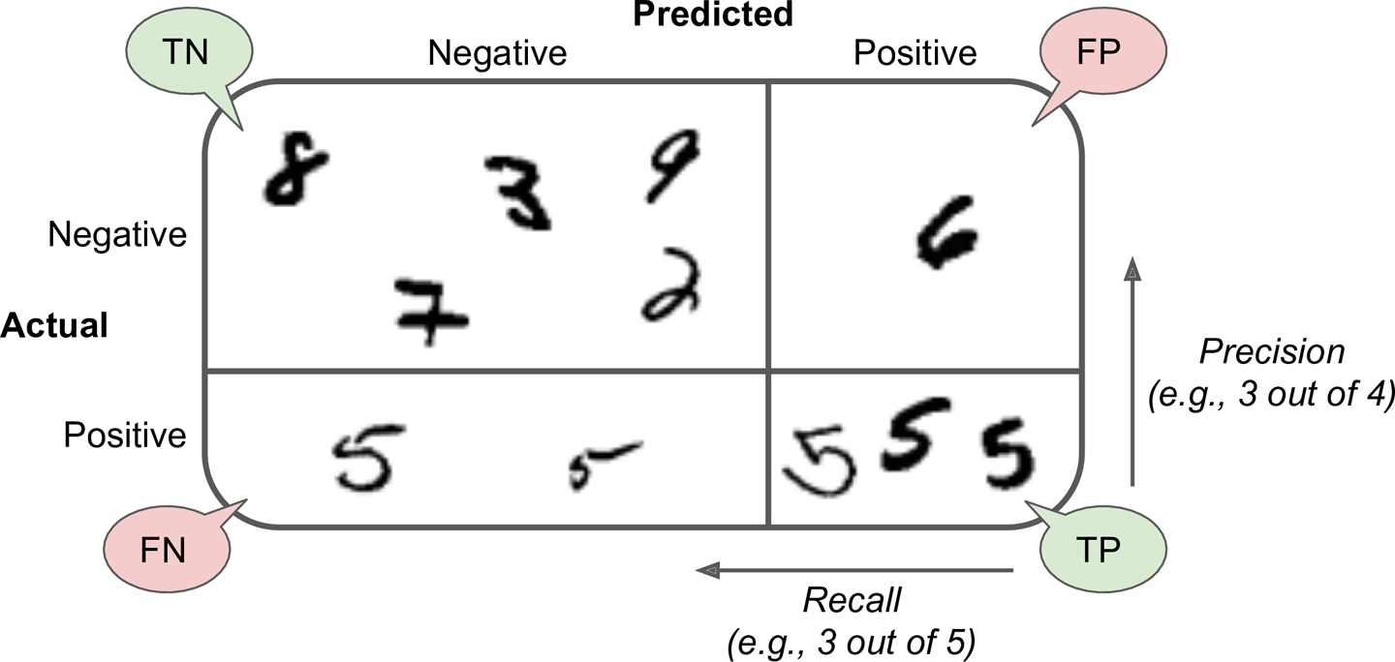

*Figure 3-2. An illustrated confusion matrix*

**Precision and Recall**

Scikit-Learn provides several functions to compute classifier metrics, including precision and recall:

**>>> from** **sklearn.metrics** **import** precision_score, recall_score

**>>>** precision_score(y_train_5, y_train_pred) *# == 4344 / (4344 + 1307)*

0.76871350203503808

**>>>** recall_score(y_train_5, y_train_pred) *# == 4344 / (4344 + 1077)*

0.80132816823464303

Now your 5-detector does not look as shiny as it did when you looked at its accuracy. When it claims an image represents a 5, it is correct only 77% of the time. Moreover, it only detects 80% of the 5s.

It is often convenient to combine precision and recall into a single metric called the *F1 score*, in particular if you need a simple way to compare two classifiers. The F1 score is the *harmonic mean* of precision and recall ([Equation 3-3](https://www.safaribooksonline.com/library/view/hands-on-machine-learning/9781491962282/ch03.html#equation_three_three)). Whereas the regular mean treats all values equally, the harmonic mean gives much more weight to low values. As a result, the classifier will only get a high F1 score if both recall and precision are high.

*Equation 3-3. F1 score*



To compute the F1 score, simply call the f1_score() function:

**>>> from** **sklearn.metrics** **import** f1_score

**>>>** f1_score(y_train_5, y_train_pred)

0.78468208092485547

The F1 score favors classifiers that have similar precision and recall. This is not always what you want: in some contexts you mostly care about precision, and in other contexts you really care about recall. For example, if you trained a classifier to detect videos that are safe for kids, you would probably prefer a classifier that rejects many good videos (low recall) but keeps only safe ones (high precision), rather than a classifier that has a much higher recall but lets a few really bad videos show up in your product (in such cases, you may even want to add a human pipeline to check the classifier’s video selection). On the other hand, suppose you train a classifier to detect shoplifters on surveillance images: it is probably fine if your classifier has only 30% precision as long as it has 99% recall (sure, the security guards will get a few false alerts, but almost all shoplifters will get caught).

Unfortunately, you can’t have it both ways: increasing precision reduces recall, and vice versa. This is called the *precision/recall tradeoff*.

**Precision/Recall Tradeoff**

To understand this tradeoff, let’s look at how the SGDClassifier makes its classification decisions. For each instance, it computes a score based on a *decision function*, and if that score is greater than a threshold, it assigns the instance to the positive class, or else it assigns it to the negative class. [Figure 3-3](https://www.safaribooksonline.com/library/view/hands-on-machine-learning/9781491962282/ch03.html#decision_threshold_diagram) shows a few digits positioned from the lowest score on the left to the highest score on the right. Suppose the *decision threshold* is positioned at the central arrow (between the two 5s): you will find 4 true positives (actual 5s) on the right of that threshold, and one false positive (actually a 6). Therefore, with that threshold, the precision is 80% (4 out of 5). But out of 6 actual 5s, the classifier only detects 4, so the recall is 67% (4 out of 6). Now if you raise the threshold (move it to the arrow on the right), the false positive (the 6) becomes a true negative, thereby increasing precision (up to 100% in this case), but one true positive becomes a false negative, decreasing recall down to 50%. Conversely, lowering the threshold increases recall and reduces precision.

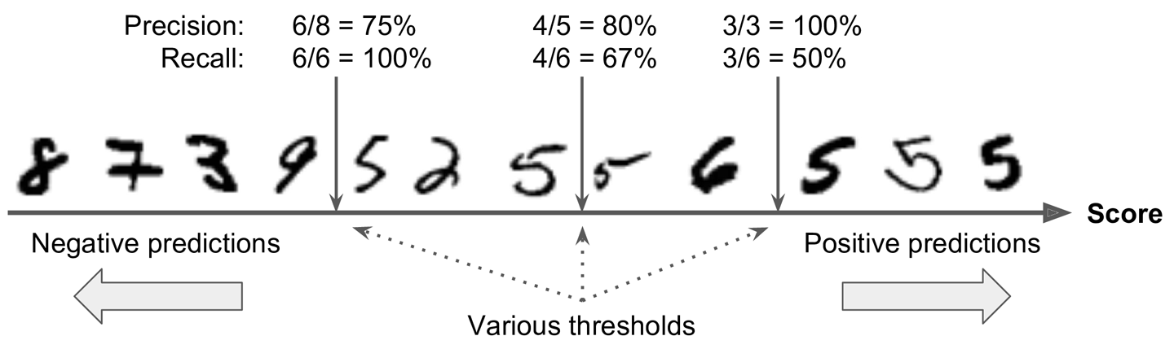

*Figure 3-3. Decision threshold and precision/recall tradeoff*

Scikit-Learn does not let you set the threshold directly, but it does give you access to the decision scores that it uses to make predictions. Instead of calling the classifier’s predict() method, you can call its decision_function() method, which returns a score for each instance, and then make predictions based on those scores using any threshold you want:

**>>>** y_scores = sgd_clf.decision_function([some_digit])

**>>>** y_scores

array([ 161855.74572176])

**>>>** threshold = 0

**>>>** y_some_digit_pred = (y_scores > threshold)

array([ True], dtype=bool)

The SGDClassifier uses a threshold equal to 0, so the previous code returns the same result as the predict()method (i.e., True). Let’s raise the threshold:

**>>>** threshold = 200000

**>>>** y_some_digit_pred = (y_scores > threshold)

**>>>** y_some_digit_pred

array([False], dtype=bool)

This confirms that raising the threshold decreases recall. The image actually represents a 5, and the classifier detects it when the threshold is 0, but it misses it when the threshold is increased to 200,000.

So how can you decide which threshold to use? For this you will first need to get the scores of all instances in the training set using the cross_val_predict() function again, but this time specifying that you want it to return decision scores instead of predictions:

y_scores = cross_val_predict(sgd_clf, X_train, y_train_5, cv=3,

method="decision_function")

Now with these scores you can compute precision and recall for all possible thresholds using the precision_recall_curve() function:

**from** **sklearn.metrics** **import** precision_recall_curve

precisions, recalls, thresholds = precision_recall_curve(y_train_5, y_scores)

Finally, you can plot precision and recall as functions of the threshold value using Matplotlib ([Figure 3-4](https://www.safaribooksonline.com/library/view/hands-on-machine-learning/9781491962282/ch03.html#precision_recall_vs_threshold_plot)):

**def** plot_precision_recall_vs_threshold(precisions, recalls, thresholds):

plt.plot(thresholds, precisions[:-1], "b--", label="Precision")

plt.plot(thresholds, recalls[:-1], "g-", label="Recall")

plt.xlabel("Threshold")

plt.legend(loc="center left")

plt.ylim([0, 1])

plot_precision_recall_vs_threshold(precisions, recalls, thresholds)

plt.show()

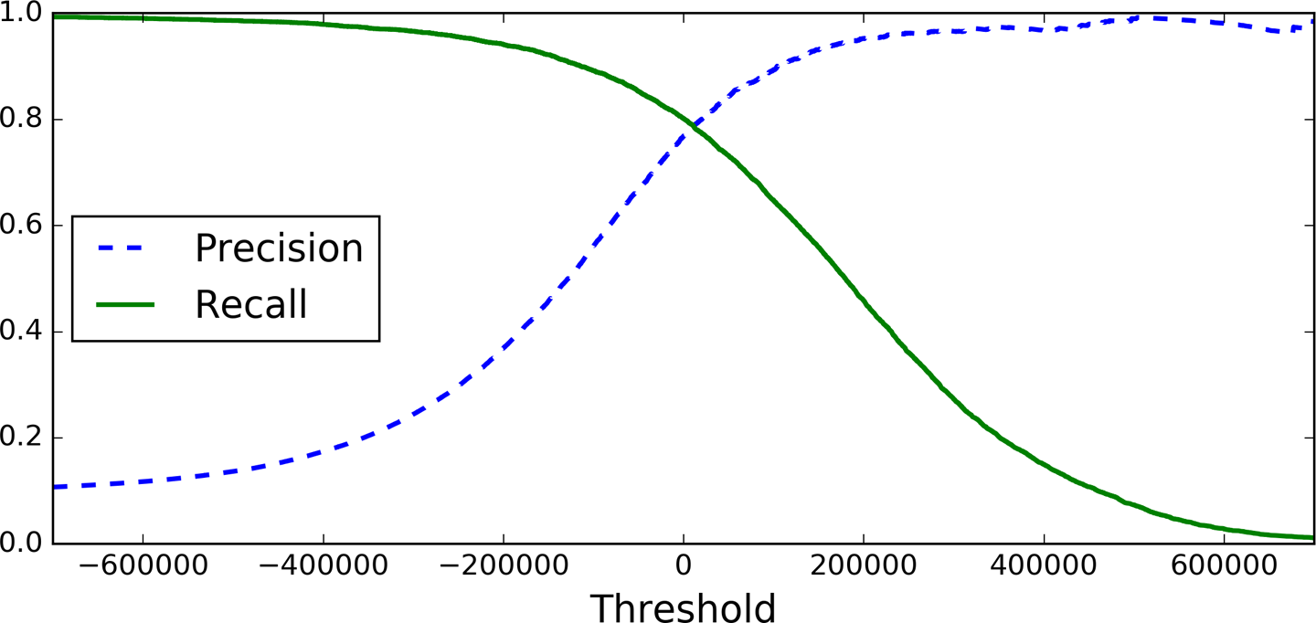

*Figure 3-4. Precision and recall versus the decision threshold*

**NOTE**

You may wonder why the precision curve is bumpier than the recall curve in [Figure 3-4](https://www.safaribooksonline.com/library/view/hands-on-machine-learning/9781491962282/ch03.html#precision_recall_vs_threshold_plot). The reason is that precision may sometimes go down when you raise the threshold (although in general it will go up). To understand why, look back at [Figure 3-3](https://www.safaribooksonline.com/library/view/hands-on-machine-learning/9781491962282/ch03.html#decision_threshold_diagram) and notice what happens when you start from the central threshold and move it just one digit to the right: precision goes from 4/5 (80%) down to 3/4 (75%). On the other hand, recall can only go down when the threshold is increased, which explains why its curve looks smooth.

Now you can simply select the threshold value that gives you the best precision/recall tradeoff for your task. Another way to select a good precision/recall tradeoff is to plot precision directly against recall, as shown in [Figure 3-5](https://www.safaribooksonline.com/library/view/hands-on-machine-learning/9781491962282/ch03.html#precision_vs_recall_plot).

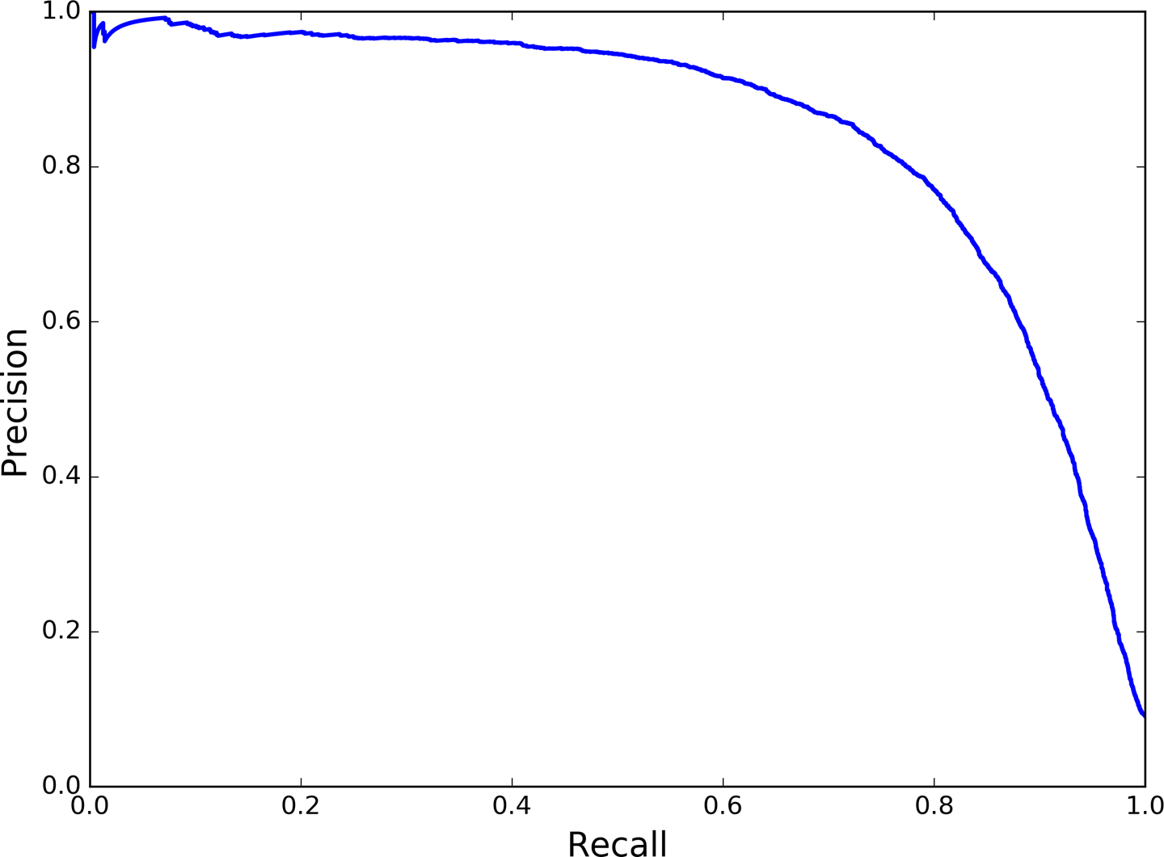

*Figure 3-5. Precision versus recall*

You can see that precision really starts to fall sharply around 80% recall. You will probably want to select a precision/recall tradeoff just before that drop—for example, at around 60% recall. But of course the choice depends on your project.

So let’s suppose you decide to aim for 90% precision. You look up the first plot (zooming in a bit) and find that you need to use a threshold of about 70,000. To make predictions (on the training set for now), instead of calling the classifier’s predict() method, you can just run this code:

y_train_pred_90 = (y_scores > 70000)

Let’s check these predictions’ precision and recall:

**>>>** precision_score(y_train_5, y_train_pred_90)

0.86592051164915484

**>>>** recall_score(y_train_5, y_train_pred_90)

0.69931746910164172

Great, you have a 90% precision classifier (or close enough)! As you can see, it is fairly easy to create a classifier with virtually any precision you want: just set a high enough threshold, and you’re done. Hmm, not so fast. A high-precision classifier is not very useful if its recall is too low!

**TIP**

If someone says “let’s reach 99% precision,” you should ask, “at what recall?”

**The ROC Curve**

The *receiver operating characteristic* (ROC) curve is another common tool used with binary classifiers. It is very similar to the precision/recall curve, but instead of plotting precision versus recall, the ROC curve plots the *true positive rate* (another name for recall) against the *false positive rate*. The FPR is the ratio of negative instances that are incorrectly classified as positive. It is equal to one minus the *true negative rate*, which is the ratio of negative instances that are correctly classified as negative. The TNR is also called *specificity*. Hence the ROC curve plots *sensitivity* (recall) versus 1 – *specificity*.

To plot the ROC curve, you first need to compute the TPR and FPR for various threshold values, using the roc_curve() function:

**from** **sklearn.metrics** **import** roc_curve

fpr, tpr, thresholds = roc_curve(y_train_5, y_scores)

Then you can plot the FPR against the TPR using Matplotlib. This code produces the plot in [Figure 3-6](https://www.safaribooksonline.com/library/view/hands-on-machine-learning/9781491962282/ch03.html#roc_curve_plot):

**def** plot_roc_curve(fpr, tpr, label=None):

plt.plot(fpr, tpr, linewidth=2, label=label)

plt.plot([0, 1], [0, 1], 'k--')

plt.axis([0, 1, 0, 1])

plt.xlabel('False Positive Rate')

plt.ylabel('True Positive Rate')

plot_roc_curve(fpr, tpr)

plt.show()

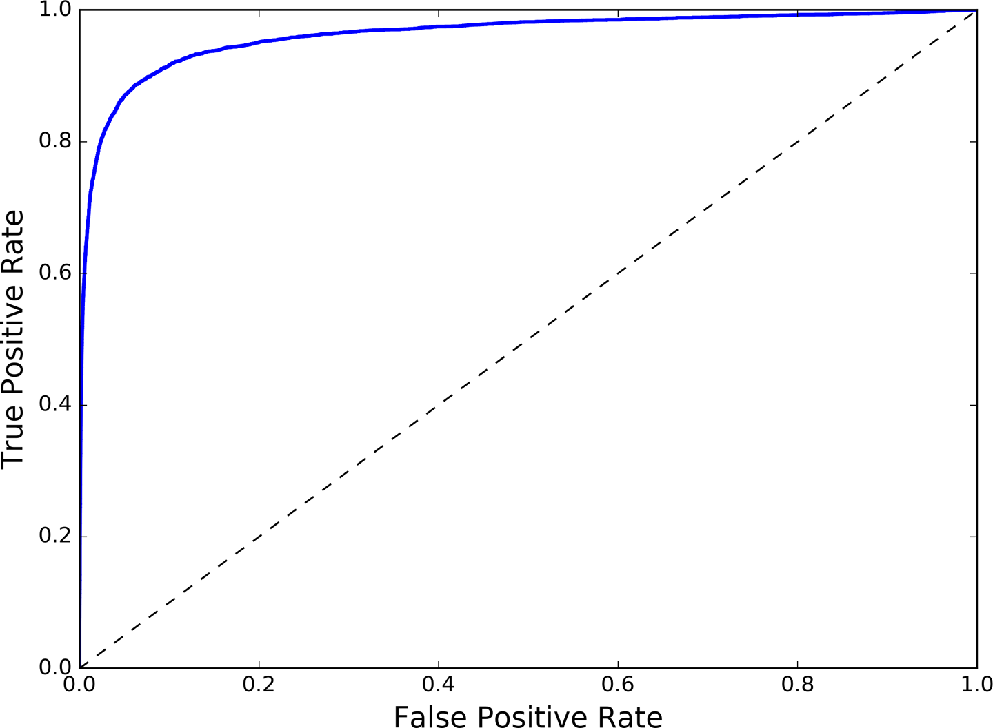

*Figure 3-6. ROC curve*

Once again there is a tradeoff: the higher the recall (TPR), the more false positives (FPR) the classifier produces. The dotted line represents the ROC curve of a purely random classifier; a good classifier stays as far away from that line as possible (toward the top-left corner).

One way to compare classifiers is to measure the *area under the curve* (AUC). A perfect classifier will have a *ROC AUC* equal to 1, whereas a purely random classifier will have a ROC AUC equal to 0.5. Scikit-Learn provides a function to compute the ROC AUC:

**>>> from** **sklearn.metrics** **import** roc_auc_score

**>>>** roc_auc_score(y_train_5, y_scores)

0.96244965559671547

**TIP**

Since the ROC curve is so similar to the precision/recall (or PR) curve, you may wonder how to decide which one to use. As a rule of thumb, you should prefer the PR curve whenever the positive class is rare or when you care more about the false positives than the false negatives, and the ROC curve otherwise. For example, looking at the previous ROC curve (and the ROC AUC score), you may think that the classifier is really good. But this is mostly because there are few positives (5s) compared to the negatives (non-5s). In contrast, the PR curve makes it clear that the classifier has room for improvement (the curve could be closer to the top-right corner).

Let’s train a RandomForestClassifier and compare its ROC curve and ROC AUC score to the SGDClassifier. First, you need to get scores for each instance in the training set. But due to the way it works (see [Chapter 7](https://www.safaribooksonline.com/library/view/hands-on-machine-learning/9781491962282/ch07.html#ensembles_chapter)), the RandomForestClassifier class does not have a decision_function() method. Instead it has a predict_proba() method. Scikit-Learn classifiers generally have one or the other. The predict_proba() method returns an array containing a row per instance and a column per class, each containing the probability that the given instance belongs to the given class (e.g., 70% chance that the image represents a 5):

**from** **sklearn.ensemble** **import** RandomForestClassifier

forest_clf = RandomForestClassifier(random_state=42)

y_probas_forest = cross_val_predict(forest_clf, X_train, y_train_5, cv=3,

method="predict_proba")

But to plot a ROC curve, you need scores, not probabilities. A simple solution is to use the positive class’s probability as the score:

y_scores_forest = y_probas_forest[:, 1] *# score = proba of positive class*

fpr_forest, tpr_forest, thresholds_forest = roc_curve(y_train_5,y_scores_forest)

Now you are ready to plot the ROC curve. It is useful to plot the first ROC curve as well to see how they compare ([Figure 3-7](https://www.safaribooksonline.com/library/view/hands-on-machine-learning/9781491962282/ch03.html#roc_curve_comparison_plot)):

plt.plot(fpr, tpr, "b:", label="SGD")

plot_roc_curve(fpr_forest, tpr_forest, "Random Forest")

plt.legend(loc="lower right")

plt.show()

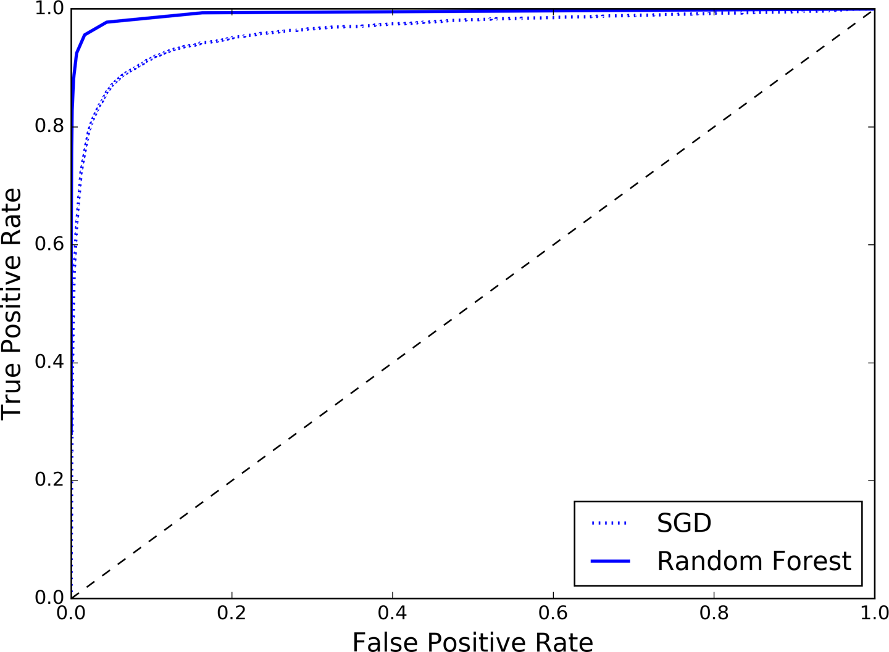

*Figure 3-7. Comparing ROC curves*

As you can see in [Figure 3-7](https://www.safaribooksonline.com/library/view/hands-on-machine-learning/9781491962282/ch03.html#roc_curve_comparison_plot), the RandomForestClassifier’s ROC curve looks much better than the SGDClassifier’s: it comes much closer to the top-left corner. As a result, its ROC AUC score is also significantly better:

**>>>** roc_auc_score(y_train_5, y_scores_forest)

0.99312433660038291

Try measuring the precision and recall scores: you should find 98.5% precision and 82.8% recall. Not too bad!

Hopefully you now know how to train binary classifiers, choose the appropriate metric for your task, evaluate your classifiers using cross-validation, select the precision/recall tradeoff that fits your needs, and compare various models using ROC curves and ROC AUC scores. Now let’s try to detect more than just the 5s.

**Multiclass Classification**

Whereas binary classifiers distinguish between two classes, *multiclass classifiers* (also called *multinomial classifiers*) can distinguish between more than two classes.

Some algorithms (such as Random Forest classifiers or naive Bayes classifiers) are capable of handling multiple classes directly. Others (such as Support Vector Machine classifiers or Linear classifiers) are strictly binary classifiers. However, there are various strategies that you can use to perform multiclass classification using multiple binary classifiers.

For example, one way to create a system that can classify the digit images into 10 classes (from 0 to 9) is to train 10 binary classifiers, one for each digit (a 0-detector, a 1-detector, a 2-detector, and so on). Then when you want to classify an image, you get the decision score from each classifier for that image and you select the class whose classifier outputs the highest score. This is called the *one-versus-all* (OvA) strategy (also called *one-versus-the-rest*).

Another strategy is to train a binary classifier for every pair of digits: one to distinguish 0s and 1s, another to distinguish 0s and 2s, another for 1s and 2s, and so on. This is called the *one-versus-one* (OvO) strategy. If there are *N* classes, you need to train *N* × (*N* – 1) / 2 classifiers. For the MNIST problem, this means training 45 binary classifiers! When you want to classify an image, you have to run the image through all 45 classifiers and see which class wins the most duels. The main advantage of OvO is that each classifier only needs to be trained on the part of the training set for the two classes that it must distinguish.

Some algorithms (such as Support Vector Machine classifiers) scale poorly with the size of the training set, so for these algorithms OvO is preferred since it is faster to train many classifiers on small training sets than training few classifiers on large training sets. For most binary classification algorithms, however, OvA is preferred.

Scikit-Learn detects when you try to use a binary classification algorithm for a multiclass classification task, and it automatically runs OvA (except for SVM classifiers for which it uses OvO). Let’s try this with the SGDClassifier:

**>>>** sgd_clf.fit(X_train, y_train) *# y_train, not y_train_5*

**>>>** sgd_clf.predict([some_digit])

array([ 5.])

That was easy! This code trains the SGDClassifier on the training set using the original target classes from 0 to 9 (y_train), instead of the 5-versus-all target classes (y_train_5). Then it makes a prediction (a correct one in this case). Under the hood, Scikit-Learn actually trained 10 binary classifiers, got their decision scores for the image, and selected the class with the highest score.

To see that this is indeed the case, you can call the decision_function() method. Instead of returning just one score per instance, it now returns 10 scores, one per class:

**>>>** some_digit_scores = sgd_clf.decision_function([some_digit])

**>>>** some_digit_scores

array([[-311402.62954431, -363517.28355739, -446449.5306454 ,

-183226.61023518, -414337.15339485, 161855.74572176,

-452576.39616343, -471957.14962573, -518542.33997148,

-536774.63961222]])

The highest score is indeed the one corresponding to class 5:

**>>>** np.argmax(some_digit_scores)

5

**>>>** sgd_clf.classes_

array([ 0., 1., 2., 3., 4., 5., 6., 7., 8., 9.])

**>>>** sgd_clf.classes_[5]

5.0

**WARNING**

When a classifier is trained, it stores the list of target classes in its classes_ attribute, ordered by value. In this case, the index of each class in the classes_ array conveniently matches the class itself (e.g., the class at index 5 happens to be class 5), but in general you won’t be so lucky.

If you want to force ScikitLearn to use one-versus-one or one-versus-all, you can use the OneVsOneClassifier or OneVsRestClassifier classes. Simply create an instance and pass a binary classifier to its constructor. For example, this code creates a multiclass classifier using the OvO strategy, based on a SGDClassifier:

**>>> from** **sklearn.multiclass** **import** OneVsOneClassifier

**>>>** ovo_clf = OneVsOneClassifier(SGDClassifier(random_state=42))

**>>>** ovo_clf.fit(X_train, y_train)

**>>>** ovo_clf.predict([some_digit])

array([ 5.])

**>>>** len(ovo_clf.estimators_)

45

Training a RandomForestClassifier is just as easy:

**>>>** forest_clf.fit(X_train, y_train)

**>>>** forest_clf.predict([some_digit])

array([ 5.])

This time Scikit-Learn did not have to run OvA or OvO because Random Forest classifiers can directly classify instances into multiple classes. You can call predict_proba() to get the list of probabilities that the classifier assigned to each instance for each class:

**>>>** forest_clf.predict_proba([some_digit])

array([[ 0.1, 0. , 0. , 0.1, 0. , 0.8, 0. , 0. , 0. , 0. ]])

You can see that the classifier is fairly confident about its prediction: the 0.8 at the 5th index in the array means that the model estimates an 80% probability that the image represents a 5. It also thinks that the image could instead be a 0 or a 3 (10% chance each).

Now of course you want to evaluate these classifiers. As usual, you want to use cross-validation. Let’s evaluate the SGDClassifier’s accuracy using the cross_val_score() function:

**>>>** cross_val_score(sgd_clf, X_train, y_train, cv=3, scoring="accuracy")

array([ 0.84063187, 0.84899245, 0.86652998])

It gets over 84% on all test folds. If you used a random classifier, you would get 10% accuracy, so this is not such a bad score, but you can still do much better. For example, simply scaling the inputs (as discussed in [Chapter 2](https://www.safaribooksonline.com/library/view/hands-on-machine-learning/9781491962282/ch02.html#project_chapter)) increases accuracy above 90%:

**>>> from** **sklearn.preprocessing** **import** StandardScaler

**>>>** scaler = StandardScaler()

**>>>** X_train_scaled = scaler.fit_transform(X_train.astype(np.float64))

**>>>** cross_val_score(sgd_clf, X_train_scaled, y_train, cv=3, scoring="accuracy")

array([ 0.91011798, 0.90874544, 0.906636 ])

**Error Analysis**

Of course, if this were a real project, you would follow the steps in your Machine Learning project checklist (see [Appendix B](https://www.safaribooksonline.com/library/view/hands-on-machine-learning/9781491962282/app02.html#project_checklist_appendix)): exploring data preparation options, trying out multiple models, shortlisting the best ones and fine-tuning their hyperparameters using GridSearchCV, and automating as much as possible, as you did in the previous chapter. Here, we will assume that you have found a promising model and you want to find ways to improve it. One way to do this is to analyze the types of errors it makes.

First, you can look at the confusion matrix. You need to make predictions using the cross_val_predict()function, then call the confusion_matrix() function, just like you did earlier:

**>>>** y_train_pred = cross_val_predict(sgd_clf, X_train_scaled, y_train, cv=3)

**>>>** conf_mx = confusion_matrix(y_train, y_train_pred)

**>>>** conf_mx

array([[5725, 3, 24, 9, 10, 49, 50, 10, 39, 4],

[ 2, 6493, 43, 25, 7, 40, 5, 10, 109, 8],

[ 51, 41, 5321, 104, 89, 26, 87, 60, 166, 13],

[ 47, 46, 141, 5342, 1, 231, 40, 50, 141, 92],

[ 19, 29, 41, 10, 5366, 9, 56, 37, 86, 189],

[ 73, 45, 36, 193, 64, 4582, 111, 30, 193, 94],

[ 29, 34, 44, 2, 42, 85, 5627, 10, 45, 0],

[ 25, 24, 74, 32, 54, 12, 6, 5787, 15, 236],

[ 52, 161, 73, 156, 10, 163, 61, 25, 5027, 123],

[ 43, 35, 26, 92, 178, 28, 2, 223, 82, 5240]])

That’s a lot of numbers. It’s often more convenient to look at an image representation of the confusion matrix, using Matplotlib’s matshow() function:

plt.matshow(conf_mx, cmap=plt.cm.gray)

plt.show()

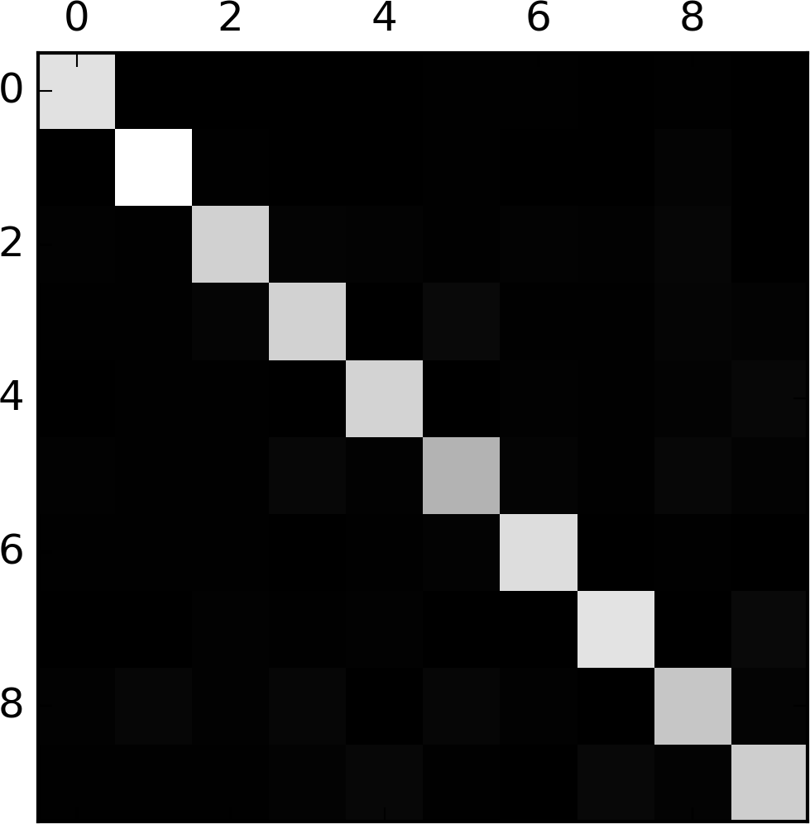

This confusion matrix looks fairly good, since most images are on the main diagonal, which means that they were classified correctly. The 5s look slightly darker than the other digits, which could mean that there are fewer images of 5s in the dataset or that the classifier does not perform as well on 5s as on other digits. In fact, you can verify that both are the case.

Let’s focus the plot on the errors. First, you need to divide each value in the confusion matrix by the number of images in the corresponding class, so you can compare error rates instead of absolute number of errors (which would make abundant classes look unfairly bad):

row_sums = conf_mx.sum(axis=1, keepdims=True)

norm_conf_mx = conf_mx / row_sums

Now let’s fill the diagonal with zeros to keep only the errors, and let’s plot the result:

np.fill_diagonal(norm_conf_mx, 0)

plt.matshow(norm_conf_mx, cmap=plt.cm.gray)

plt.show()

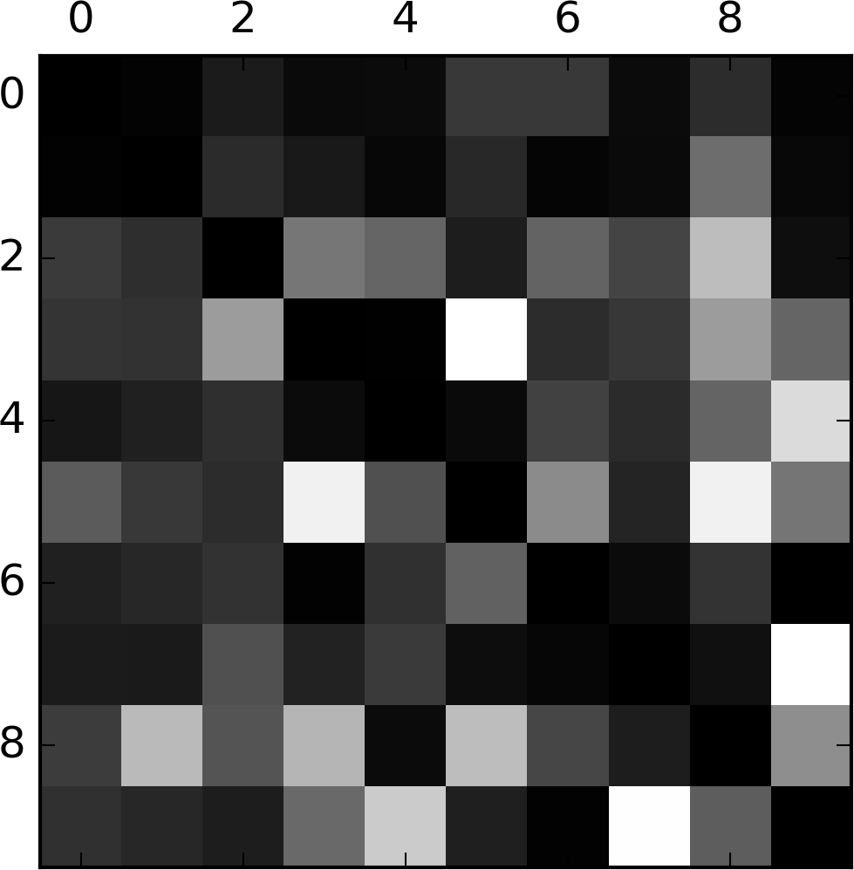

Now you can clearly see the kinds of errors the classifier makes. Remember that rows represent actual classes, while columns represent predicted classes. The columns for classes 8 and 9 are quite bright, which tells you that many images get misclassified as 8s or 9s. Similarly, the rows for classes 8 and 9 are also quite bright, telling you that 8s and 9s are often confused with other digits. Conversely, some rows are pretty dark, such as row 1: this means that most 1s are classified correctly (a few are confused with 8s, but that’s about it). Notice that the errors are not perfectly symmetrical; for example, there are more 5s misclassified as 8s than the reverse.

Analyzing the confusion matrix can often give you insights on ways to improve your classifier. Looking at this plot, it seems that your efforts should be spent on improving classification of 8s and 9s, as well as fixing the specific 3/5 confusion. For example, you could try to gather more training data for these digits. Or you could engineer new features that would help the classifier—for example, writing an algorithm to count the number of closed loops (e.g., 8 has two, 6 has one, 5 has none). Or you could preprocess the images (e.g., using Scikit-Image, Pillow, or OpenCV) to make some patterns stand out more, such as closed loops.

Analyzing individual errors can also be a good way to gain insights on what your classifier is doing and why it is failing, but it is more difficult and time-consuming. For example, let’s plot examples of 3s and 5s (the plot_digits() function just uses Matplotlib’s imshow() function; see this chapter’s Jupyter notebook for details):

cl_a, cl_b = 3, 5

X_aa = X_train[(y_train == cl_a) & (y_train_pred == cl_a)]

X_ab = X_train[(y_train == cl_a) & (y_train_pred == cl_b)]

X_ba = X_train[(y_train == cl_b) & (y_train_pred == cl_a)]

X_bb = X_train[(y_train == cl_b) & (y_train_pred == cl_b)]

plt.figure(figsize=(8,8))

plt.subplot(221); plot_digits(X_aa[:25], images_per_row=5)

plt.subplot(222); plot_digits(X_ab[:25], images_per_row=5)

plt.subplot(223); plot_digits(X_ba[:25], images_per_row=5)

plt.subplot(224); plot_digits(X_bb[:25], images_per_row=5)

plt.show()

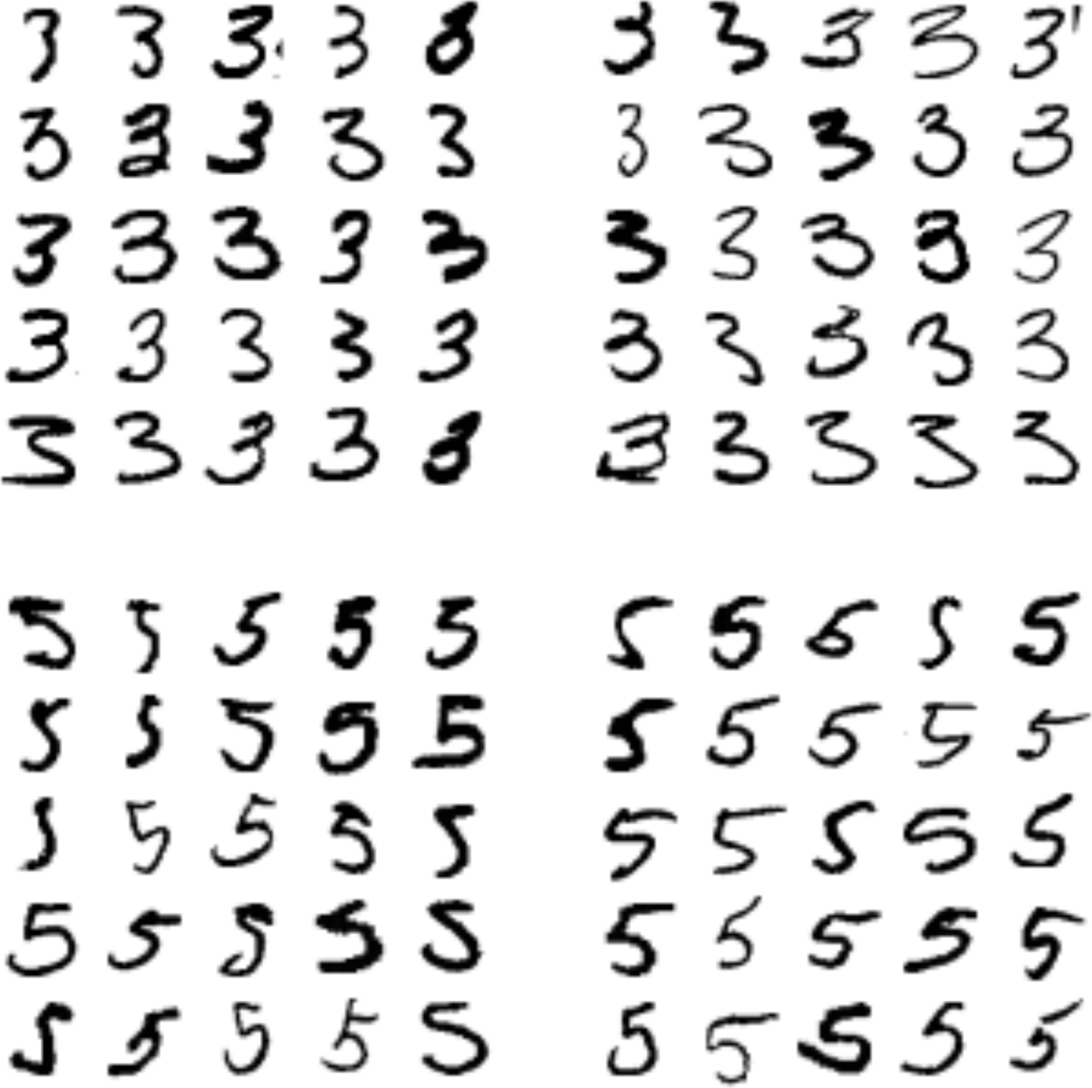

The two 5×5 blocks on the left show digits classified as 3s, and the two 5×5 blocks on the right show images classified as 5s. Some of the digits that the classifier gets wrong (i.e., in the bottom-left and top-right blocks) are so badly written that even a human would have trouble classifying them (e.g., the 5 on the 8th row and 1st column truly looks like a 3). However, most misclassified images seem like obvious errors to us, and it’s hard to understand why the classifier made the mistakes it did.[3](https://www.safaribooksonline.com/library/view/hands-on-machine-learning/9781491962282/ch03.html#idm140583015963696) The reason is that we used a simple SGDClassifier, which is a linear model. All it does is assign a weight per class to each pixel, and when it sees a new image it just sums up the weighted pixel intensities to get a score for each class. So since 3s and 5s differ only by a few pixels, this model will easily confuse them.

The main difference between 3s and 5s is the position of the small line that joins the top line to the bottom arc. If you draw a 3 with the junction slightly shifted to the left, the classifier might classify it as a 5, and vice versa. In other words, this classifier is quite sensitive to image shifting and rotation. So one way to reduce the 3/5 confusion would be to preprocess the images to ensure that they are well centered and not too rotated. This will probably help reduce other errors as well.

**Multilabel Classification**

Until now each instance has always been assigned to just one class. In some cases you may want your classifier to output multiple classes for each instance. For example, consider a face-recognition classifier: what should it do if it recognizes several people on the same picture? Of course it should attach one label per person it recognizes. Say the classifier has been trained to recognize three faces, Alice, Bob, and Charlie; then when it is shown a picture of Alice and Charlie, it should output [1, 0, 1] (meaning “Alice yes, Bob no, Charlie yes”). Such a classification system that outputs multiple binary labels is called a *multilabel classification* system.

We won’t go into face recognition just yet, but let’s look at a simpler example, just for illustration purposes:

**from** **sklearn.neighbors** **import** KNeighborsClassifier

y_train_large = (y_train >= 7)

y_train_odd = (y_train % 2 == 1)

y_multilabel = np.c_[y_train_large, y_train_odd]

knn_clf = KNeighborsClassifier()

knn_clf.fit(X_train, y_multilabel)

This code creates a y_multilabel array containing two target labels for each digit image: the first indicates whether or not the digit is large (7, 8, or 9) and the second indicates whether or not it is odd. The next lines create a KNeighborsClassifier instance (which supports multilabel classification, but not all classifiers do) and we train it using the multiple targets array. Now you can make a prediction, and notice that it outputs two labels:

**>>>** knn_clf.predict([some_digit])

array([[False, True]], dtype=bool)

And it gets it right! The digit 5 is indeed not large (False) and odd (True).

There are many ways to evaluate a multilabel classifier, and selecting the right metric really depends on your project. For example, one approach is to measure the F1 score for each individual label (or any other binary classifier metric discussed earlier), then simply compute the average score. This code computes the average F1score across all labels:

**>>>** y_train_knn_pred = cross_val_predict(knn_clf, X_train, y_multilabel, cv=3)

**>>>** f1_score(y_multilabel, y_train_knn_pred, average="macro")

0.97709078477525002

This assumes that all labels are equally important, which may not be the case. In particular, if you have many more pictures of Alice than of Bob or Charlie, you may want to give more weight to the classifier’s score on pictures of Alice. One simple option is to give each label a weight equal to its *support* (i.e., the number of instances with that target label). To do this, simply set average="weighted" in the preceding code.[4](https://www.safaribooksonline.com/library/view/hands-on-machine-learning/9781491962282/ch03.html#idm140583015688400)

**Multioutput Classification**

The last type of classification task we are going to discuss here is called *multioutput-multiclass classification* (or simply *multioutput classification*). It is simply a generalization of multilabel classification where each label can be multiclass (i.e., it can have more than two possible values).

To illustrate this, let’s build a system that removes noise from images. It will take as input a noisy digit image, and it will (hopefully) output a clean digit image, represented as an array of pixel intensities, just like the MNIST images. Notice that the classifier’s output is multilabel (one label per pixel) and each label can have multiple values (pixel intensity ranges from 0 to 255). It is thus an example of a multioutput classification system.

**NOTE**

The line between classification and regression is sometimes blurry, such as in this example. Arguably, predicting pixel intensity is more akin to regression than to classification. Moreover, multioutput systems are not limited to classification tasks; you could even have a system that outputs multiple labels per instance, including both class labels and value labels.

Let’s start by creating the training and test sets by taking the MNIST images and adding noise to their pixel intensities using NumPy’s randint() function. The target images will be the original images:

noise = np.random.randint(0, 100, (len(X_train), 784))

X_train_mod = X_train + noise

noise = np.random.randint(0, 100, (len(X_test), 784))

X_test_mod = X_test + noise

y_train_mod = X_train

y_test_mod = X_test

Let’s take a peek at an image from the test set (yes, we’re snooping on the test data, so you should be frowning right now):

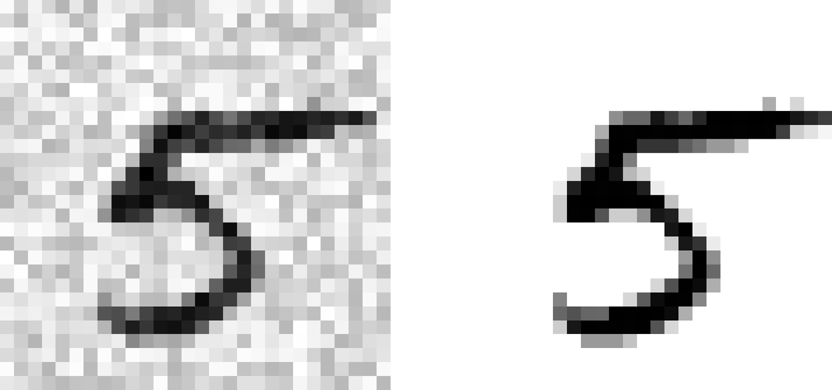

On the left is the noisy input image, and on the right is the clean target image. Now let’s train the classifier and make it clean this image:

knn_clf.fit(X_train_mod, y_train_mod)

clean_digit = knn_clf.predict([X_test_mod[some_index]])

plot_digit(clean_digit)



Looks close enough to the target! This concludes our tour of classification. Hopefully you should now know how to select good metrics for classification tasks, pick the appropriate precision/recall tradeoff, compare classifiers, and more generally build good classification systems for a variety of tasks.

**Exercises**

1. Try to build a classifier for the MNIST dataset that achieves over 97% accuracy on the test set. Hint: the KNeighborsClassifier works quite well for this task; you just need to find good hyperparameter values (try a grid search on the weights and n_neighbors hyperparameters).
2. Write a function that can shift an MNIST image in any direction (left, right, up, or down) by one pixel.[5](https://www.safaribooksonline.com/library/view/hands-on-machine-learning/9781491962282/ch03.html#idm140583015605376)Then, for each image in the training set, create four shifted copies (one per direction) and add them to the training set. Finally, train your best model on this expanded training set and measure its accuracy on the test set. You should observe that your model performs even better now! This technique of artificially growing the training set is called *data augmentation* or *training set expansion*.
3. Tackle the *Titanic* dataset. A great place to start is on [Kaggle](https://www.kaggle.com/c/titanic).
4. Build a spam classifier (a more challenging exercise):
   * Download examples of spam and ham from [Apache SpamAssassin’s public datasets](https://spamassassin.apache.org/old/publiccorpus/).
   * Unzip the datasets and familiarize yourself with the data format.
   * Split the datasets into a training set and a test set.
   * Write a data preparation pipeline to convert each email into a feature vector. Your preparation pipeline should transform an email into a (sparse) vector indicating the presence or absence of each possible word. For example, if all emails only ever contain four words, “Hello,” “how,” “are,” “you,” then the email “Hello you Hello Hello you” would be converted into a vector [1, 0, 0, 1] (meaning [“Hello” is present, “how” is absent, “are” is absent, “you” is present]), or [3, 0, 0, 2] if you prefer to count the number of occurrences of each word.
   * You may want to add hyperparameters to your preparation pipeline to control whether or not to strip off email headers, convert each email to lowercase, remove punctuation, replace all URLs with “URL,” replace all numbers with “NUMBER,” or even perform *stemming* (i.e., trim off word endings; there are Python libraries available to do this).
   * Then try out several classifiers and see if you can build a great spam classifier, with both high recall and high precision.

Solutions to these exercises are available in the online Jupyter notebooks at [*https://github.com/ageron/handson-ml*](https://github.com/ageron/handson-ml).

[1](https://www.safaribooksonline.com/library/view/hands-on-machine-learning/9781491962282/ch03.html#idm140583018681024-marker) By default Scikit-Learn caches downloaded datasets in a directory called *$HOME/scikit_learn_data*.

[2](https://www.safaribooksonline.com/library/view/hands-on-machine-learning/9781491962282/ch03.html#idm140583018272848-marker) Shuffling may be a bad idea in some contexts—for example, if you are working on time series data (such as stock market prices or weather conditions). We will explore this in the next chapters.

[3](https://www.safaribooksonline.com/library/view/hands-on-machine-learning/9781491962282/ch03.html#idm140583015963696-marker) But remember that our brain is a fantastic pattern recognition system, and our visual system does a lot of complex preprocessing before any information reaches our consciousness, so the fact that it feels simple does not mean that it is.

[4](https://www.safaribooksonline.com/library/view/hands-on-machine-learning/9781491962282/ch03.html#idm140583015688400-marker) Scikit-Learn offers a few other averaging options and multilabel classifier metrics; see the documentation for more details.

[5](https://www.safaribooksonline.com/library/view/hands-on-machine-learning/9781491962282/ch03.html#idm140583015605376-marker) You can use the shift() function from the scipy.ndimage.interpolation module. For example, shift(image, [2, 1], cval=0) shifts the image 2 pixels down and 1 pixel to the right.

[back to top](https://www.safaribooksonline.com/library/view/hands-on-machine-learning/9781491962282/ch03.html)

* [Recommended](https://www.safaribooksonline.com/r/)

* [Playlists](https://www.safaribooksonline.com/playlists/)

* [History](https://www.safaribooksonline.com/history/)

* [Topics](https://www.safaribooksonline.com/topics?q=*&limit=21)

* [Tutorials](https://www.safaribooksonline.com/tutorials/)

* [Settings](https://www.safaribooksonline.com/u/)

* [Support](https://www.safaribooksonline.com/public/support)

* [Get the App](https://www.safaribooksonline.com/apps/)

* [Sign Out](https://www.safaribooksonline.com/accounts/logout/)

© 2018 [Safari](https://www.safaribooksonline.com/). [Terms of Service](https://www.safaribooksonline.com/terms/) / [Privacy Policy](https://www.safaribooksonline.com/privacy/)

[Skip to content](https://www.safaribooksonline.com/library/view/hands-on-machine-learning/9781491962282/ch04.html#container)

* [Safari Home](https://www.safaribooksonline.com/home/)
* [Recommended](https://www.safaribooksonline.com/r/)
* [Playlists](https://www.safaribooksonline.com/playlists/)
  + [History](https://www.safaribooksonline.com/history/)
  + [Topics](https://www.safaribooksonline.com/topics)
  + [Tutorials](https://www.safaribooksonline.com/tutorials/)
  + [Offers & Deals](https://www.safaribooksonline.com/library/view/hands-on-machine-learning/9781491962282/ch04.html)
    - [Conferences](https://www.safaribooksonline.com/oreilly-conferences/)
    - [Newsletters](https://get.oreilly.com/email-signup.html)
  + [Highlights](https://www.safaribooksonline.com/u/a70de58f-070b-479c-a5b6-e2a9675d8345/)
  + [Settings](https://www.safaribooksonline.com/u/)
  + [Support](https://www.safaribooksonline.com/public/support)
  + [Sign Out](https://www.safaribooksonline.com/accounts/logout/)

[Table of Contents for](https://www.safaribooksonline.com/library/view/hands-on-machine-learning/9781491962282/ch04.html)

[Hands-On Machine Learning with Scikit-Learn and TensorFlow](https://www.safaribooksonline.com/library/view/hands-on-machine-learning/9781491962282/ch04.html)

* [Search in book...](https://www.safaribooksonline.com/library/view/hands-on-machine-learning/9781491962282/ch04.html)

Top of Form

Bottom of Form

* [Toggle Font Controls](https://www.safaribooksonline.com/library/view/hands-on-machine-learning/9781491962282/ch04.html)

[PREVPrevious Chapter](https://www.safaribooksonline.com/library/view/hands-on-machine-learning/9781491962282/ch03.html)

[3. Classification](https://www.safaribooksonline.com/library/view/hands-on-machine-learning/9781491962282/ch03.html)

[NEXTNext Chapter](https://www.safaribooksonline.com/library/view/hands-on-machine-learning/9781491962282/ch05.html)

[5. Support Vector Machines](https://www.safaribooksonline.com/library/view/hands-on-machine-learning/9781491962282/ch05.html)

**Chapter 4. Training Models**

So far we have treated Machine Learning models and their training algorithms mostly like black boxes. If you went through some of the exercises in the previous chapters, you may have been surprised by how much you can get done without knowing anything about what’s under the hood: you optimized a regression system, you improved a digit image classifier, and you even built a spam classifier from scratch—all this without knowing how they actually work. Indeed, in many situations you don’t really need to know the implementation details.

However, having a good understanding of how things work can help you quickly home in on the appropriate model, the right training algorithm to use, and a good set of hyperparameters for your task. Understanding what’s under the hood will also help you debug issues and perform error analysis more efficiently. Lastly, most of the topics discussed in this chapter will be essential in understanding, building, and training neural networks (discussed in [Part II](https://www.safaribooksonline.com/library/view/hands-on-machine-learning/9781491962282/part02.html#neural_nets_part) of this book).

In this chapter, we will start by looking at the Linear Regression model, one of the simplest models there is. We will discuss two very different ways to train it:

* Using a direct “closed-form” equation that directly computes the model parameters that best fit the model to the training set (i.e., the model parameters that minimize the cost function over the training set).
* Using an iterative optimization approach, called Gradient Descent (GD), that gradually tweaks the model parameters to minimize the cost function over the training set, eventually converging to the same set of parameters as the first method. We will look at a few variants of Gradient Descent that we will use again and again when we study neural networks in [Part II](https://www.safaribooksonline.com/library/view/hands-on-machine-learning/9781491962282/part02.html#neural_nets_part): Batch GD, Mini-batch GD, and Stochastic GD.

Next we will look at Polynomial Regression, a more complex model that can fit nonlinear datasets. Since this model has more parameters than Linear Regression, it is more prone to overfitting the training data, so we will look at how to detect whether or not this is the case, using learning curves, and then we will look at several regularization techniques that can reduce the risk of overfitting the training set.

Finally, we will look at two more models that are commonly used for classification tasks: Logistic Regression and Softmax Regression.

**WARNING**

There will be quite a few math equations in this chapter, using basic notions of linear algebra and calculus. To understand these equations, you will need to know what vectors and matrices are, how to transpose them, what the dot product is, what matrix inverse is, and what partial derivatives are. If you are unfamiliar with these concepts, please go through the linear algebra and calculus introductory tutorials available as Jupyter notebooks in the online supplemental material. For those who are truly allergic to mathematics, you should still go through this chapter and simply skip the equations; hopefully, the text will be sufficient to help you understand most of the concepts.

**Linear Regression**

In [Chapter 1](https://www.safaribooksonline.com/library/view/hands-on-machine-learning/9781491962282/ch01.html#landscape_chapter), we looked at a simple regression model of life satisfaction: *life_satisfaction* = *θ*0 + *θ*1 × *GDP_per_capita*.

This model is just a linear function of the input feature GDP_per_capita. *θ*0 and *θ*1 are the model’s parameters.

More generally, a linear model makes a prediction by simply computing a weighted sum of the input features, plus a constant called the *bias term* (also called the *intercept term*), as shown in [Equation 4-1](https://www.safaribooksonline.com/library/view/hands-on-machine-learning/9781491962282/ch04.html#equation_four_one).

*Equation 4-1. Linear Regression model prediction*



* *ŷ* is the predicted value.
* *n* is the number of features.
* *x*i is the ith feature value.
* *θj* is the jth model parameter (including the bias term *θ*0 and the feature weights *θ*1, *θ*2, ⋯, *θn*).

This can be written much more concisely using a vectorized form, as shown in [Equation 4-2](https://www.safaribooksonline.com/library/view/hands-on-machine-learning/9781491962282/ch04.html#linear_regression_prediction_vectorized_equation).

*Equation 4-2. Linear Regression model prediction (vectorized form)*

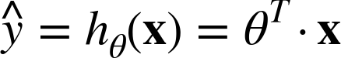

* *θ* is the model’s *parameter vector*, containing the bias term *θ*0 and the feature weights *θ*1 to *θ*n.
* *θT* is the transpose of *θ* (a row vector instead of a column vector).
* **x** is the instance’s *feature vector*, containing *x*0 to *xn*, with *x*0 always equal to 1.
* *θT* · **x** is the dot product of *θT* and **x**.
* *hθ* is the hypothesis function, using the model parameters *θ*.

Okay, that’s the Linear Regression model, so now how do we train it? Well, recall that training a model means setting its parameters so that the model best fits the training set. For this purpose, we first need a measure of how well (or poorly) the model fits the training data. In [Chapter 2](https://www.safaribooksonline.com/library/view/hands-on-machine-learning/9781491962282/ch02.html#project_chapter) we saw that the most common performance measure of a regression model is the Root Mean Square Error (RMSE) ([Equation 2-1](https://www.safaribooksonline.com/library/view/hands-on-machine-learning/9781491962282/ch02.html#rmse_equation)). Therefore, to train a Linear Regression model, you need to find the value of *θ* that minimizes the RMSE. In practice, it is simpler to minimize the Mean Square Error (MSE) than the RMSE, and it leads to the same result (because the value that minimizes a function also minimizes its square root).[1](https://www.safaribooksonline.com/library/view/hands-on-machine-learning/9781491962282/ch04.html#idm140583015469376)

The MSE of a Linear Regression hypothesis *hθ* on a training set **X** is calculated using [Equation 4-3](https://www.safaribooksonline.com/library/view/hands-on-machine-learning/9781491962282/ch04.html#mse_cost_function).

*Equation 4-3. MSE cost function for a Linear Regression model*

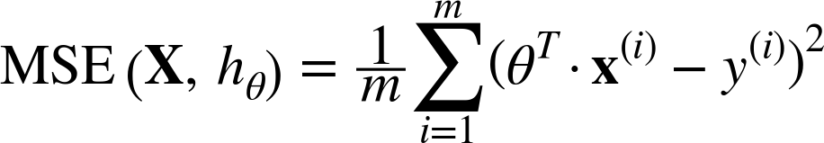

Most of these notations were presented in [Chapter 2](https://www.safaribooksonline.com/library/view/hands-on-machine-learning/9781491962282/ch02.html#project_chapter) (see [“Notations”](https://www.safaribooksonline.com/library/view/hands-on-machine-learning/9781491962282/ch02.html#notations)). The only difference is that we write *hθ*instead of just *h* in order to make it clear that the model is parametrized by the vector *θ*. To simplify notations, we will just write MSE(*θ*) instead of MSE(**X**, *hθ*).

**The Normal Equation**

To find the value of *θ* that minimizes the cost function, there is a *closed-form solution*—in other words, a mathematical equation that gives the result directly. This is called the *Normal Equation* ([Equation 4-4](https://www.safaribooksonline.com/library/view/hands-on-machine-learning/9781491962282/ch04.html#equation_four_four)).[2](https://www.safaribooksonline.com/library/view/hands-on-machine-learning/9781491962282/ch04.html#idm140583015450496)

*Equation 4-4. Normal Equation*

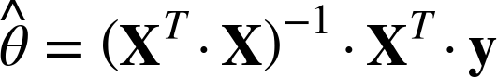

*  is the value of  that minimizes the cost function.
* **y** is the vector of target values containing *y*(1) to *y*(*m*).

Let’s generate some linear-looking data to test this equation on ([Figure 4-1](https://www.safaribooksonline.com/library/view/hands-on-machine-learning/9781491962282/ch04.html#randomly_generated_linear_dataset)):

**import** **numpy** **as** **np**

X = 2 * np.random.rand(100, 1)

y = 4 + 3 * X + np.random.randn(100, 1)

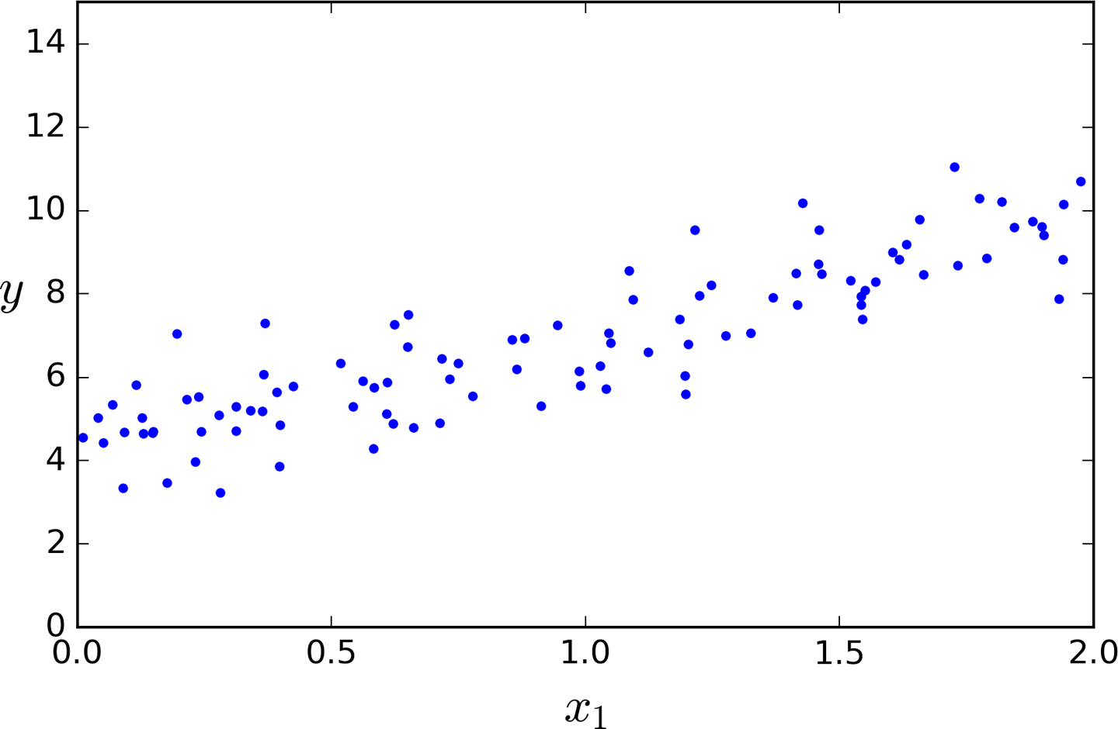

*Figure 4-1. Randomly generated linear dataset*

Now let’s compute  using the Normal Equation. We will use the inv() function from NumPy’s Linear Algebra module (np.linalg) to compute the inverse of a matrix, and the dot() method for matrix multiplication:

X_b = np.c_[np.ones((100, 1)), X] *# add x0 = 1 to each instance*

theta_best = np.linalg.inv(X_b.T.dot(X_b)).dot(X_b.T).dot(y)

The actual function that we used to generate the data is *y* = 4 + 3*x*1 + Gaussian noise. Let’s see what the equation found:

**>>>** theta_best

array([[ 4.21509616],

[ 2.77011339]])

We would have hoped for *θ*0 = 4 and *θ*1 = 3 instead of *θ*0 = 4.215 and *θ*1 = 2.770. Close enough, but the noise made it impossible to recover the exact parameters of the original function.

Now you can make predictions using :

**>>>** X_new = np.array([[0], [2]])

**>>>** X_new_b = np.c_[np.ones((2, 1)), X_new] *# add x0 = 1 to each instance*

**>>>** y_predict = X_new_b.dot(theta_best)

**>>>** y_predict

array([[ 4.21509616],

[ 9.75532293]])

Let’s plot this model’s predictions ([Figure 4-2](https://www.safaribooksonline.com/library/view/hands-on-machine-learning/9781491962282/ch04.html#linear_regression_model_predictions)):

plt.plot(X_new, y_predict, "r-")

plt.plot(X, y, "b.")

plt.axis([0, 2, 0, 15])

plt.show()

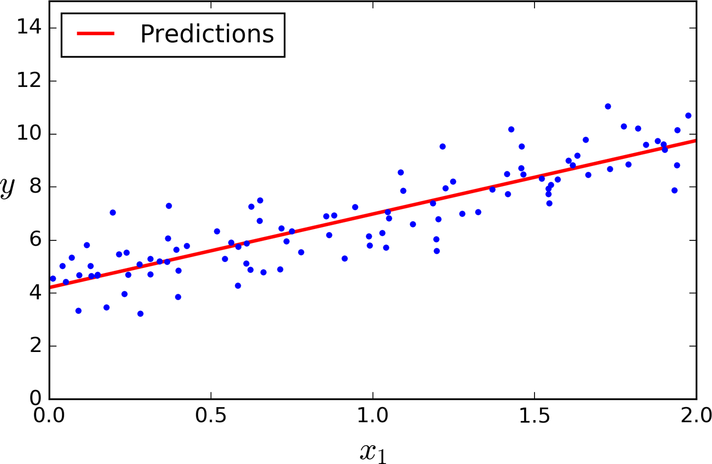

*Figure 4-2. Linear Regression model predictions*

The equivalent code using Scikit-Learn looks like this:[3](https://www.safaribooksonline.com/library/view/hands-on-machine-learning/9781491962282/ch04.html#idm140583015070064)

**>>> from** **sklearn.linear_model** **import** LinearRegression

**>>>** lin_reg = LinearRegression()

**>>>** lin_reg.fit(X, y)

**>>>** lin_reg.intercept_, lin_reg.coef_

(array([ 4.21509616]), array([[ 2.77011339]]))

**>>>** lin_reg.predict(X_new)

array([[ 4.21509616],

[ 9.75532293]])

**Computational Complexity**

The Normal Equation computes the inverse of **X***T* · **X**, which is an *n* × *n* matrix (where *n* is the number of features). The *computational complexity* of inverting such a matrix is typically about *O*(*n*2.4) to *O*(*n*3) (depending on the implementation). In other words, if you double the number of features, you multiply the computation time by roughly 22.4 = 5.3 to 23 = 8.

**WARNING**

The Normal Equation gets very slow when the number of features grows large (e.g., 100,000).

On the positive side, this equation is linear with regards to the number of instances in the training set (it is *O*(*m*)), so it handles large training sets efficiently, provided they can fit in memory.

Also, once you have trained your Linear Regression model (using the Normal Equation or any other algorithm), predictions are very fast: the computational complexity is linear with regards to both the number of instances you want to make predictions on and the number of features. In other words, making predictions on twice as many instances (or twice as many features) will just take roughly twice as much time.

Now we will look at very different ways to train a Linear Regression model, better suited for cases where there are a large number of features, or too many training instances to fit in memory.

**Gradient Descent**

*Gradient Descent* is a very generic optimization algorithm capable of finding optimal solutions to a wide range of problems. The general idea of Gradient Descent is to tweak parameters iteratively in order to minimize a cost function.

Suppose you are lost in the mountains in a dense fog; you can only feel the slope of the ground below your feet. A good strategy to get to the bottom of the valley quickly is to go downhill in the direction of the steepest slope. This is exactly what Gradient Descent does: it measures the local gradient of the error function with regards to the parameter vector *θ*, and it goes in the direction of descending gradient. Once the gradient is zero, you have reached a minimum!

Concretely, you start by filling *θ* with random values (this is called *random initialization*), and then you improve it gradually, taking one baby step at a time, each step attempting to decrease the cost function (e.g., the MSE), until the algorithm *converges* to a minimum (see [Figure 4-3](https://www.safaribooksonline.com/library/view/hands-on-machine-learning/9781491962282/ch04.html#gradient_descent_diagram)).

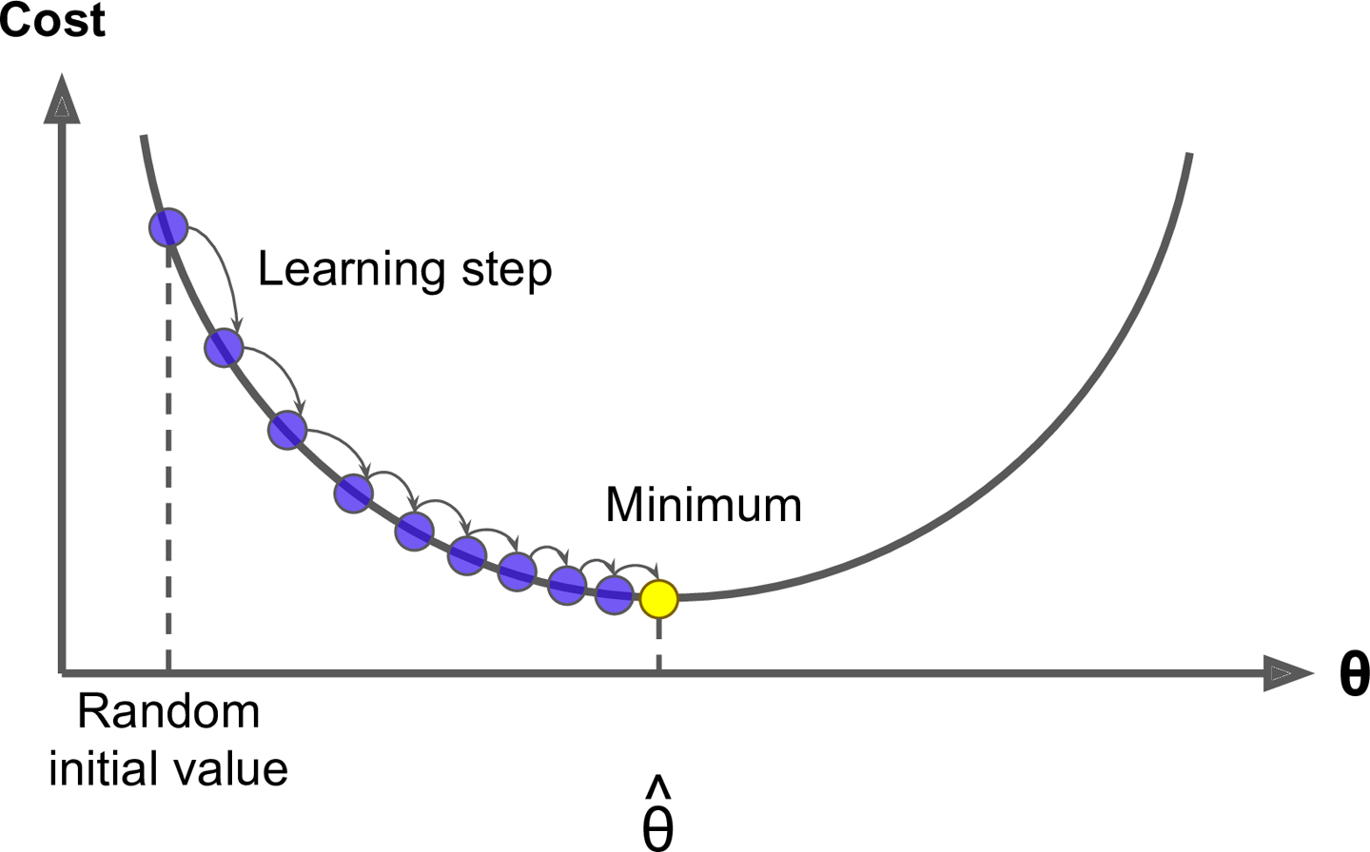

*Figure 4-3. Gradient Descent*

An important parameter in Gradient Descent is the size of the steps, determined by the *learning rate*hyperparameter. If the learning rate is too small, then the algorithm will have to go through many iterations to converge, which will take a long time (see [Figure 4-4](https://www.safaribooksonline.com/library/view/hands-on-machine-learning/9781491962282/ch04.html#small_learning_rate_diagram)).

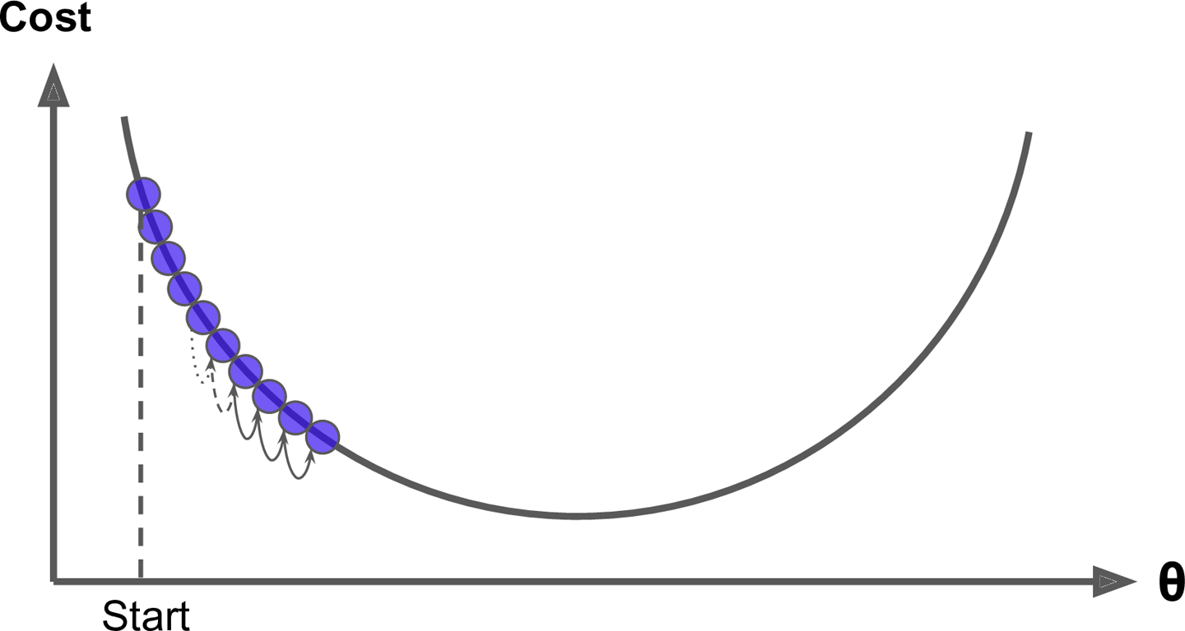

*Figure 4-4. Learning rate too small*

On the other hand, if the learning rate is too high, you might jump across the valley and end up on the other side, possibly even higher up than you were before. This might make the algorithm diverge, with larger and larger values, failing to find a good solution (see [Figure 4-5](https://www.safaribooksonline.com/library/view/hands-on-machine-learning/9781491962282/ch04.html#large_learning_rate_diagram)).

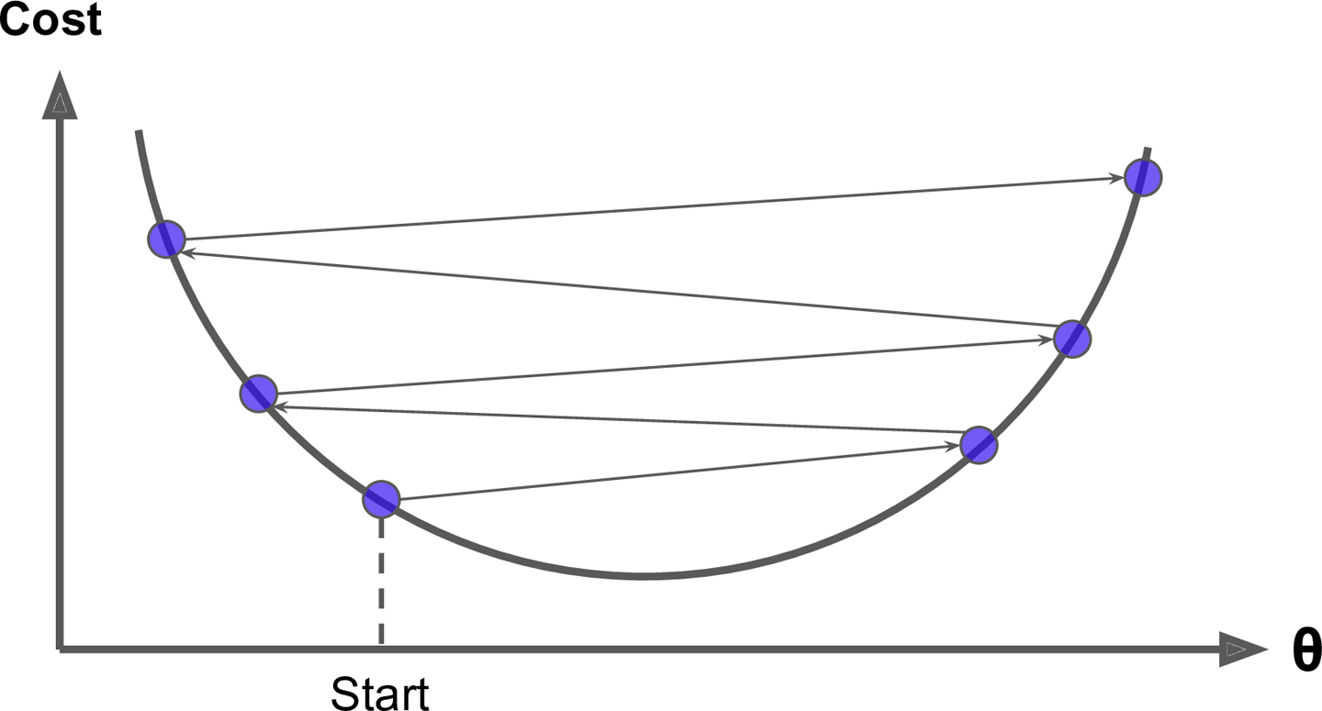

*Figure 4-5. Learning rate too large*

Finally, not all cost functions look like nice regular bowls. There may be holes, ridges, plateaus, and all sorts of irregular terrains, making convergence to the minimum very difficult. [Figure 4-6](https://www.safaribooksonline.com/library/view/hands-on-machine-learning/9781491962282/ch04.html#gradient_descent_pitfalls_diagram) shows the two main challenges with Gradient Descent: if the random initialization starts the algorithm on the left, then it will converge to a *local minimum*, which is not as good as the *global minimum*. If it starts on the right, then it will take a very long time to cross the plateau, and if you stop too early you will never reach the global minimum.

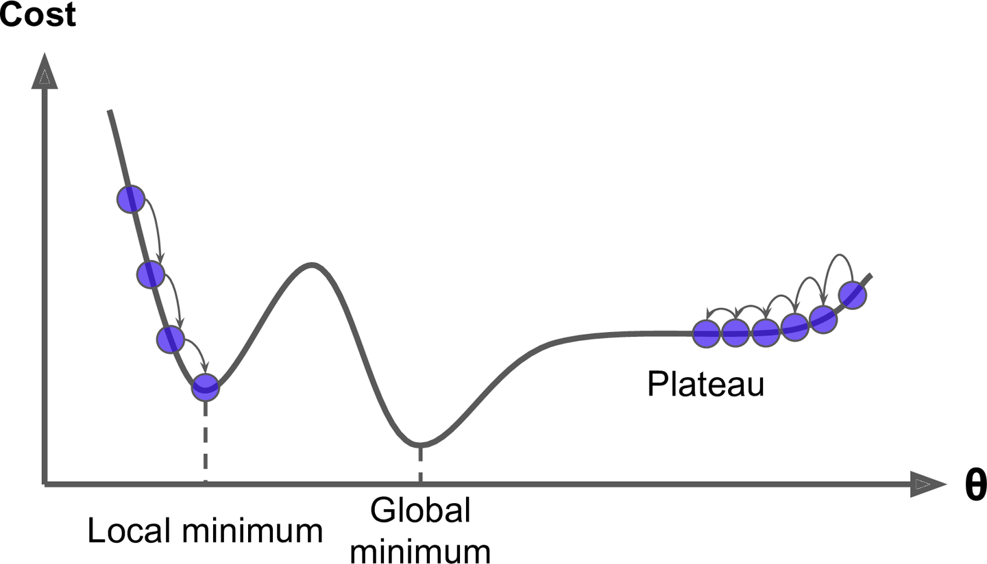

*Figure 4-6. Gradient Descent pitfalls*

Fortunately, the MSE cost function for a Linear Regression model happens to be a *convex function*, which means that if you pick any two points on the curve, the line segment joining them never crosses the curve. This implies that there are no local minima, just one global minimum. It is also a continuous function with a slope that never changes abruptly.[4](https://www.safaribooksonline.com/library/view/hands-on-machine-learning/9781491962282/ch04.html#idm140583015175824) These two facts have a great consequence: Gradient Descent is guaranteed to approach arbitrarily close the global minimum (if you wait long enough and if the learning rate is not too high).

In fact, the cost function has the shape of a bowl, but it can be an elongated bowl if the features have very different scales. [Figure 4-7](https://www.safaribooksonline.com/library/view/hands-on-machine-learning/9781491962282/ch04.html#elongated_bowl_diagram) shows Gradient Descent on a training set where features 1 and 2 have the same scale (on the left), and on a training set where feature 1 has much smaller values than feature 2 (on the right).[5](https://www.safaribooksonline.com/library/view/hands-on-machine-learning/9781491962282/ch04.html#idm140583015172240)

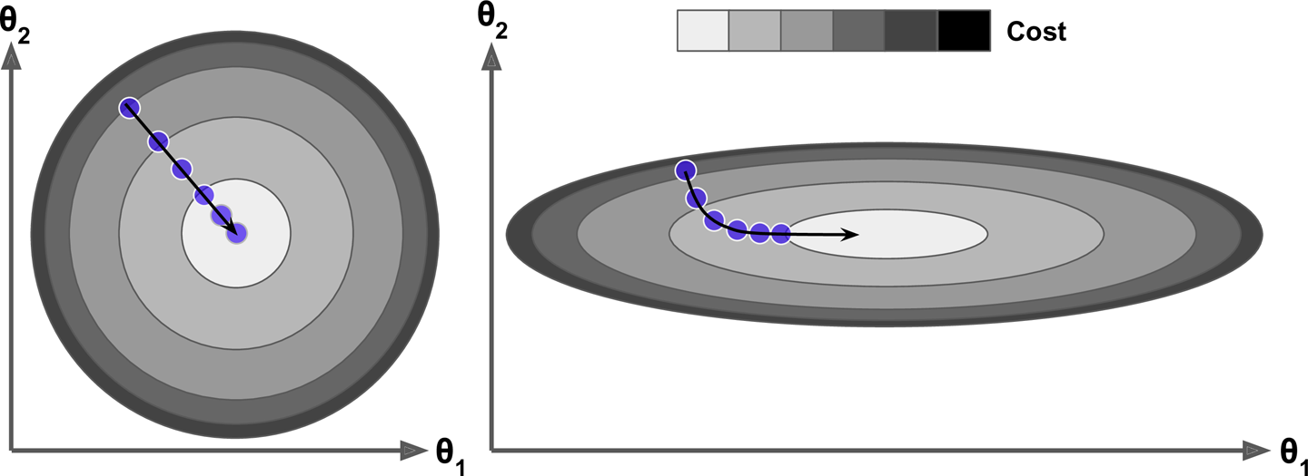

*Figure 4-7. Gradient Descent with and without feature scaling*

As you can see, on the left the Gradient Descent algorithm goes straight toward the minimum, thereby reaching it quickly, whereas on the right it first goes in a direction almost orthogonal to the direction of the global minimum, and it ends with a long march down an almost flat valley. It will eventually reach the minimum, but it will take a long time.

**WARNING**

When using Gradient Descent, you should ensure that all features have a similar scale (e.g., using Scikit-Learn’s StandardScaler class), or else it will take much longer to converge.

This diagram also illustrates the fact that training a model means searching for a combination of model parameters that minimizes a cost function (over the training set). It is a search in the model’s *parameter space*: the more parameters a model has, the more dimensions this space has, and the harder the search is: searching for a needle in a 300-dimensional haystack is much trickier than in three dimensions. Fortunately, since the cost function is convex in the case of Linear Regression, the needle is simply at the bottom of the bowl.

**Batch Gradient Descent**

To implement Gradient Descent, you need to compute the gradient of the cost function with regards to each model parameter *θj*. In other words, you need to calculate how much the cost function will change if you change *θj* just a little bit. This is called a *partial derivative*. It is like asking “what is the slope of the mountain under my feet if I face east?” and then asking the same question facing north (and so on for all other dimensions, if you can imagine a universe with more than three dimensions). [Equation 4-5](https://www.safaribooksonline.com/library/view/hands-on-machine-learning/9781491962282/ch04.html#mse_partial_derivatives) computes the partial derivative of the cost function with regards to parameter *θj*, noted .

*Equation 4-5. Partial derivatives of the cost function*

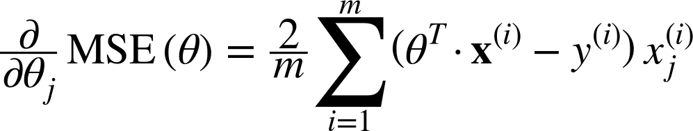

Instead of computing these partial derivatives individually, you can use [Equation 4-6](https://www.safaribooksonline.com/library/view/hands-on-machine-learning/9781491962282/ch04.html#mse_gradient_vector) to compute them all in one go. The gradient vector, noted ∇*θ*MSE(*θ*), contains all the partial derivatives of the cost function (one for each model parameter).

*Equation 4-6. Gradient vector of the cost function*

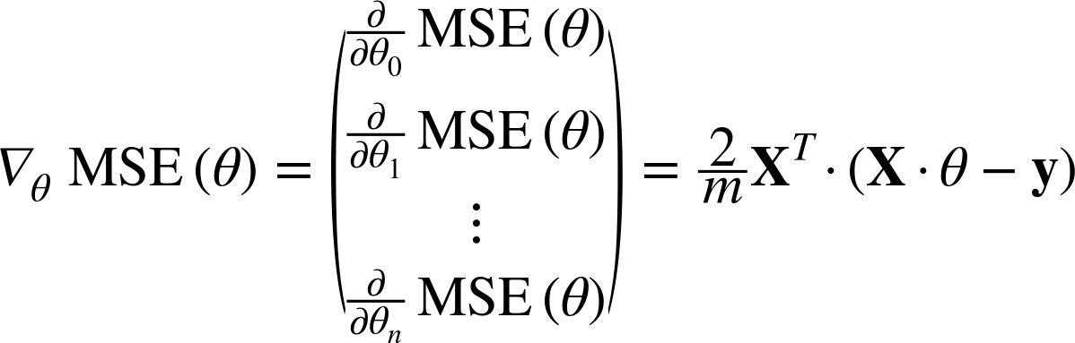

**WARNING**

Notice that this formula involves calculations over the full training set **X**, at each Gradient Descent step! This is why the algorithm is called *Batch Gradient Descent*: it uses the whole batch of training data at every step. As a result it is terribly slow on very large training sets (but we will see much faster Gradient Descent algorithms shortly). However, Gradient Descent scales well with the number of features; training a Linear Regression model when there are hundreds of thousands of features is much faster using Gradient Descent than using the Normal Equation.

Once you have the gradient vector, which points uphill, just go in the opposite direction to go downhill. This means subtracting ∇*θ*MSE(*θ*) from *θ*. This is where the learning rate *η* comes into play:[6](https://www.safaribooksonline.com/library/view/hands-on-machine-learning/9781491962282/ch04.html#idm140583015137072) multiply the gradient vector by *η* to determine the size of the downhill step ([Equation 4-7](https://www.safaribooksonline.com/library/view/hands-on-machine-learning/9781491962282/ch04.html#gradient_descent_step)).

*Equation 4-7. Gradient Descent step*

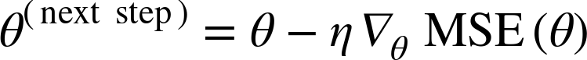

Let’s look at a quick implementation of this algorithm:

eta = 0.1 *# learning rate*

n_iterations = 1000

m = 100

theta = np.random.randn(2,1) *# random initialization*

**for** iteration **in** range(n_iterations):

gradients = 2/m * X_b.T.dot(X_b.dot(theta) - y)

theta = theta - eta * gradients

That wasn’t too hard! Let’s look at the resulting theta:

**>>>** theta

array([[ 4.21509616],

[ 2.77011339]])

Hey, that’s exactly what the Normal Equation found! Gradient Descent worked perfectly. But what if you had used a different learning rate eta? [Figure 4-8](https://www.safaribooksonline.com/library/view/hands-on-machine-learning/9781491962282/ch04.html#gradient_descent_plot) shows the first 10 steps of Gradient Descent using three different learning rates (the dashed line represents the starting point).

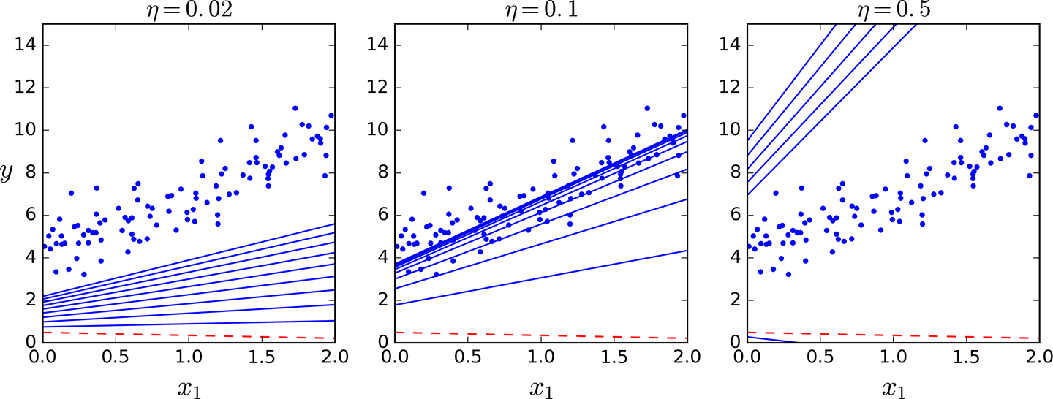

*Figure 4-8. Gradient Descent with various learning rates*

On the left, the learning rate is too low: the algorithm will eventually reach the solution, but it will take a long time. In the middle, the learning rate looks pretty good: in just a few iterations, it has already converged to the solution. On the right, the learning rate is too high: the algorithm diverges, jumping all over the place and actually getting further and further away from the solution at every step.

To find a good learning rate, you can use grid search (see [Chapter 2](https://www.safaribooksonline.com/library/view/hands-on-machine-learning/9781491962282/ch02.html#project_chapter)). However, you may want to limit the number of iterations so that grid search can eliminate models that take too long to converge.

You may wonder how to set the number of iterations. If it is too low, you will still be far away from the optimal solution when the algorithm stops, but if it is too high, you will waste time while the model parameters do not change anymore. A simple solution is to set a very large number of iterations but to interrupt the algorithm when the gradient vector becomes tiny—that is, when its norm becomes smaller than a tiny number *ϵ* (called the *tolerance*)—because this happens when Gradient Descent has (almost) reached the minimum.

**CONVERGENCE RATE**

When the cost function is convex and its slope does not change abruptly (as is the case for the MSE cost function), Batch Gradient Descent with a fixed learning rate will eventually converge to the optimal solution, but you may have to wait a while: it can take O(1/*ϵ*) iterations to reach the optimum within a range of *ϵ*depending on the shape of the cost function. If you divide the tolerance by 10 to have a more precise solution, then the algorithm will have to run about 10 times longer.

**Stochastic Gradient Descent**

The main problem with Batch Gradient Descent is the fact that it uses the whole training set to compute the gradients at every step, which makes it very slow when the training set is large. At the opposite extreme, *Stochastic Gradient Descent* just picks a random instance in the training set at every step and computes the gradients based only on that single instance. Obviously this makes the algorithm much faster since it has very little data to manipulate at every iteration. It also makes it possible to train on huge training sets, since only one instance needs to be in memory at each iteration (SGD can be implemented as an out-of-core algorithm.[7](https://www.safaribooksonline.com/library/view/hands-on-machine-learning/9781491962282/ch04.html#idm140583014883200))

On the other hand, due to its stochastic (i.e., random) nature, this algorithm is much less regular than Batch Gradient Descent: instead of gently decreasing until it reaches the minimum, the cost function will bounce up and down, decreasing only on average. Over time it will end up very close to the minimum, but once it gets there it will continue to bounce around, never settling down (see [Figure 4-9](https://www.safaribooksonline.com/library/view/hands-on-machine-learning/9781491962282/ch04.html#sgd_random_walk_diagram)). So once the algorithm stops, the final parameter values are good, but not optimal.

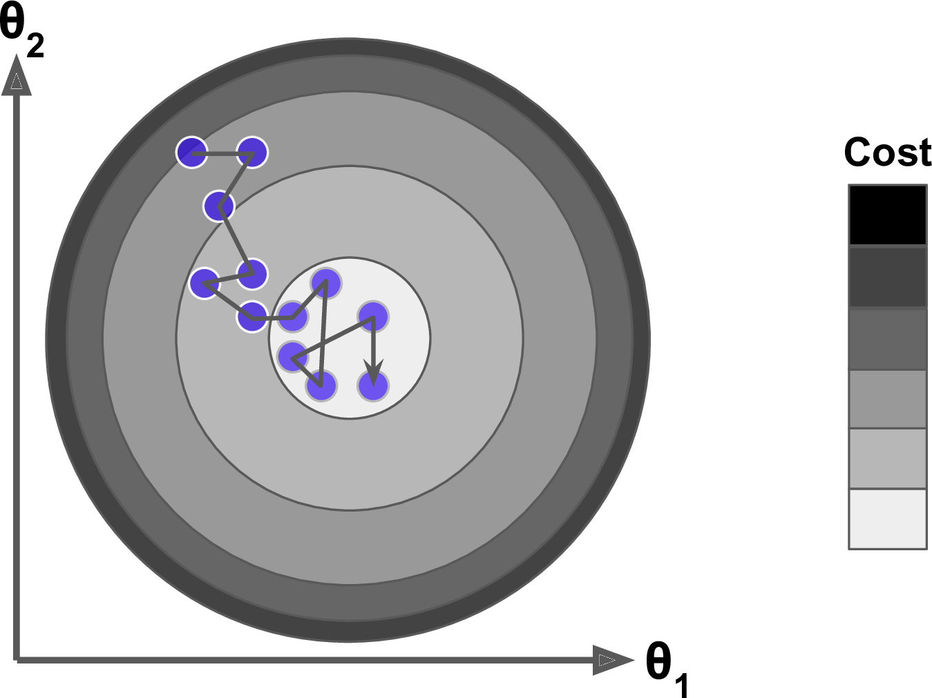

*Figure 4-9. Stochastic Gradient Descent*

When the cost function is very irregular (as in [Figure 4-6](https://www.safaribooksonline.com/library/view/hands-on-machine-learning/9781491962282/ch04.html#gradient_descent_pitfalls_diagram)), this can actually help the algorithm jump out of local minima, so Stochastic Gradient Descent has a better chance of finding the global minimum than Batch Gradient Descent does.

Therefore randomness is good to escape from local optima, but bad because it means that the algorithm can never settle at the minimum. One solution to this dilemma is to gradually reduce the learning rate. The steps start out large (which helps make quick progress and escape local minima), then get smaller and smaller, allowing the algorithm to settle at the global minimum. This process is called *simulated annealing*, because it resembles the process of annealing in metallurgy where molten metal is slowly cooled down. The function that determines the learning rate at each iteration is called the *learning schedule*. If the learning rate is reduced too quickly, you may get stuck in a local minimum, or even end up frozen halfway to the minimum. If the learning rate is reduced too slowly, you may jump around the minimum for a long time and end up with a suboptimal solution if you halt training too early.

This code implements Stochastic Gradient Descent using a simple learning schedule:

n_epochs = 50

t0, t1 = 5, 50 *# learning schedule hyperparameters*

**def** learning_schedule(t):

**return** t0 / (t + t1)

theta = np.random.randn(2,1) *# random initialization*

**for** epoch **in** range(n_epochs):

**for** i **in** range(m):

random_index = np.random.randint(m)

xi = X_b[random_index:random_index+1]

yi = y[random_index:random_index+1]

gradients = 2 * xi.T.dot(xi.dot(theta) - yi)

eta = learning_schedule(epoch * m + i)

theta = theta - eta * gradients

By convention we iterate by rounds of *m* iterations; each round is called an *epoch*. While the Batch Gradient Descent code iterated 1,000 times through the whole training set, this code goes through the training set only 50 times and reaches a fairly good solution:

**>>>** theta

array([[ 4.21076011],

[ 2.74856079]])

[Figure 4-10](https://www.safaribooksonline.com/library/view/hands-on-machine-learning/9781491962282/ch04.html#sgd_plot) shows the first 10 steps of training (notice how irregular the steps are).

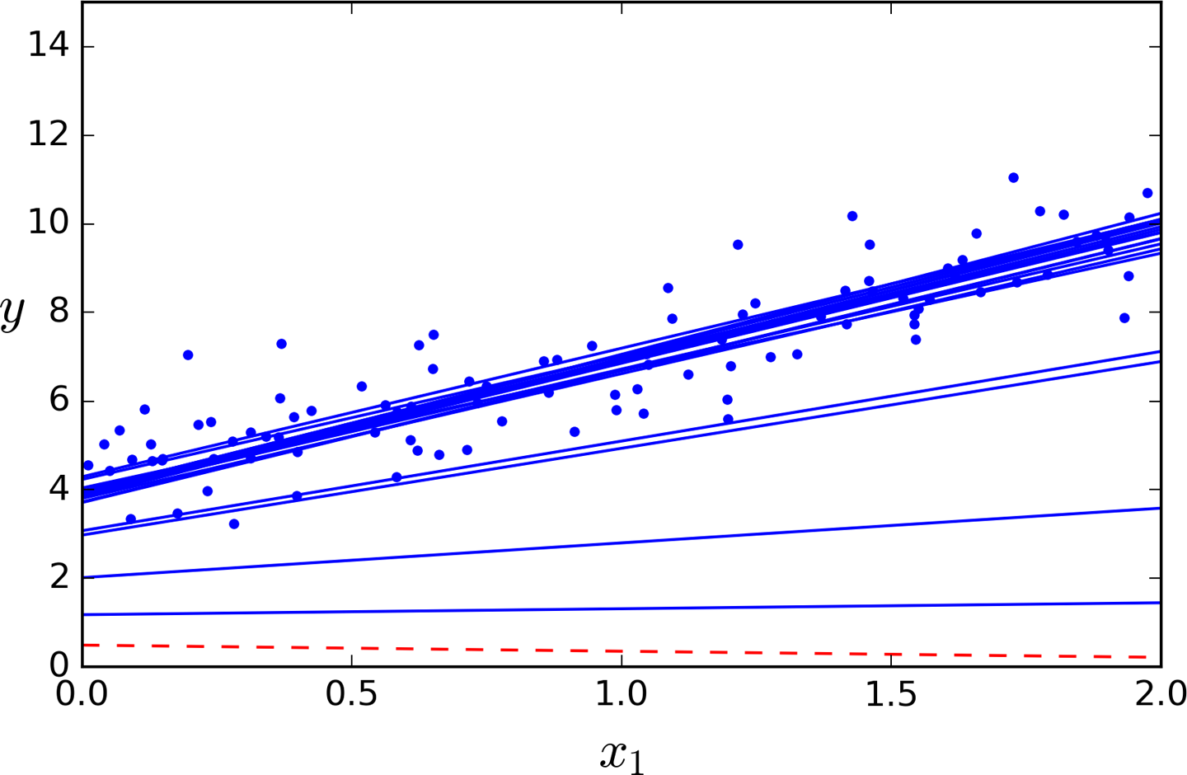

*Figure 4-10. Stochastic Gradient Descent first 10 steps*

Note that since instances are picked randomly, some instances may be picked several times per epoch while others may not be picked at all. If you want to be sure that the algorithm goes through every instance at each epoch, another approach is to shuffle the training set, then go through it instance by instance, then shuffle it again, and so on. However, this generally converges more slowly.

To perform Linear Regression using SGD with Scikit-Learn, you can use the SGDRegressor class, which defaults to optimizing the squared error cost function. The following code runs 50 epochs, starting with a learning rate of 0.1 (eta0=0.1), using the default learning schedule (different from the preceding one), and it does not use any regularization (penalty=None; more details on this shortly):

**from** **sklearn.linear_model** **import** SGDRegressor

sgd_reg = SGDRegressor(n_iter=50, penalty=None, eta0=0.1)

sgd_reg.fit(X, y.ravel())

Once again, you find a solution very close to the one returned by the Normal Equation:

**>>>** sgd_reg.intercept_, sgd_reg.coef_

(array([ 4.16782089]), array([ 2.72603052]))

**Mini-batch Gradient Descent**

The last Gradient Descent algorithm we will look at is called *Mini-batch Gradient Descent*. It is quite simple to understand once you know Batch and Stochastic Gradient Descent: at each step, instead of computing the gradients based on the full training set (as in Batch GD) or based on just one instance (as in Stochastic GD), Mini-batch GD computes the gradients on small random sets of instances called *mini-batches*. The main advantage of Mini-batch GD over Stochastic GD is that you can get a performance boost from hardware optimization of matrix operations, especially when using GPUs.

The algorithm’s progress in parameter space is less erratic than with SGD, especially with fairly large mini-batches. As a result, Mini-batch GD will end up walking around a bit closer to the minimum than SGD. But, on the other hand, it may be harder for it to escape from local minima (in the case of problems that suffer from local minima, unlike Linear Regression as we saw earlier). [Figure 4-11](https://www.safaribooksonline.com/library/view/hands-on-machine-learning/9781491962282/ch04.html#gradient_descent_paths_plot) shows the paths taken by the three Gradient Descent algorithms in parameter space during training. They all end up near the minimum, but Batch GD’s path actually stops at the minimum, while both Stochastic GD and Mini-batch GD continue to walk around. However, don’t forget that Batch GD takes a lot of time to take each step, and Stochastic GD and Mini-batch GD would also reach the minimum if you used a good learning schedule.

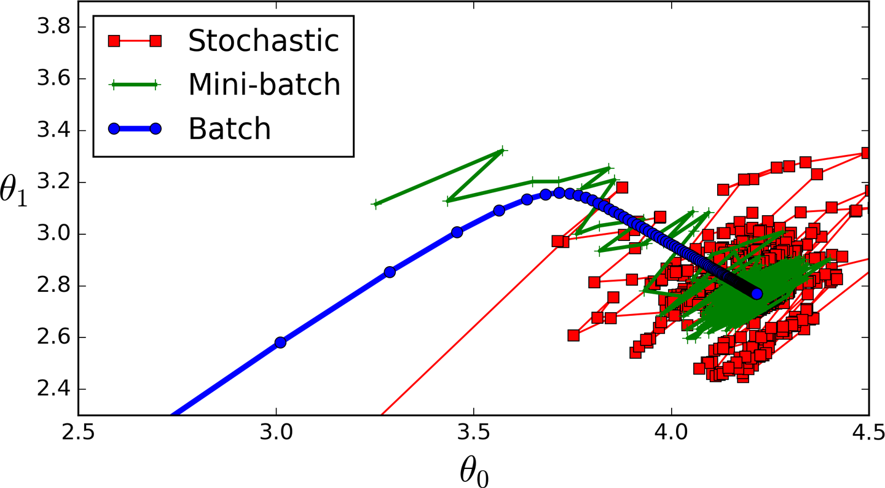

*Figure 4-11. Gradient Descent paths in parameter space*

Let’s compare the algorithms we’ve discussed so far for Linear Regression[8](https://www.safaribooksonline.com/library/view/hands-on-machine-learning/9781491962282/ch04.html#idm140583014635472) (recall that *m* is the number of training instances and *n* is the number of features); see [Table 4-1](https://www.safaribooksonline.com/library/view/hands-on-machine-learning/9781491962282/ch04.html#linear_regression_algorithm_comparison).

| **Algorithm** | **Large *m*** | **Out-of-core support** | **Large *n*** | **Hyperparams** | **Scaling required** | **Scikit-Learn** |
| --- | --- | --- | --- | --- | --- | --- |
| Normal Equation | Fast | No | Slow | 0 | No | LinearRegression |
| Batch GD | Slow | No | Fast | 2 | Yes | n/a |
| Stochastic GD | Fast | Yes | Fast | ≥2 | Yes | SGDRegressor |
| Mini-batch GD | Fast | Yes | Fast | ≥2 | Yes | SGDRegressor |
| *Table 4-1. Comparison of algorithms for Linear Regression* | | | | | | |

**NOTE**

There is almost no difference after training: all these algorithms end up with very similar models and make predictions in exactly the same way.

**Polynomial Regression**

What if your data is actually more complex than a simple straight line? Surprisingly, you can actually use a linear model to fit nonlinear data. A simple way to do this is to add powers of each feature as new features, then train a linear model on this extended set of features. This technique is called *Polynomial Regression*.

Let’s look at an example. First, let’s generate some nonlinear data, based on a simple *quadratic equation*[9](https://www.safaribooksonline.com/library/view/hands-on-machine-learning/9781491962282/ch04.html#idm140583014666720) (plus some noise; see [Figure 4-12](https://www.safaribooksonline.com/library/view/hands-on-machine-learning/9781491962282/ch04.html#generated_nonlinear_and_noisy_dataset)):

m = 100

X = 6 * np.random.rand(m, 1) - 3

y = 0.5 * X**2 + X + 2 + np.random.randn(m, 1)

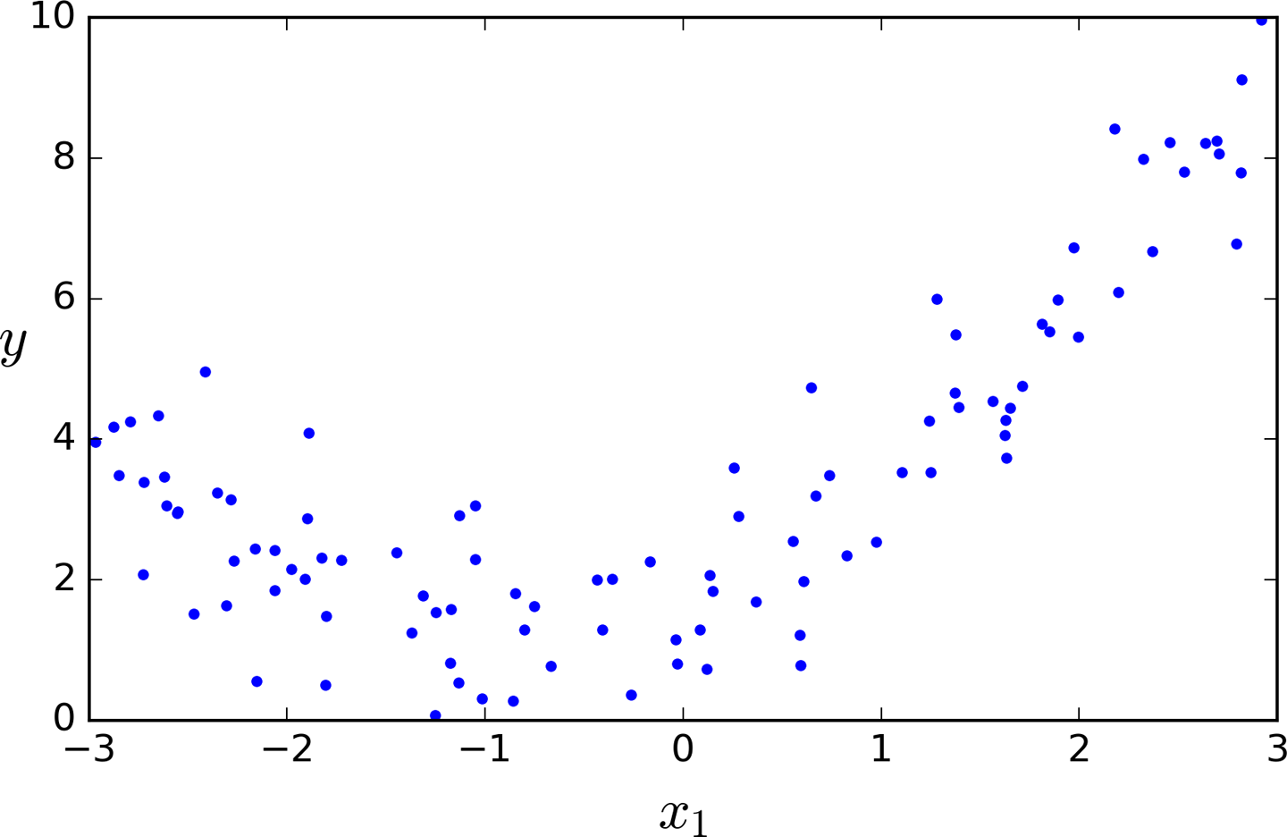

*Figure 4-12. Generated nonlinear and noisy dataset*

Clearly, a straight line will never fit this data properly. So let’s use Scikit-Learn’s PolynomialFeatures class to transform our training data, adding the square (2nd-degree polynomial) of each feature in the training set as new features (in this case there is just one feature):

**>>> from** **sklearn.preprocessing** **import** PolynomialFeatures

**>>>** poly_features = PolynomialFeatures(degree=2, include_bias=False)

**>>>** X_poly = poly_features.fit_transform(X)

**>>>** X[0]

array([-0.75275929])

**>>>** X_poly[0]

array([-0.75275929, 0.56664654])

X_poly now contains the original feature of X plus the square of this feature. Now you can fit a LinearRegression model to this extended training data ([Figure 4-13](https://www.safaribooksonline.com/library/view/hands-on-machine-learning/9781491962282/ch04.html#polynomial_regression_model_predictions)):

**>>>** lin_reg = LinearRegression()

**>>>** lin_reg.fit(X_poly, y)

**>>>** lin_reg.intercept_, lin_reg.coef_

(array([ 1.78134581]), array([[ 0.93366893, 0.56456263]]))

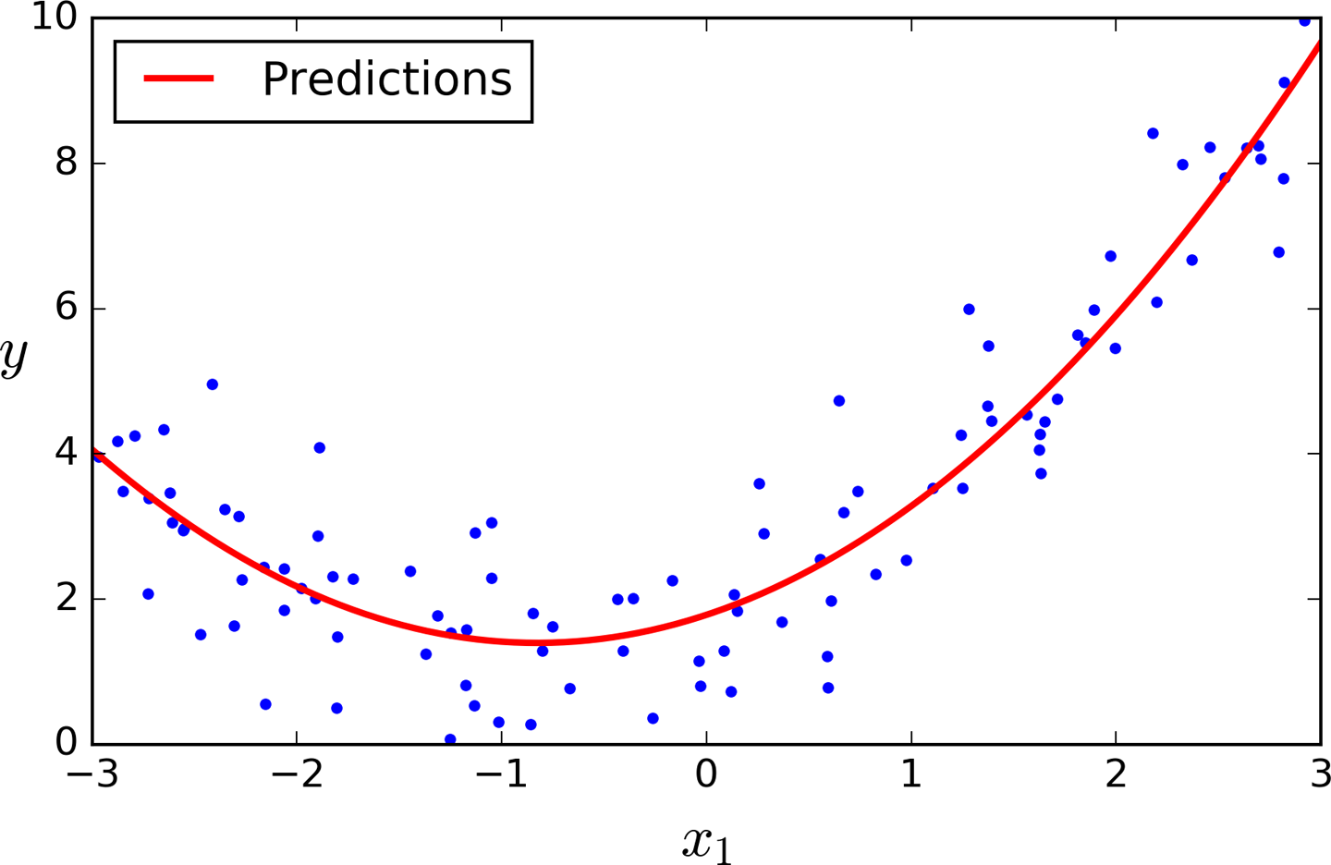

*Figure 4-13. Polynomial Regression model predictions*

Not bad: the model estimates  when in fact the original function was .

Note that when there are multiple features, Polynomial Regression is capable of finding relationships between features (which is something a plain Linear Regression model cannot do). This is made possible by the fact that PolynomialFeatures also adds all combinations of features up to the given degree. For example, if there were two features *a* and *b*, PolynomialFeatures with degree=3 would not only add the features *a*2, *a*3, *b*2, and *b*3, but also the combinations *ab*, *a*2*b*, and *ab*2.

**WARNING**

PolynomialFeatures(degree=d) transforms an array containing *n* features into an array containing  features, where *n*! is the *factorial* of *n*, equal to 1 × 2 × 3 × ⋯ × *n*. Beware of the combinatorial explosion of the number of features!

**Learning Curves**

If you perform high-degree Polynomial Regression, you will likely fit the training data much better than with plain Linear Regression. For example, [Figure 4-14](https://www.safaribooksonline.com/library/view/hands-on-machine-learning/9781491962282/ch04.html#high_degree_polynomials_plot) applies a 300-degree polynomial model to the preceding training data, and compares the result with a pure linear model and a quadratic model (2nd-degree polynomial). Notice how the 300-degree polynomial model wiggles around to get as close as possible to the training instances.

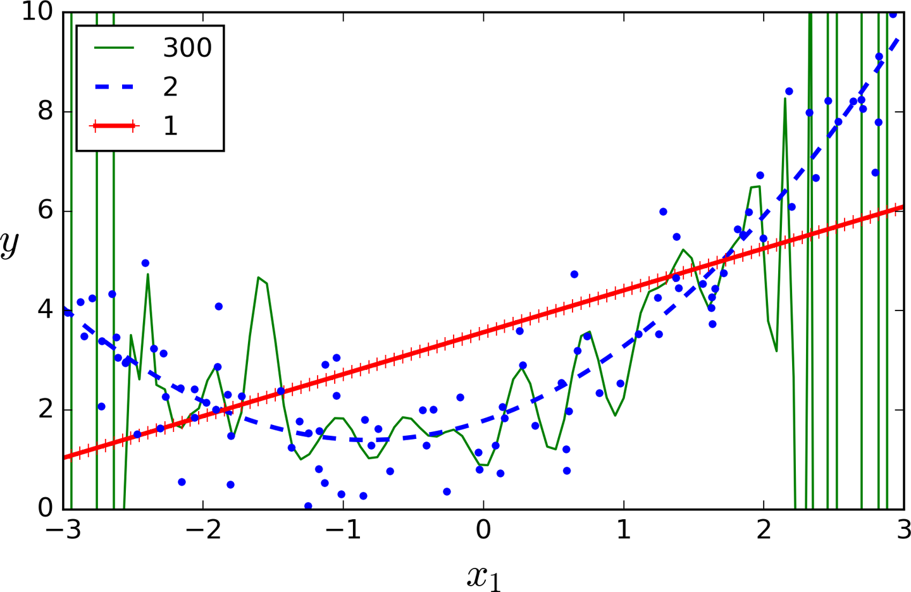

*Figure 4-14. High-degree Polynomial Regression*

Of course, this high-degree Polynomial Regression model is severely overfitting the training data, while the linear model is underfitting it. The model that will generalize best in this case is the quadratic model. It makes sense since the data was generated using a quadratic model, but in general you won’t know what function generated the data, so how can you decide how complex your model should be? How can you tell that your model is overfitting or underfitting the data?

In [Chapter 2](https://www.safaribooksonline.com/library/view/hands-on-machine-learning/9781491962282/ch02.html#project_chapter) you used cross-validation to get an estimate of a model’s generalization performance. If a model performs well on the training data but generalizes poorly according to the cross-validation metrics, then your model is overfitting. If it performs poorly on both, then it is underfitting. This is one way to tell when a model is too simple or too complex.

Another way is to look at the *learning curves*: these are plots of the model’s performance on the training set and the validation set as a function of the training set size (or the training iteration). To generate the plots, simply train the model several times on different sized subsets of the training set. The following code defines a function that plots the learning curves of a model given some training data:

**from** **sklearn.metrics** **import** mean_squared_error

**from** **sklearn.model_selection** **import** train_test_split

**def** plot_learning_curves(model, X, y):

X_train, X_val, y_train, y_val = train_test_split(X, y, test_size=0.2)

train_errors, val_errors = [], []

**for** m **in** range(1, len(X_train)):

model.fit(X_train[:m], y_train[:m])

y_train_predict = model.predict(X_train[:m])

y_val_predict = model.predict(X_val)

train_errors.append(mean_squared_error(y_train_predict, y_train[:m]))

val_errors.append(mean_squared_error(y_val_predict, y_val))

plt.plot(np.sqrt(train_errors), "r-+", linewidth=2, label="train")

plt.plot(np.sqrt(val_errors), "b-", linewidth=3, label="val")

Let’s look at the learning curves of the plain Linear Regression model (a straight line; [Figure 4-15](https://www.safaribooksonline.com/library/view/hands-on-machine-learning/9781491962282/ch04.html#learning_curves)):

lin_reg = LinearRegression()

plot_learning_curves(lin_reg, X, y)

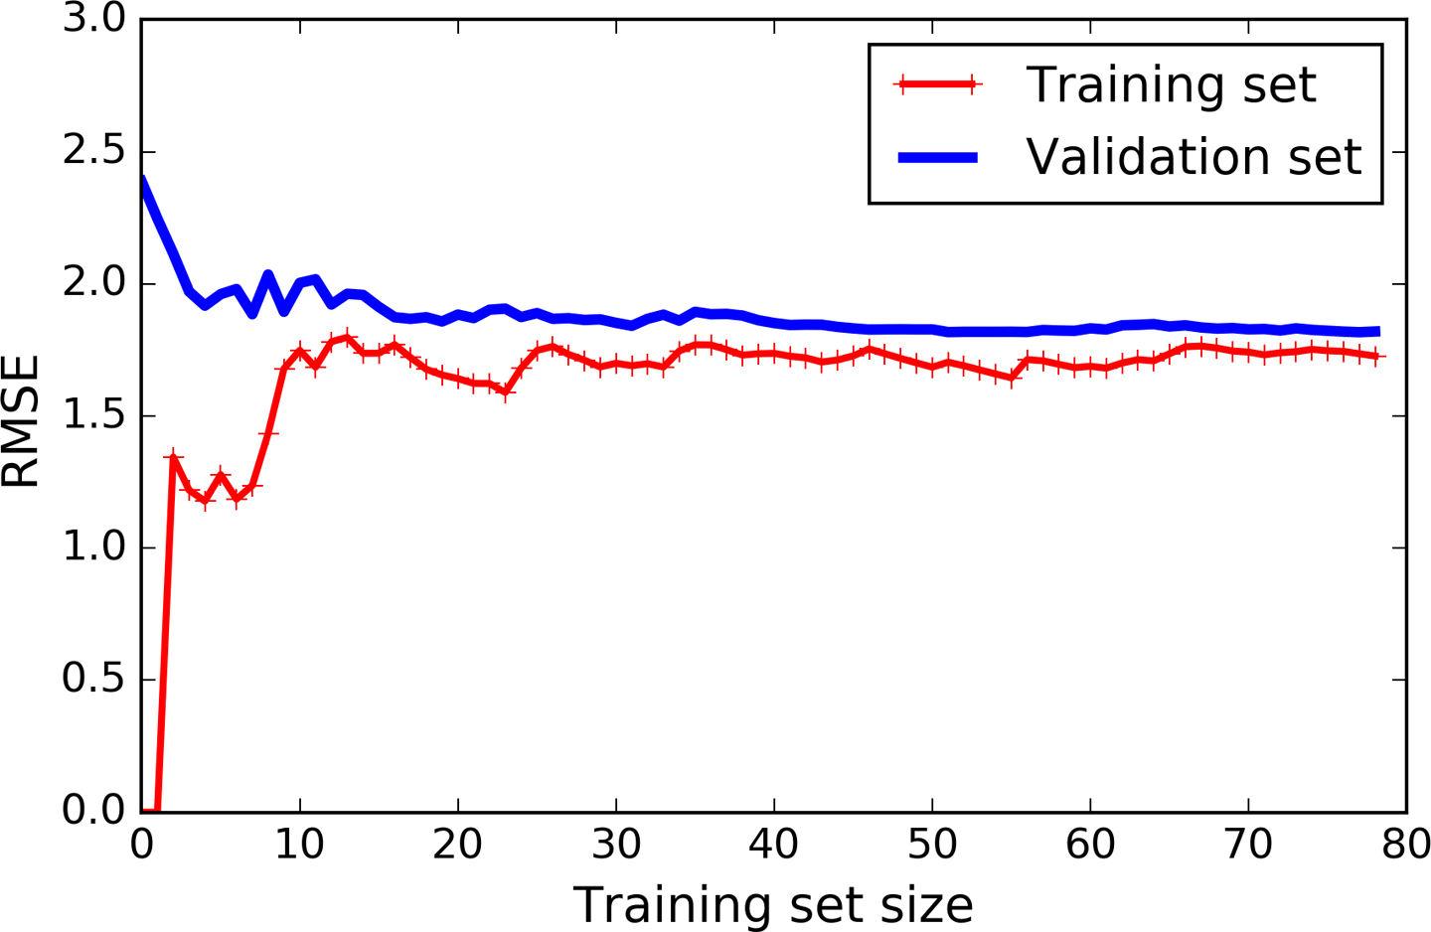

*Figure 4-15. Learning curves*

This deserves a bit of explanation. First, let’s look at the performance on the training data: when there are just one or two instances in the training set, the model can fit them perfectly, which is why the curve starts at zero. But as new instances are added to the training set, it becomes impossible for the model to fit the training data perfectly, both because the data is noisy and because it is not linear at all. So the error on the training data goes up until it reaches a plateau, at which point adding new instances to the training set doesn’t make the average error much better or worse. Now let’s look at the performance of the model on the validation data. When the model is trained on very few training instances, it is incapable of generalizing properly, which is why the validation error is initially quite big. Then as the model is shown more training examples, it learns and thus the validation error slowly goes down. However, once again a straight line cannot do a good job modeling the data, so the error ends up at a plateau, very close to the other curve.

These learning curves are typical of an underfitting model. Both curves have reached a plateau; they are close and fairly high.

**TIP**

If your model is underfitting the training data, adding more training examples will not help. You need to use a more complex model or come up with better features.

Now let’s look at the learning curves of a 10th-degree polynomial model on the same data ([Figure 4-16](https://www.safaribooksonline.com/library/view/hands-on-machine-learning/9781491962282/ch04.html#learning_curves_for_the_polynomial_model)):

**from** **sklearn.pipeline** **import** Pipeline

polynomial_regression = Pipeline([

("poly_features", PolynomialFeatures(degree=10, include_bias=False)),

("lin_reg", LinearRegression()),

])

plot_learning_curves(polynomial_regression, X, y)

These learning curves look a bit like the previous ones, but there are two very important differences:

* The error on the training data is much lower than with the Linear Regression model.
* There is a gap between the curves. This means that the model performs significantly better on the training data than on the validation data, which is the hallmark of an overfitting model. However, if you used a much larger training set, the two curves would continue to get closer.

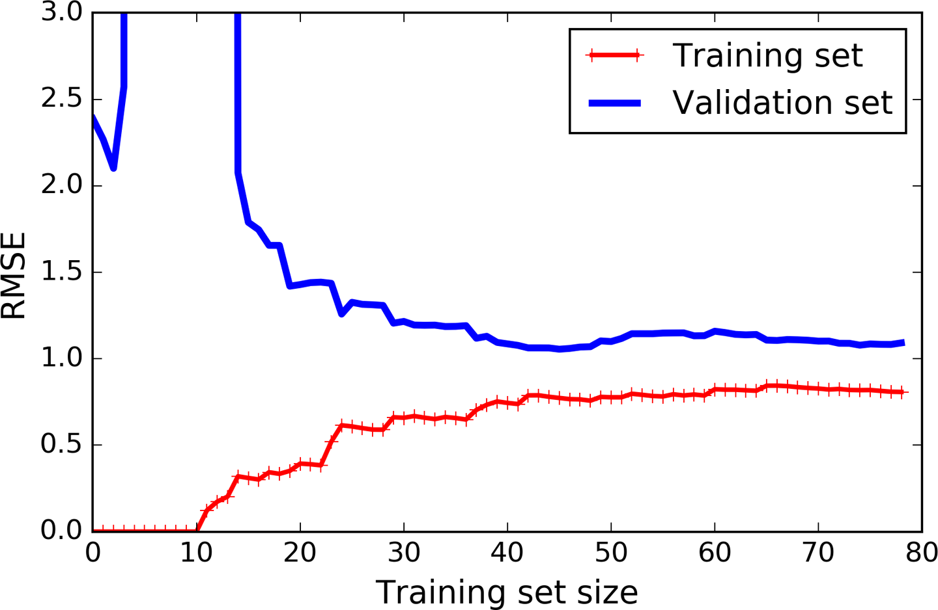

*Figure 4-16. Learning curves for the polynomial model*

**TIP**

One way to improve an overfitting model is to feed it more training data until the validation error reaches the training error.

**THE BIAS/VARIANCE TRADEOFF**

An important theoretical result of statistics and Machine Learning is the fact that a model’s generalization error can be expressed as the sum of three very different errors:

*Bias*

This part of the generalization error is due to wrong assumptions, such as assuming that the data is linear when it is actually quadratic. A high-bias model is most likely to underfit the training data.[10](https://www.safaribooksonline.com/library/view/hands-on-machine-learning/9781491962282/ch04.html#idm140583013925712)

*Variance*

This part is due to the model’s excessive sensitivity to small variations in the training data. A model with many degrees of freedom (such as a high-degree polynomial model) is likely to have high variance, and thus to overfit the training data.

*Irreducible error*

This part is due to the noisiness of the data itself. The only way to reduce this part of the error is to clean up the data (e.g., fix the data sources, such as broken sensors, or detect and remove outliers).

Increasing a model’s complexity will typically increase its variance and reduce its bias. Conversely, reducing a model’s complexity increases its bias and reduces its variance. This is why it is called a tradeoff.

**Regularized Linear Models**

As we saw in Chapters [1](https://www.safaribooksonline.com/library/view/hands-on-machine-learning/9781491962282/ch01.html#landscape_chapter) and [2](https://www.safaribooksonline.com/library/view/hands-on-machine-learning/9781491962282/ch02.html#project_chapter), a good way to reduce overfitting is to regularize the model (i.e., to constrain it): the fewer degrees of freedom it has, the harder it will be for it to overfit the data. For example, a simple way to regularize a polynomial model is to reduce the number of polynomial degrees.

For a linear model, regularization is typically achieved by constraining the weights of the model. We will now look at Ridge Regression, Lasso Regression, and Elastic Net, which implement three different ways to constrain the weights.

**Ridge Regression**

*Ridge Regression* (also called *Tikhonov regularization*) is a regularized version of Linear Regression: a *regularization term* equal to  is added to the cost function. This forces the learning algorithm to not only fit the data but also keep the model weights as small as possible. Note that the regularization term should only be added to the cost function during training. Once the model is trained, you want to evaluate the model’s performance using the unregularized performance measure.

**NOTE**

It is quite common for the cost function used during training to be different from the performance measure used for testing. Apart from regularization, another reason why they might be different is that a good training cost function should have optimization-friendly derivatives, while the performance measure used for testing should be as close as possible to the final objective. A good example of this is a classifier trained using a cost function such as the log loss (discussed in a moment) but evaluated using precision/recall.

The hyperparameter *α* controls how much you want to regularize the model. If *α* = 0 then Ridge Regression is just Linear Regression. If *α* is very large, then all weights end up very close to zero and the result is a flat line going through the data’s mean. [Equation 4-8](https://www.safaribooksonline.com/library/view/hands-on-machine-learning/9781491962282/ch04.html#ridge_cost_function) presents the Ridge Regression cost function.[11](https://www.safaribooksonline.com/library/view/hands-on-machine-learning/9781491962282/ch04.html#idm140583014064160)

*Equation 4-8. Ridge Regression cost function*

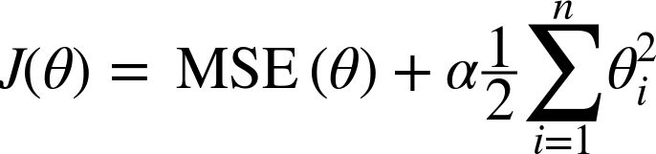

Note that the bias term *θ*0 is not regularized (the sum starts at *i* = 1, not 0). If we define **w** as the vector of feature weights (*θ*1 to *θn*), then the regularization term is simply equal to ½(∥ **w** ∥2)2, where ∥ · ∥2 represents the ℓ2 norm of the weight vector.[12](https://www.safaribooksonline.com/library/view/hands-on-machine-learning/9781491962282/ch04.html#idm140583014052960) For Gradient Descent, just add *α***w** to the MSE gradient vector ([Equation 4-6](https://www.safaribooksonline.com/library/view/hands-on-machine-learning/9781491962282/ch04.html#mse_gradient_vector)).

**WARNING**

It is important to scale the data (e.g., using a StandardScaler) before performing Ridge Regression, as it is sensitive to the scale of the input features. This is true of most regularized models.

[Figure 4-17](https://www.safaribooksonline.com/library/view/hands-on-machine-learning/9781491962282/ch04.html#ridge_regression_plot) shows several Ridge models trained on some linear data using different *α* value. On the left, plain Ridge models are used, leading to linear predictions. On the right, the data is first expanded using PolynomialFeatures(degree=10), then it is scaled using a StandardScaler, and finally the Ridge models are applied to the resulting features: this is Polynomial Regression with Ridge regularization. Note how increasing *α* leads to flatter (i.e., less extreme, more reasonable) predictions; this reduces the model’s variance but increases its bias.

As with Linear Regression, we can perform Ridge Regression either by computing a closed-form equation or by performing Gradient Descent. The pros and cons are the same. [Equation 4-9](https://www.safaribooksonline.com/library/view/hands-on-machine-learning/9781491962282/ch04.html#ridge_regression_solution) shows the closed-form solution (where **A** is the *n* × *n* *identity matrix*[13](https://www.safaribooksonline.com/library/view/hands-on-machine-learning/9781491962282/ch04.html#idm140583014038192) except with a 0 in the top-left cell, corresponding to the bias term).

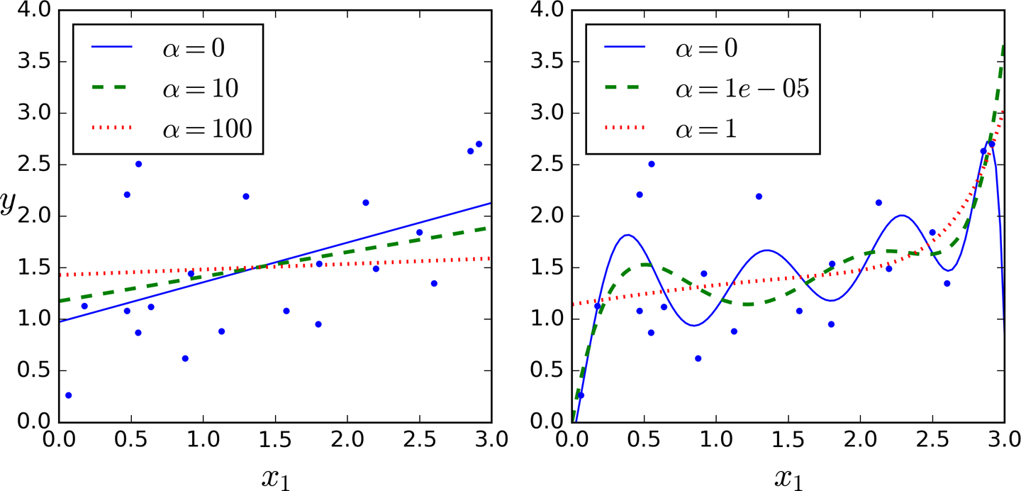

*Figure 4-17. Ridge Regression*

*Equation 4-9. Ridge Regression closed-form solution*

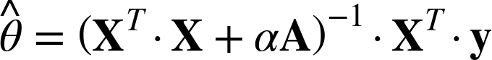

Here is how to perform Ridge Regression with Scikit-Learn using a closed-form solution (a variant of [Equation 4-9](https://www.safaribooksonline.com/library/view/hands-on-machine-learning/9781491962282/ch04.html#ridge_regression_solution) using a matrix factorization technique by André-Louis Cholesky):

**>>> from** **sklearn.linear_model** **import** Ridge

**>>>** ridge_reg = Ridge(alpha=1, solver="cholesky")

**>>>** ridge_reg.fit(X, y)

**>>>** ridge_reg.predict([[1.5]])

array([[ 1.55071465]])

And using Stochastic Gradient Descent:[14](https://www.safaribooksonline.com/library/view/hands-on-machine-learning/9781491962282/ch04.html#idm140583013780400)

**>>>** sgd_reg = SGDRegressor(penalty="l2")

**>>>** sgd_reg.fit(X, y.ravel())

**>>>** sgd_reg.predict([[1.5]])

array([ 1.13500145])

The penalty hyperparameter sets the type of regularization term to use. Specifying "l2" indicates that you want SGD to add a regularization term to the cost function equal to half the square of the ℓ2 norm of the weight vector: this is simply Ridge Regression.

**Lasso Regression**

*Least Absolute Shrinkage and Selection Operator Regression* (simply called *Lasso Regression*) is another regularized version of Linear Regression: just like Ridge Regression, it adds a regularization term to the cost function, but it uses the ℓ1 norm of the weight vector instead of half the square of the ℓ2 norm (see [Equation 4-10](https://www.safaribooksonline.com/library/view/hands-on-machine-learning/9781491962282/ch04.html#lasso_cost_function)).

*Equation 4-10. Lasso Regression cost function*

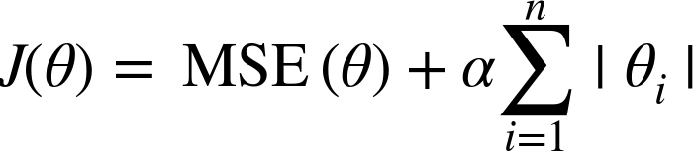

[Figure 4-18](https://www.safaribooksonline.com/library/view/hands-on-machine-learning/9781491962282/ch04.html#lasso_regression_plot) shows the same thing as [Figure 4-17](https://www.safaribooksonline.com/library/view/hands-on-machine-learning/9781491962282/ch04.html#ridge_regression_plot) but replaces Ridge models with Lasso models and uses smaller *α* values.

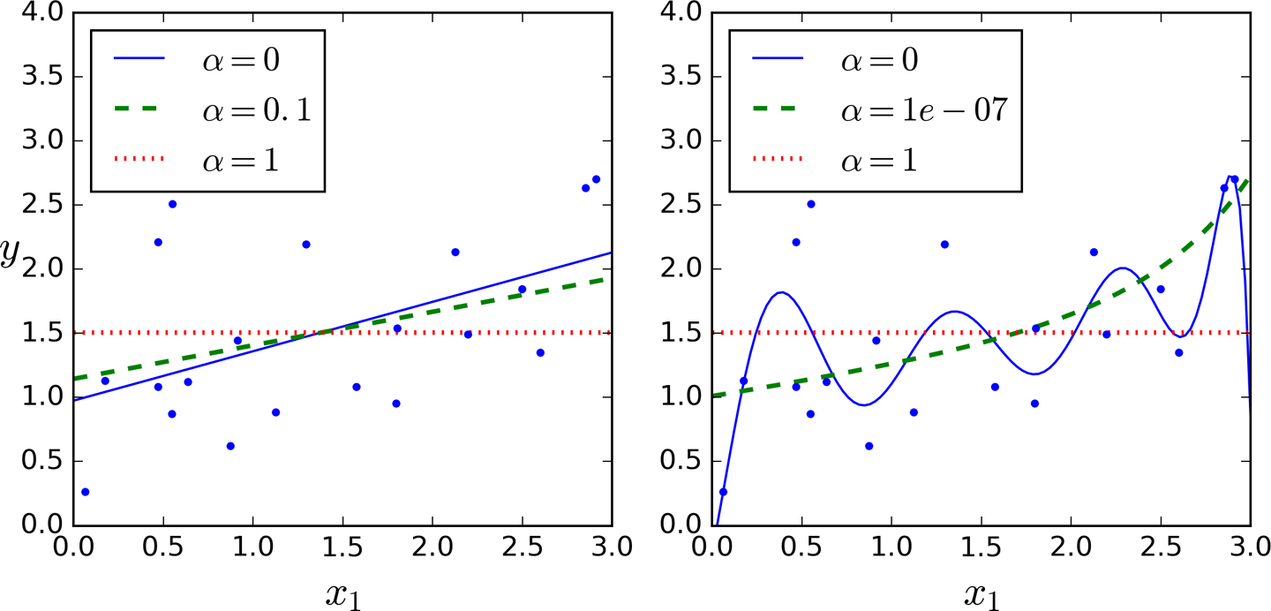

*Figure 4-18. Lasso Regression*

An important characteristic of Lasso Regression is that it tends to completely eliminate the weights of the least important features (i.e., set them to zero). For example, the dashed line in the right plot on [Figure 4-18](https://www.safaribooksonline.com/library/view/hands-on-machine-learning/9781491962282/ch04.html#lasso_regression_plot) (with *α* = 10-7) looks quadratic, almost linear: all the weights for the high-degree polynomial features are equal to zero. In other words, Lasso Regression automatically performs feature selection and outputs a *sparse model* (i.e., with few nonzero feature weights).

You can get a sense of why this is the case by looking at [Figure 4-19](https://www.safaribooksonline.com/library/view/hands-on-machine-learning/9781491962282/ch04.html#lasso_vs_ridge_plot): on the top-left plot, the background contours (ellipses) represent an unregularized MSE cost function (*α* = 0), and the white circles show the Batch Gradient Descent path with that cost function. The foreground contours (diamonds) represent the ℓ1 penalty, and the triangles show the BGD path for this penalty only (*α* → ∞). Notice how the path first reaches *θ*1 = 0, then rolls down a gutter until it reaches *θ*2 = 0. On the top-right plot, the contours represent the same cost function plus an ℓ1 penalty with *α* = 0.5. The global minimum is on the *θ*2 = 0 axis. BGD first reaches *θ*2 = 0, then rolls down the gutter until it reaches the global minimum. The two bottom plots show the same thing but uses an ℓ2 penalty instead. The regularized minimum is closer to *θ* = 0 than the unregularized minimum, but the weights do not get fully eliminated.

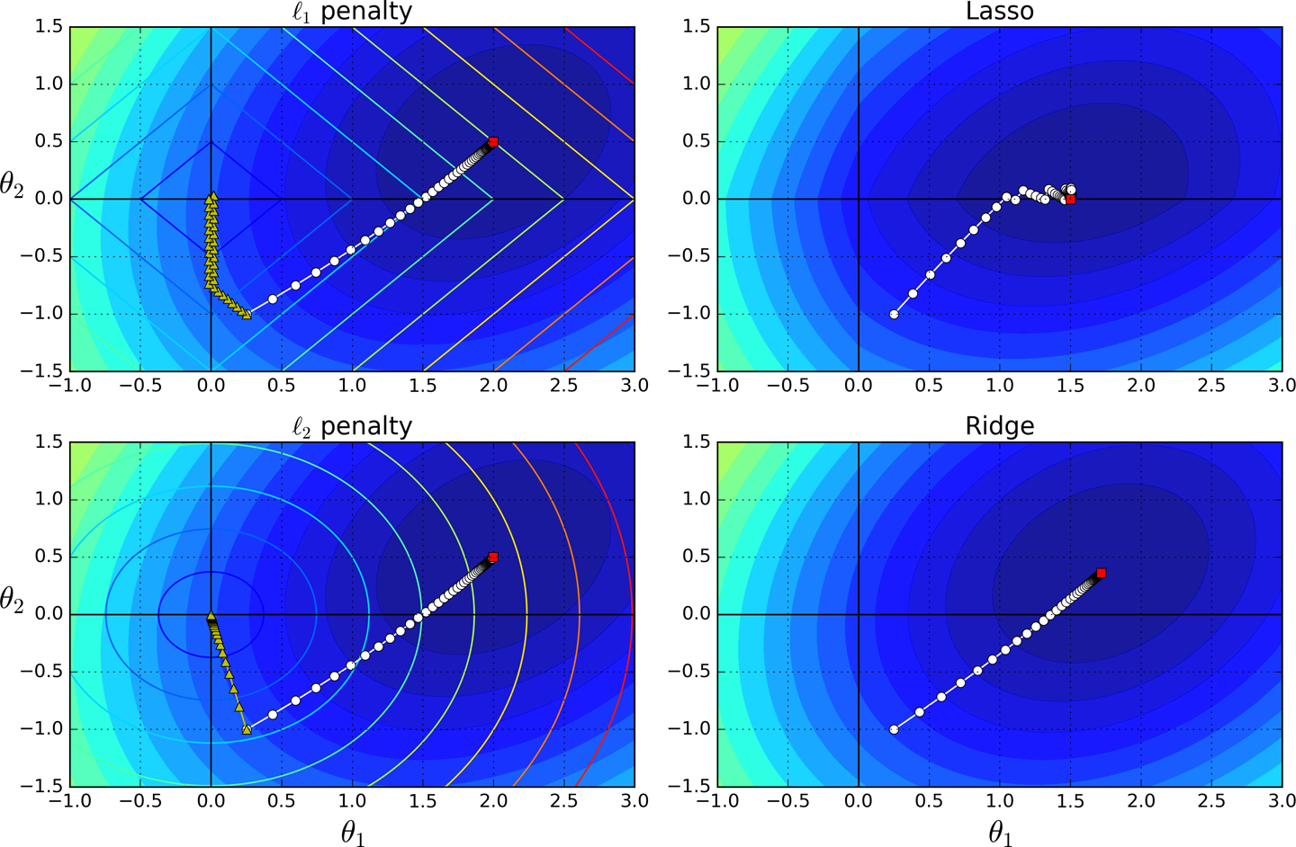

*Figure 4-19. Lasso versus Ridge regularization*

**TIP**

On the Lasso cost function, the BGD path tends to bounce across the gutter toward the end. This is because the slope changes abruptly at *θ*2 = 0. You need to gradually reduce the learning rate in order to actually converge to the global minimum.

The Lasso cost function is not differentiable at *θi* = 0 (for *i* = 1, 2, ⋯, *n*), but Gradient Descent still works fine if you use a *subgradient vector* **g**[15](https://www.safaribooksonline.com/library/view/hands-on-machine-learning/9781491962282/ch04.html#idm140583013735648) instead when any *θi* = 0. [Equation 4-11](https://www.safaribooksonline.com/library/view/hands-on-machine-learning/9781491962282/ch04.html#lasso_subgradient_vector) shows a subgradient vector equation you can use for Gradient Descent with the Lasso cost function.

*Equation 4-11. Lasso Regression subgradient vector*

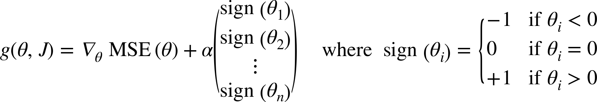

Here is a small Scikit-Learn example using the Lasso class. Note that you could instead use an SGDRegressor(penalty="l1").

**>>> from** **sklearn.linear_model** **import** Lasso

**>>>** lasso_reg = Lasso(alpha=0.1)

**>>>** lasso_reg.fit(X, y)

**>>>** lasso_reg.predict([[1.5]])

array([ 1.53788174])

**Elastic Net**

Elastic Net is a middle ground between Ridge Regression and Lasso Regression. The regularization term is a simple mix of both Ridge and Lasso’s regularization terms, and you can control the mix ratio *r*. When *r* = 0, Elastic Net is equivalent to Ridge Regression, and when *r* = 1, it is equivalent to Lasso Regression (see [Equation 4-12](https://www.safaribooksonline.com/library/view/hands-on-machine-learning/9781491962282/ch04.html#elastic_net_cost_function)).

*Equation 4-12. Elastic Net cost function*

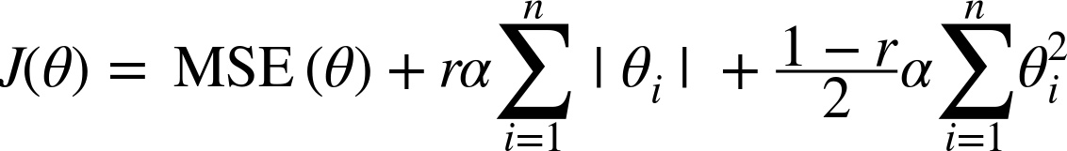

So when should you use plain Linear Regression (i.e., without any regularization), Ridge, Lasso, or Elastic Net? It is almost always preferable to have at least a little bit of regularization, so generally you should avoid plain Linear Regression. Ridge is a good default, but if you suspect that only a few features are actually useful, you should prefer Lasso or Elastic Net since they tend to reduce the useless features’ weights down to zero as we have discussed. In general, Elastic Net is preferred over Lasso since Lasso may behave erratically when the number of features is greater than the number of training instances or when several features are strongly correlated.

Here is a short example using Scikit-Learn’s ElasticNet (l1_ratio corresponds to the mix ratio *r*):

**>>> from** **sklearn.linear_model** **import** ElasticNet

**>>>** elastic_net = ElasticNet(alpha=0.1, l1_ratio=0.5)

**>>>** elastic_net.fit(X, y)

**>>>** elastic_net.predict([[1.5]])

array([ 1.54333232])

**Early Stopping**

A very different way to regularize iterative learning algorithms such as Gradient Descent is to stop training as soon as the validation error reaches a minimum. This is called *early stopping*. [Figure 4-20](https://www.safaribooksonline.com/library/view/hands-on-machine-learning/9781491962282/ch04.html#early_stopping_plot) shows a complex model (in this case a high-degree Polynomial Regression model) being trained using Batch Gradient Descent. As the epochs go by, the algorithm learns and its prediction error (RMSE) on the training set naturally goes down, and so does its prediction error on the validation set. However, after a while the validation error stops decreasing and actually starts to go back up. This indicates that the model has started to overfit the training data. With early stopping you just stop training as soon as the validation error reaches the minimum. It is such a simple and efficient regularization technique that Geoffrey Hinton called it a “beautiful free lunch.”

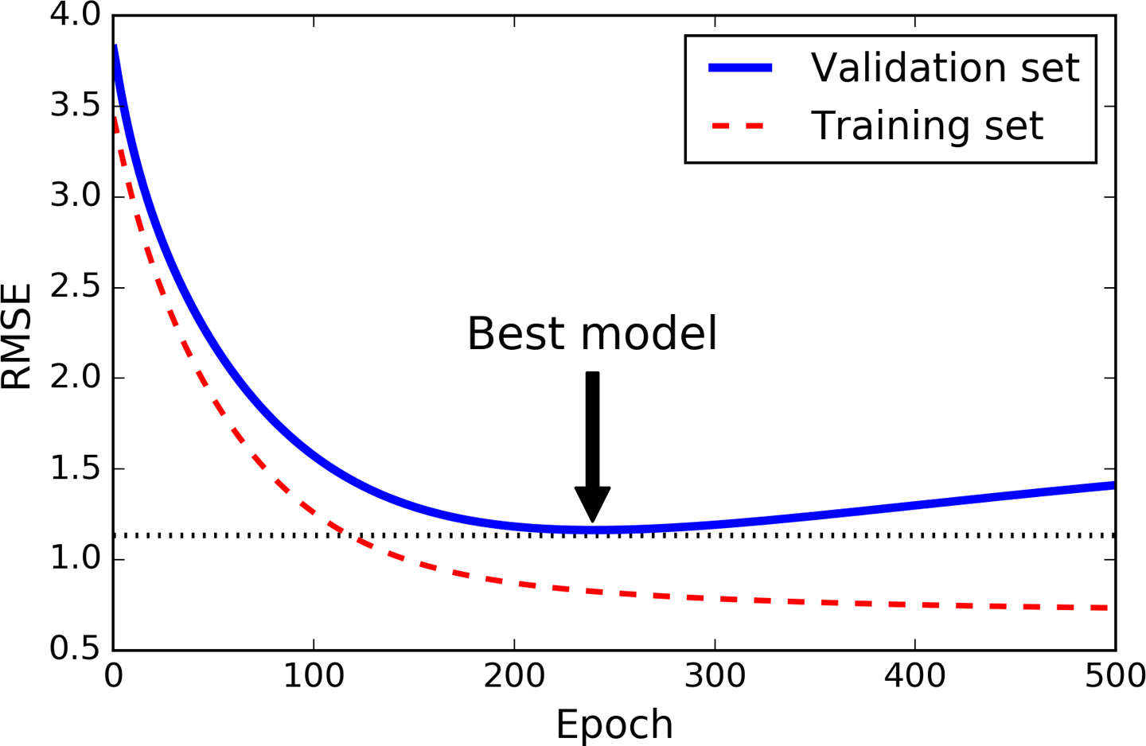

*Figure 4-20. Early stopping regularization*

**TIP**

With Stochastic and Mini-batch Gradient Descent, the curves are not so smooth, and it may be hard to know whether you have reached the minimum or not. One solution is to stop only after the validation error has been above the minimum for some time (when you are confident that the model will not do any better), then roll back the model parameters to the point where the validation error was at a minimum.

Here is a basic implementation of early stopping:

**from** **sklearn.base** **import** clone

*# prepare the data*

poly_scaler = Pipeline([

("poly_features", PolynomialFeatures(degree=90, include_bias=False)),

("std_scaler", StandardScaler()) ])

X_train_poly_scaled = poly_scaler.fit_transform(X_train)

X_val_poly_scaled = poly_scaler.transform(X_val)

sgd_reg = SGDRegressor(n_iter=1, warm_start=True, penalty=None,

learning_rate="constant", eta0=0.0005)

minimum_val_error = float("inf")

best_epoch = None

best_model = None

**for** epoch **in** range(1000):

sgd_reg.fit(X_train_poly_scaled, y_train) *# continues where it left off*

y_val_predict = sgd_reg.predict(X_val_poly_scaled)

val_error = mean_squared_error(y_val_predict, y_val)

**if** val_error < minimum_val_error:

minimum_val_error = val_error

best_epoch = epoch

best_model = clone(sgd_reg)

Note that with warm_start=True, when the fit() method is called, it just continues training where it left off instead of restarting from scratch.

**Logistic Regression**

As we discussed in [Chapter 1](https://www.safaribooksonline.com/library/view/hands-on-machine-learning/9781491962282/ch01.html#landscape_chapter), some regression algorithms can be used for classification as well (and vice versa). *Logistic Regression* (also called *Logit Regression*) is commonly used to estimate the probability that an instance belongs to a particular class (e.g., what is the probability that this email is spam?). If the estimated probability is greater than 50%, then the model predicts that the instance belongs to that class (called the positive class, labeled “1”), or else it predicts that it does not (i.e., it belongs to the negative class, labeled “0”). This makes it a binary classifier.

**Estimating Probabilities**

So how does it work? Just like a Linear Regression model, a Logistic Regression model computes a weighted sum of the input features (plus a bias term), but instead of outputting the result directly like the Linear Regression model does, it outputs the *logistic* of this result (see [Equation 4-13](https://www.safaribooksonline.com/library/view/hands-on-machine-learning/9781491962282/ch04.html#logisticregression_model_estimated_probability_vectorized_form)).

*Equation 4-13. Logistic Regression model estimated probability (vectorized form)*

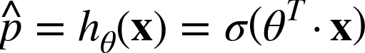

The logistic—also called the *logit*, noted *σ*(·)—is a *sigmoid function* (i.e., *S*-shaped) that outputs a number between 0 and 1. It is defined as shown in [Equation 4-14](https://www.safaribooksonline.com/library/view/hands-on-machine-learning/9781491962282/ch04.html#equation_four_fourteen) and [Figure 4-21](https://www.safaribooksonline.com/library/view/hands-on-machine-learning/9781491962282/ch04.html#figure_four_twenty_one).

*Equation 4-14. Logistic function*

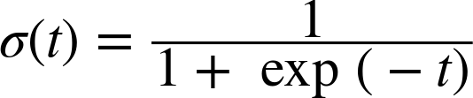

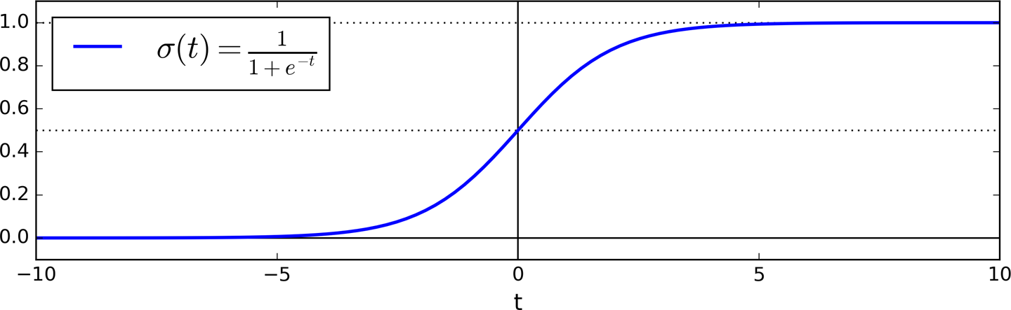

*Figure 4-21. Logistic function*

Once the Logistic Regression model has estimated the probability  = *hθ*(**x**) that an instance **x** belongs to the positive class, it can make its prediction *ŷ* easily (see [Equation 4-15](https://www.safaribooksonline.com/library/view/hands-on-machine-learning/9781491962282/ch04.html#equation_four_fifteen)).

*Equation 4-15. Logistic Regression model prediction*

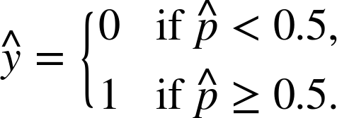

Notice that *σ*(*t*) < 0.5 when *t* < 0, and *σ*(*t*) ≥ 0.5 when *t* ≥ 0, so a Logistic Regression model predicts 1 if *θT* · **x** is positive, and 0 if it is negative.

**Training and Cost Function**

Good, now you know how a Logistic Regression model estimates probabilities and makes predictions. But how is it trained? The objective of training is to set the parameter vector *θ* so that the model estimates high probabilities for positive instances (*y* = 1) and low probabilities for negative instances (*y* = 0). This idea is captured by the cost function shown in [Equation 4-16](https://www.safaribooksonline.com/library/view/hands-on-machine-learning/9781491962282/ch04.html#cost_function_of_a_single_training_instance) for a single training instance **x**.

*Equation 4-16. Cost function of a single training instance*

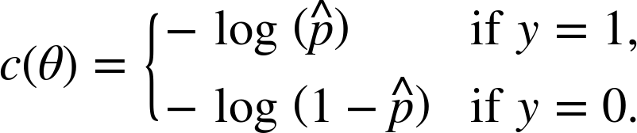

This cost function makes sense because – log(*t*) grows very large when *t* approaches 0, so the cost will be large if the model estimates a probability close to 0 for a positive instance, and it will also be very large if the model estimates a probability close to 1 for a negative instance. On the other hand, – log(*t*) is close to 0 when *t* is close to 1, so the cost will be close to 0 if the estimated probability is close to 0 for a negative instance or close to 1 for a positive instance, which is precisely what we want.

The cost function over the whole training set is simply the average cost over all training instances. It can be written in a single expression (as you can verify easily), called the *log loss*, shown in [Equation 4-17](https://www.safaribooksonline.com/library/view/hands-on-machine-learning/9781491962282/ch04.html#logistic_regression_cost_function).

*Equation 4-17. Logistic Regression cost function (log loss)*

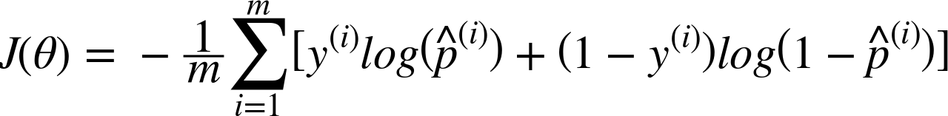

The bad news is that there is no known closed-form equation to compute the value of *θ* that minimizes this cost function (there is no equivalent of the Normal Equation). But the good news is that this cost function is convex, so Gradient Descent (or any other optimization algorithm) is guaranteed to find the global minimum (if the learning rate is not too large and you wait long enough). The partial derivatives of the cost function with regards to the jth model parameter *θj* is given by [Equation 4-18](https://www.safaribooksonline.com/library/view/hands-on-machine-learning/9781491962282/ch04.html#logistic_cost_function_partial_derivatives).

*Equation 4-18. Logistic cost function partial derivatives*

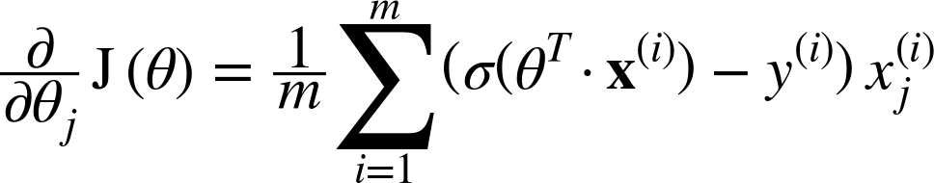

This equation looks very much like [Equation 4-5](https://www.safaribooksonline.com/library/view/hands-on-machine-learning/9781491962282/ch04.html#mse_partial_derivatives): for each instance it computes the prediction error and multiplies it by the jth feature value, and then it computes the average over all training instances. Once you have the gradient vector containing all the partial derivatives you can use it in the Batch Gradient Descent algorithm. That’s it: you now know how to train a Logistic Regression model. For Stochastic GD you would of course just take one instance at a time, and for Mini-batch GD you would use a mini-batch at a time.

**Decision Boundaries**

Let’s use the iris dataset to illustrate Logistic Regression. This is a famous dataset that contains the sepal and petal length and width of 150 iris flowers of three different species: Iris-Setosa, Iris-Versicolor, and Iris-Virginica (see [Figure 4-22](https://www.safaribooksonline.com/library/view/hands-on-machine-learning/9781491962282/ch04.html#iris_dataset_diagram)).

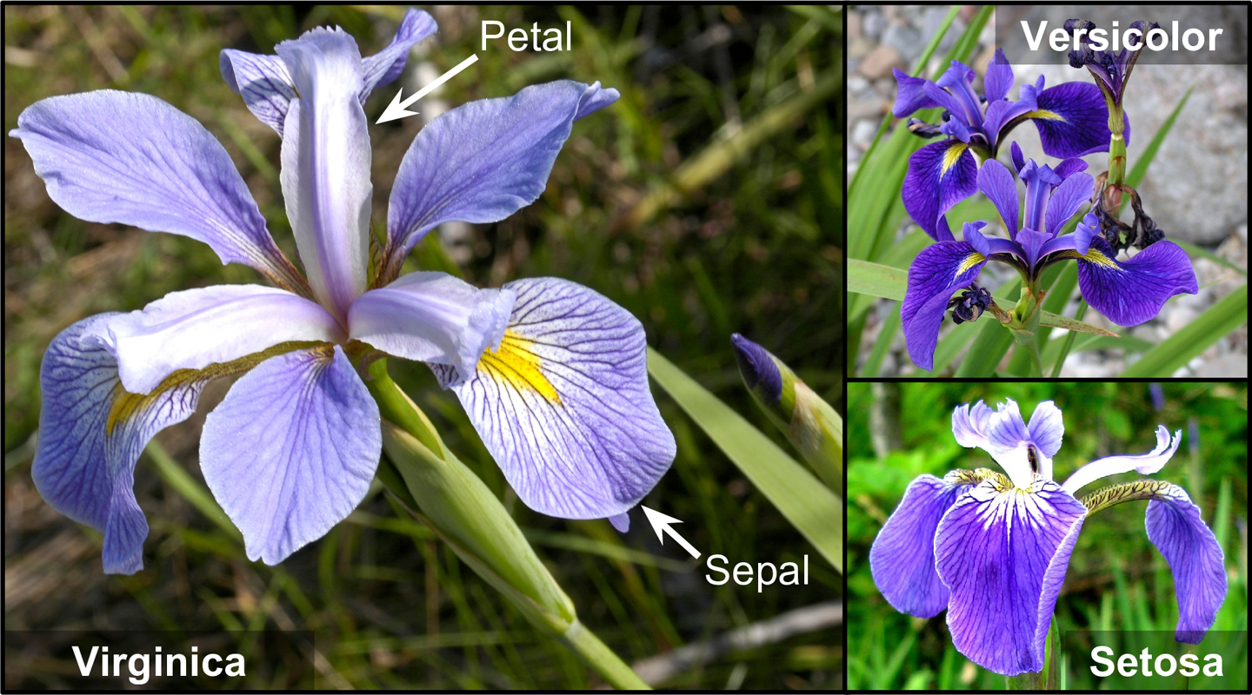

*Figure 4-22. Flowers of three iris plant species*[*16*](https://www.safaribooksonline.com/library/view/hands-on-machine-learning/9781491962282/ch04.html#idm140583013308880)

Let’s try to build a classifier to detect the Iris-Virginica type based only on the petal width feature. First let’s load the data:

**>>> from** **sklearn** **import** datasets

**>>>** iris = datasets.load_iris()

**>>>** list(iris.keys())

['data', 'target_names', 'feature_names', 'target', 'DESCR']

**>>>** X = iris["data"][:, 3:] *# petal width*

**>>>** y = (iris["target"] == 2).astype(np.int) *# 1 if Iris-Virginica, else 0*

Now let’s train a Logistic Regression model:

**from** **sklearn.linear_model** **import** LogisticRegression

log_reg = LogisticRegression()

log_reg.fit(X, y)

Let’s look at the model’s estimated probabilities for flowers with petal widths varying from 0 to 3 cm ([Figure 4-23](https://www.safaribooksonline.com/library/view/hands-on-machine-learning/9781491962282/ch04.html#estimated_probabilities_and_decision_boundary)):

X_new = np.linspace(0, 3, 1000).reshape(-1, 1)

y_proba = log_reg.predict_proba(X_new)

plt.plot(X_new, y_proba[:, 1], "g-", label="Iris-Virginica")

plt.plot(X_new, y_proba[:, 0], "b--", label="Not Iris-Virginica")

*# + more Matplotlib code to make the image look pretty*

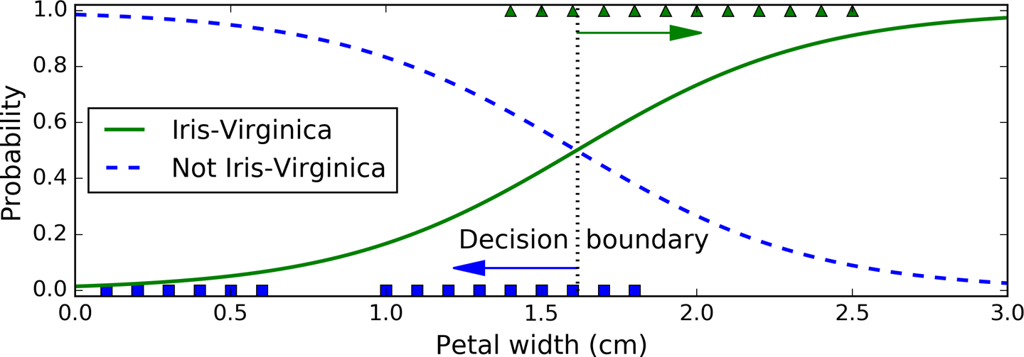

*Figure 4-23. Estimated probabilities and decision boundary*

The petal width of Iris-Virginica flowers (represented by triangles) ranges from 1.4 cm to 2.5 cm, while the other iris flowers (represented by squares) generally have a smaller petal width, ranging from 0.1 cm to 1.8 cm. Notice that there is a bit of overlap. Above about 2 cm the classifier is highly confident that the flower is an Iris-Virginica (it outputs a high probability to that class), while below 1 cm it is highly confident that it is not an Iris-Virginica (high probability for the “Not Iris-Virginica” class). In between these extremes, the classifier is unsure. However, if you ask it to predict the class (using the predict() method rather than the predict_proba()method), it will return whichever class is the most likely. Therefore, there is a *decision boundary* at around 1.6 cm where both probabilities are equal to 50%: if the petal width is higher than 1.6 cm, the classifier will predict that the flower is an Iris-Virginica, or else it will predict that it is not (even if it is not very confident):

**>>>** log_reg.predict([[1.7], [1.5]])

array([1, 0])

[Figure 4-24](https://www.safaribooksonline.com/library/view/hands-on-machine-learning/9781491962282/ch04.html#logistic_regression_contour_plot) shows the same dataset but this time displaying two features: petal width and length. Once trained, the Logistic Regression classifier can estimate the probability that a new flower is an Iris-Virginica based on these two features. The dashed line represents the points where the model estimates a 50% probability: this is the model’s decision boundary. Note that it is a linear boundary.[17](https://www.safaribooksonline.com/library/view/hands-on-machine-learning/9781491962282/ch04.html#idm140583012925696) Each parallel line represents the points where the model outputs a specific probability, from 15% (bottom left) to 90% (top right). All the flowers beyond the top-right line have an over 90% chance of being Iris-Virginica according to the model.

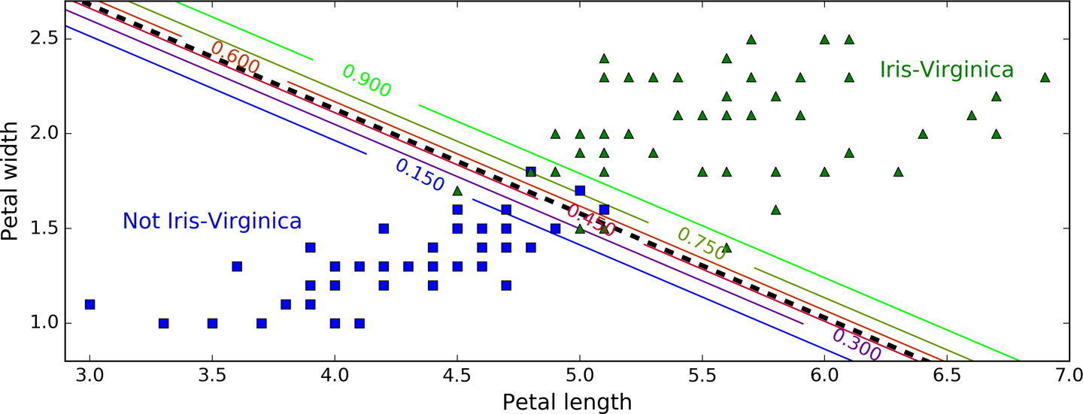

*Figure 4-24. Linear decision boundary*

Just like the other linear models, Logistic Regression models can be regularized using ℓ1 or ℓ2 penalties. Scitkit-Learn actually adds an ℓ2 penalty by default.

**NOTE**

The hyperparameter controlling the regularization strength of a Scikit-Learn LogisticRegressionmodel is not alpha (as in other linear models), but its inverse: C. The higher the value of C, the *less*the model is regularized.

**Softmax Regression**

The Logistic Regression model can be generalized to support multiple classes directly, without having to train and combine multiple binary classifiers (as discussed in [Chapter 3](https://www.safaribooksonline.com/library/view/hands-on-machine-learning/9781491962282/ch03.html#classification_chapter)). This is called *Softmax Regression*, or *Multinomial Logistic Regression*.

The idea is quite simple: when given an instance **x**, the Softmax Regression model first computes a score *sk*(**x**) for each class *k*, then estimates the probability of each class by applying the *softmax function* (also called the *normalized exponential*) to the scores. The equation to compute *sk*(**x**) should look familiar, as it is just like the equation for Linear Regression prediction (see [Equation 4-19](https://www.safaribooksonline.com/library/view/hands-on-machine-learning/9781491962282/ch04.html#softmax_score_for_class_k)).

*Equation 4-19. Softmax score for class k*

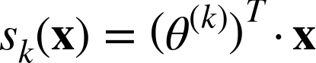

Note that each class has its own dedicated parameter vector *θ(k)*. All these vectors are typically stored as rows in a *parameter matrix* *Θ*.

Once you have computed the score of every class for the instance **x**, you can estimate the probability *k* that the instance belongs to class *k* by running the scores through the softmax function ([Equation 4-20](https://www.safaribooksonline.com/library/view/hands-on-machine-learning/9781491962282/ch04.html#softmax_function)): it computes the exponential of every score, then normalizes them (dividing by the sum of all the exponentials).

*Equation 4-20. Softmax function*

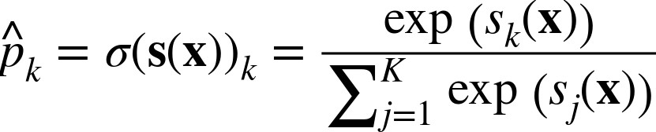

* *K* is the number of classes.
* **s**(**x**) is a vector containing the scores of each class for the instance **x**.
* *σ*(**s**(**x**))*k* is the estimated probability that the instance **x** belongs to class *k* given the scores of each class for that instance.

Just like the Logistic Regression classifier, the Softmax Regression classifier predicts the class with the highest estimated probability (which is simply the class with the highest score), as shown in [Equation 4-21](https://www.safaribooksonline.com/library/view/hands-on-machine-learning/9781491962282/ch04.html#softmax_regression_classifier_prediction).

*Equation 4-21. Softmax Regression classifier prediction*



* The *argmax* operator returns the value of a variable that maximizes a function. In this equation, it returns the value of *k* that maximizes the estimated probability *σ*(**s**(**x**))*k*.

**TIP**

The Softmax Regression classifier predicts only one class at a time (i.e., it is multiclass, not multioutput) so it should be used only with mutually exclusive classes such as different types of plants. You cannot use it to recognize multiple people in one picture.

Now that you know how the model estimates probabilities and makes predictions, let’s take a look at training. The objective is to have a model that estimates a high probability for the target class (and consequently a low probability for the other classes). Minimizing the cost function shown in [Equation 4-22](https://www.safaribooksonline.com/library/view/hands-on-machine-learning/9781491962282/ch04.html#cross_entropy_cost_function), called the *cross entropy*, should lead to this objective because it penalizes the model when it estimates a low probability for a target class. Cross entropy is frequently used to measure how well a set of estimated class probabilities match the target classes (we will use it again several times in the following chapters).

*Equation 4-22. Cross entropy cost function*

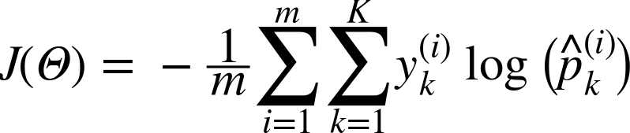

*  is equal to 1 if the target class for the ith instance is *k*; otherwise, it is equal to 0.

Notice that when there are just two classes (*K* = 2), this cost function is equivalent to the Logistic Regression’s cost function (log loss; see [Equation 4-17](https://www.safaribooksonline.com/library/view/hands-on-machine-learning/9781491962282/ch04.html#logistic_regression_cost_function)).

**CROSS ENTROPY**

Cross entropy originated from information theory. Suppose you want to efficiently transmit information about the weather every day. If there are eight options (sunny, rainy, etc.), you could encode each option using 3 bits since 23 = 8. However, if you think it will be sunny almost every day, it would be much more efficient to code “sunny” on just one bit (0) and the other seven options on 4 bits (starting with a 1). Cross entropy measures the average number of bits you actually send per option. If your assumption about the weather is perfect, cross entropy will just be equal to the entropy of the weather itself (i.e., its intrinsic unpredictability). But if your assumptions are wrong (e.g., if it rains often), cross entropy will be greater by an amount called the *Kullback–Leibler divergence*.

The cross entropy between two probability distributions *p* and *q* is defined as  (at least when the distributions are discrete).

The gradient vector of this cost function with regards to *θ(k)* is given by [Equation 4-23](https://www.safaribooksonline.com/library/view/hands-on-machine-learning/9781491962282/ch04.html#cross_entropy_gradient_vector_for_class_k):

*Equation 4-23. Cross entropy gradient vector for class k*

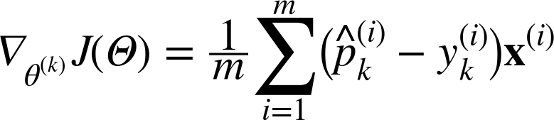

Now you can compute the gradient vector for every class, then use Gradient Descent (or any other optimization algorithm) to find the parameter matrix *Θ* that minimizes the cost function.

Let’s use Softmax Regression to classify the iris flowers into all three classes. Scikit-Learn’s LogisticRegression uses one-versus-all by default when you train it on more than two classes, but you can set the multi_class hyperparameter to "multinomial" to switch it to Softmax Regression instead. You must also specify a solver that supports Softmax Regression, such as the "lbfgs" solver (see Scikit-Learn’s documentation for more details). It also applies ℓ2 regularization by default, which you can control using the hyperparameter C.

X = iris["data"][:, (2, 3)] *# petal length, petal width*

y = iris["target"]

softmax_reg = LogisticRegression(multi_class="multinomial",solver="lbfgs", C=10)

softmax_reg.fit(X, y)

So the next time you find an iris with 5 cm long and 2 cm wide petals, you can ask your model to tell you what type of iris it is, and it will answer Iris-Virginica (class 2) with 94.2% probability (or Iris-Versicolor with 5.8% probability):

**>>>** softmax_reg.predict([[5, 2]])

array([2])

**>>>** softmax_reg.predict_proba([[5, 2]])

array([[ 6.33134078e-07, 5.75276067e-02, 9.42471760e-01]])

[Figure 4-25](https://www.safaribooksonline.com/library/view/hands-on-machine-learning/9781491962282/ch04.html#softmax_regression_contour_plot) shows the resulting decision boundaries, represented by the background colors. Notice that the decision boundaries between any two classes are linear. The figure also shows the probabilities for the Iris-Versicolor class, represented by the curved lines (e.g., the line labeled with 0.450 represents the 45% probability boundary). Notice that the model can predict a class that has an estimated probability below 50%. For example, at the point where all decision boundaries meet, all classes have an equal estimated probability of 33%.

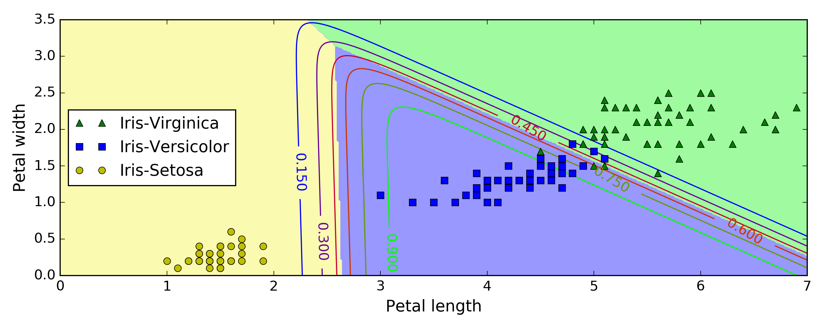

*Figure 4-25. Softmax Regression decision boundaries*

**Exercises**

1. What Linear Regression training algorithm can you use if you have a training set with millions of features?
2. Suppose the features in your training set have very different scales. What algorithms might suffer from this, and how? What can you do about it?
3. Can Gradient Descent get stuck in a local minimum when training a Logistic Regression model?
4. Do all Gradient Descent algorithms lead to the same model provided you let them run long enough?
5. Suppose you use Batch Gradient Descent and you plot the validation error at every epoch. If you notice that the validation error consistently goes up, what is likely going on? How can you fix this?
6. Is it a good idea to stop Mini-batch Gradient Descent immediately when the validation error goes up?
7. Which Gradient Descent algorithm (among those we discussed) will reach the vicinity of the optimal solution the fastest? Which will actually converge? How can you make the others converge as well?
8. Suppose you are using Polynomial Regression. You plot the learning curves and you notice that there is a large gap between the training error and the validation error. What is happening? What are three ways to solve this?
9. Suppose you are using Ridge Regression and you notice that the training error and the validation error are almost equal and fairly high. Would you say that the model suffers from high bias or high variance? Should you increase the regularization hyperparameter *α* or reduce it?
10. Why would you want to use:
    * Ridge Regression instead of plain Linear Regression (i.e., without any regularization)?
    * Lasso instead of Ridge Regression?
    * Elastic Net instead of Lasso?
11. Suppose you want to classify pictures as outdoor/indoor and daytime/nighttime. Should you implement two Logistic Regression classifiers or one Softmax Regression classifier?
12. Implement Batch Gradient Descent with early stopping for Softmax Regression (without using Scikit-Learn).

Solutions to these exercises are available in [Appendix A](https://www.safaribooksonline.com/library/view/hands-on-machine-learning/9781491962282/app01.html#solutions_appendix).

[1](https://www.safaribooksonline.com/library/view/hands-on-machine-learning/9781491962282/ch04.html#idm140583015469376-marker) It is often the case that a learning algorithm will try to optimize a different function than the performance measure used to evaluate the final model. This is generally because that function is easier to compute, because it has useful differentiation properties that the performance measure lacks, or because we want to constrain the model during training, as we will see when we discuss regularization.

[2](https://www.safaribooksonline.com/library/view/hands-on-machine-learning/9781491962282/ch04.html#idm140583015450496-marker) The demonstration that this returns the value of *θ* that minimizes the cost function is outside the scope of this book.

[3](https://www.safaribooksonline.com/library/view/hands-on-machine-learning/9781491962282/ch04.html#idm140583015070064-marker) Note that Scikit-Learn separates the bias term (intercept_) from the feature weights (coef_).

[4](https://www.safaribooksonline.com/library/view/hands-on-machine-learning/9781491962282/ch04.html#idm140583015175824-marker) Technically speaking, its derivative is *Lipschitz continuous*.

[5](https://www.safaribooksonline.com/library/view/hands-on-machine-learning/9781491962282/ch04.html#idm140583015172240-marker) Since feature 1 is smaller, it takes a larger change in *θ*1 to affect the cost function, which is why the bowl is elongated along the *θ*1 axis.

[6](https://www.safaribooksonline.com/library/view/hands-on-machine-learning/9781491962282/ch04.html#idm140583015137072-marker) Eta (*η*) is the 7th letter of the Greek alphabet.

[7](https://www.safaribooksonline.com/library/view/hands-on-machine-learning/9781491962282/ch04.html#idm140583014883200-marker) Out-of-core algorithms are discussed in [Chapter 1](https://www.safaribooksonline.com/library/view/hands-on-machine-learning/9781491962282/ch01.html#landscape_chapter).

[8](https://www.safaribooksonline.com/library/view/hands-on-machine-learning/9781491962282/ch04.html#idm140583014635472-marker) While the Normal Equation can only perform Linear Regression, the Gradient Descent algorithms can be used to train many other models, as we will see.

[9](https://www.safaribooksonline.com/library/view/hands-on-machine-learning/9781491962282/ch04.html#idm140583014666720-marker) A quadratic equation is of the form *y* = *ax*2 + *bx* + *c*.

[10](https://www.safaribooksonline.com/library/view/hands-on-machine-learning/9781491962282/ch04.html#idm140583013925712-marker) This notion of bias is not to be confused with the bias term of linear models.

[11](https://www.safaribooksonline.com/library/view/hands-on-machine-learning/9781491962282/ch04.html#idm140583014064160-marker) It is common to use the notation *J*(*θ*) for cost functions that don’t have a short name; we will often use this notation throughout the rest of this book. The context will make it clear which cost function is being discussed.

[12](https://www.safaribooksonline.com/library/view/hands-on-machine-learning/9781491962282/ch04.html#idm140583014052960-marker) Norms are discussed in [Chapter 2](https://www.safaribooksonline.com/library/view/hands-on-machine-learning/9781491962282/ch02.html#project_chapter).

[13](https://www.safaribooksonline.com/library/view/hands-on-machine-learning/9781491962282/ch04.html#idm140583014038192-marker) A square matrix full of 0s except for 1s on the main diagonal (top-left to bottom-right).

[14](https://www.safaribooksonline.com/library/view/hands-on-machine-learning/9781491962282/ch04.html#idm140583013780400-marker) Alternatively you can use the Ridge class with the "sag" solver. Stochastic Average GD is a variant of SGD. For more details, see the presentation [“Minimizing Finite Sums with the Stochastic Average Gradient Algorithm”](http://goo.gl/vxVyA2)by Mark Schmidt et al. from the University of British Columbia.

[15](https://www.safaribooksonline.com/library/view/hands-on-machine-learning/9781491962282/ch04.html#idm140583013735648-marker) You can think of a subgradient vector at a nondifferentiable point as an intermediate vector between the gradient vectors around that point.

[16](https://www.safaribooksonline.com/library/view/hands-on-machine-learning/9781491962282/ch04.html#idm140583013308880-marker) Photos reproduced from the corresponding Wikipedia pages. Iris-Virginica photo by Frank Mayfield ([Creative Commons BY-SA 2.0](https://creativecommons.org/licenses/by-sa/2.0/)), Iris-Versicolor photo by D. Gordon E. Robertson ([Creative Commons BY-SA 3.0](https://creativecommons.org/licenses/by-sa/3.0/)), and Iris-Setosa photo is public domain.

[17](https://www.safaribooksonline.com/library/view/hands-on-machine-learning/9781491962282/ch04.html#idm140583012925696-marker) It is the the set of points **x** such that *θ*0 + *θ*1*x*1 + *θ*2*x*2 = 0, which defines a straight line.

* [Recommended](https://www.safaribooksonline.com/r/)

* [Playlists](https://www.safaribooksonline.com/playlists/)

* [History](https://www.safaribooksonline.com/history/)

* [Topics](https://www.safaribooksonline.com/topics?q=*&limit=21)

* [Tutorials](https://www.safaribooksonline.com/tutorials/)

* [Settings](https://www.safaribooksonline.com/u/)

* [Support](https://www.safaribooksonline.com/public/support)

* [Get the App](https://www.safaribooksonline.com/apps/)

* [Sign Out](https://www.safaribooksonline.com/accounts/logout/)

© 2018 [Safari](https://www.safaribooksonline.com/). [Terms of Service](https://www.safaribooksonline.com/terms/) / [Privacy Policy](https://www.safaribooksonline.com/privacy/)